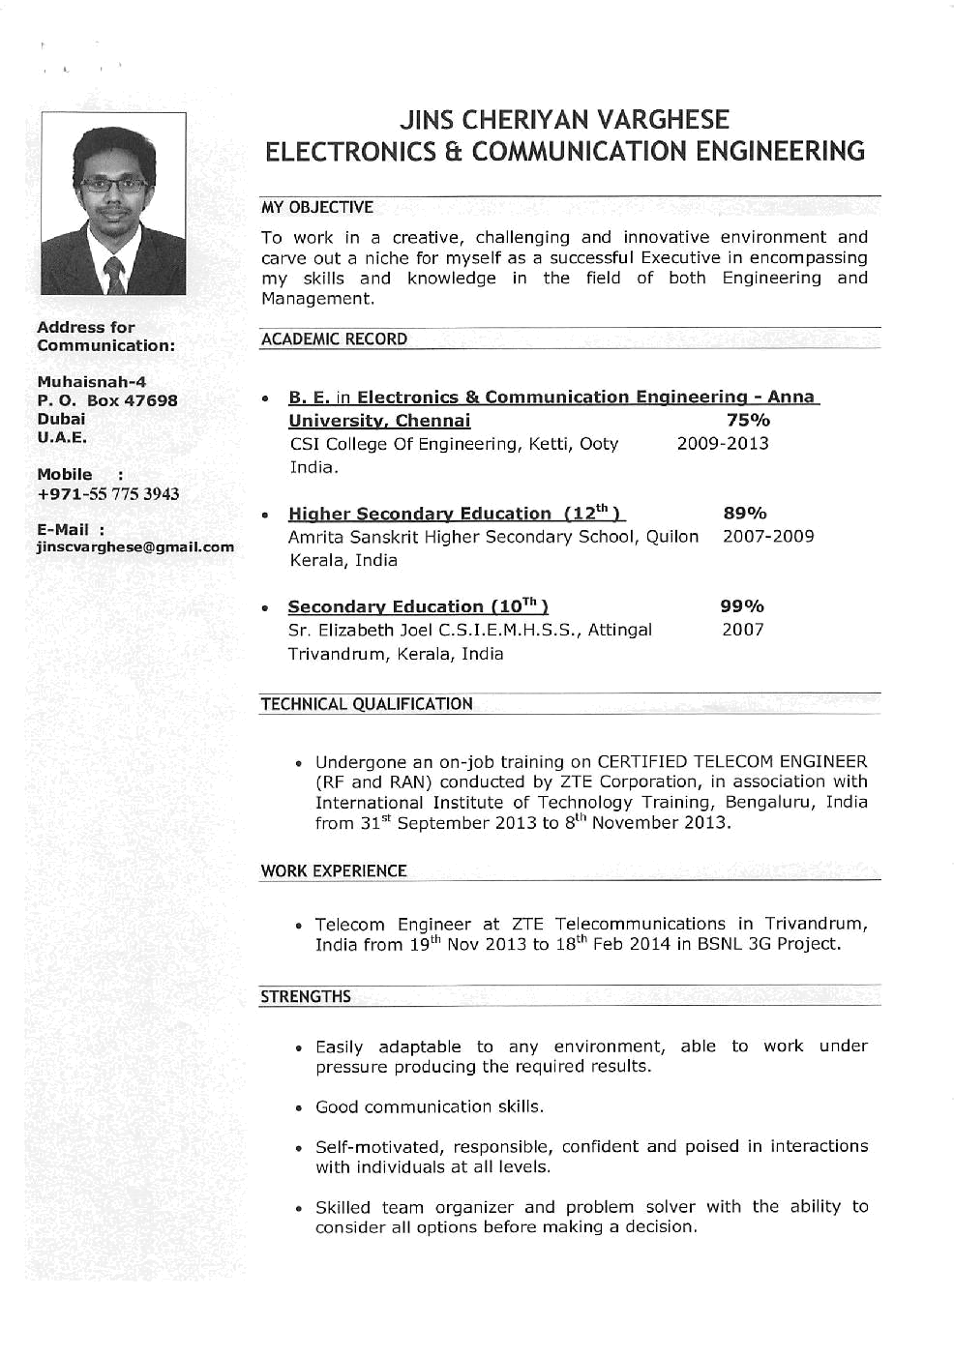
Gulfjobseeker CV No: 4338
To interview this candidate call 971505905010
Or email us back filled up Vacancy Form
http://www.gulfjobseeker.com/Free_Job_Posting_Form.doc


