CURRICULAM VITAE
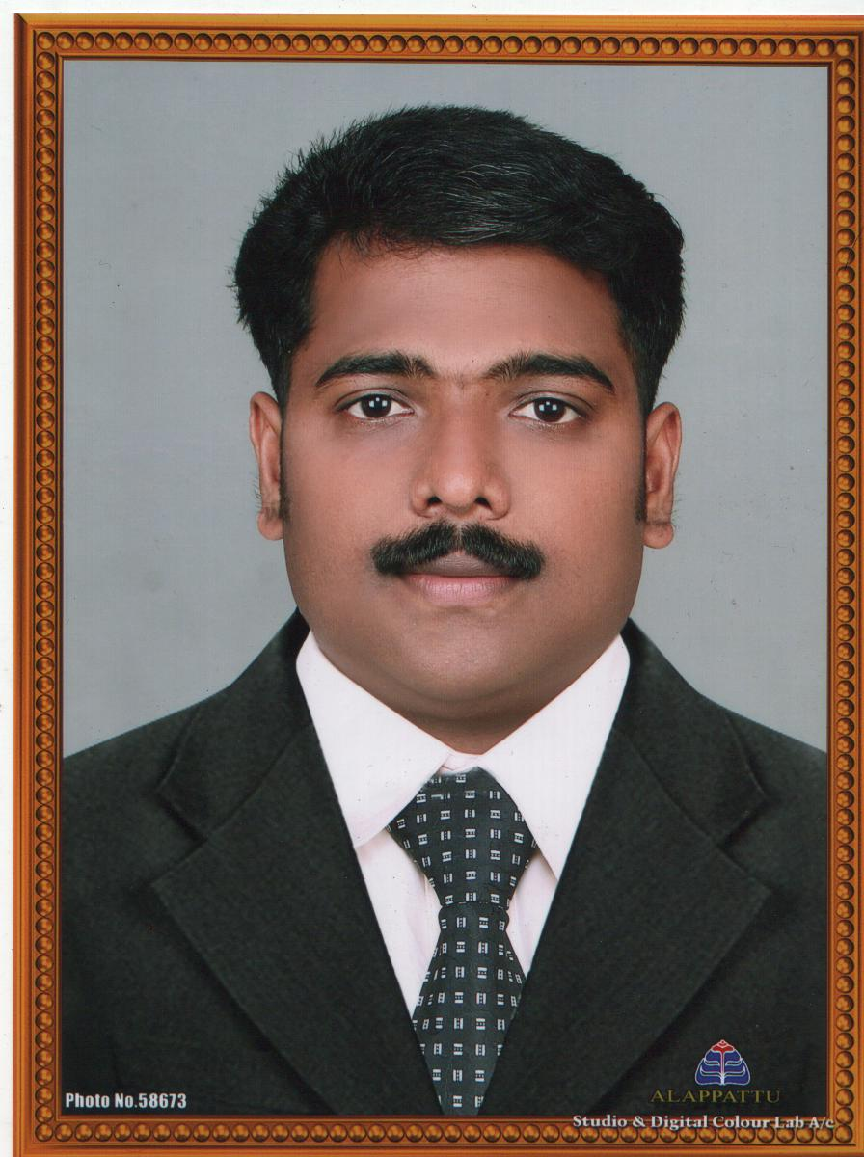

SAJEEB
SAJEEB.12@2freemail.com

Career / Placement:

Executive Secretary, Document Controller, Administrative Assistant.

Objectives:

Seeking a career in any Service with willingness to take challenges and responsibilities. To associate with a progressive organisation that gives me scope to apply my knowledge and skills along with hard work and patience, and to be involved as part of a team that works sincerely towards growth of the establishment.

Qualification Summary:

- Bachelor of Commerce - Kerala University 1995-1998
- Pre-Degree Kerala – University 1992-1994
- Secondary School Leaving Certificate

Computer Knowledge:

- Fundamentals of computers, MS Doss, MS Windows.
- Assembling and Trouble shooting.
- Office XP and Photo Shop.

Career Highlights & Strengths:

- Hard working, Team player and ability to work under pressure
- Compete the work assigned on scheduled time
- Analytical Ability and Problem Solving skills
- Energetic, qualified , innovative & Ready to Relocate
- Great written and oral communication ability in all ways

Professional Experience:

September 2006 to March 2008

I have worked as an Assistant Administrator

- Supervise office staff and the Accounts section. This includes review of invoice postings, work evaluation, decision-making and training.
- Payment processing thru Integrated Account Opening System.
  - Initiate payment proposal.
  - Review payment proposal.
  - Prepare documents for opening an account.
  - Upload payment document from Branch to Head Office.
  - Download cheque numbers from payments made.
  - Review cheque requests.
  - Review business cheques.

December January 2004 to September 2006

I have worked as an Executive secretary / Assistant Accountant in Shifa Al Khobar Poly Clinic, Al Khobar (Saudi Arabia)

- Prepare all office documents and forward the concerned
- Handling the office equipments

January 2000 to September 2004

Company Profile: HDFC Bank is one of the best banks in the private sector. It has more than 100 branches across India and does more business than any other private Bank in India.

Personal Details:

Date of birth : 15 May 1976
Nationality : Indian
Sex : Male
Marital Status : Married
Religion : Muslim
Driving Licence : Holding an Indian Light Vehicle driving licence
Visa Status : Visit

Languages Known:

English, Hindi, Malayalam and Tamil (Able to read, write and speak)

In the view of the above, I concede that I Posses necessary energy and seal in addition to my qualification and experience to meet your expectation in the event of my selection.

I assure you that I will carry out all responsibilities assigned to me with complete Sincerity.

