MIR SADIQUE HUSSAIN
Contact UAE:0566323154
Contact India :00917401028280
mirsadiqh@yahoo.in
UAE.

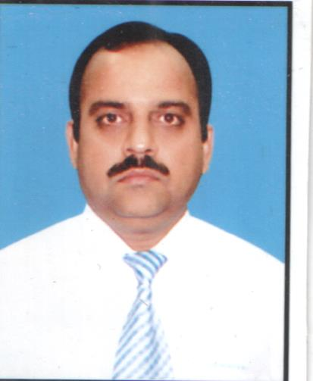

SUMMARY
Pro-active and result oriented professional with high quality experience and proven abilities in international brands’ retail store management, layout planning, strategic planning, achieving corporate objective, delivering exception rather than expectation, managing projects, analysis, team building, people management, market research, decision making, training and motivation. Demonstrated hands on management in the development and implementation of strategic plans with proven success in sales and new business developments.
Specialities:
Motivating Others
Developing Talent
Commercial Orientation
Impact
Result Focus
Customer Understanding
WORK EXPERIENCE
Jan 2012-September 2014 Baggit,Chennai

Team Leader
Was responsible for the retail operations of 14 counters in large format stores and three exclusive brand outlets in Chennai, Coimbatore & Cochin. Lead the team to maximize store contribution through exploiting every opportunity to drive sales, reduce stock loss & maintain cost controls. Also I was responsible to deliver the highest levels of motivation & development of team members & ensure individual & store compliance with all company regulations & procedures.

Dec 1996 – Oct 2011Alshaya Riyadh, Saudi Arabia

Deputy Store Manager
Job Role:
As a Deputy Store Manager I was responsible to lead the team to maximize store contribution through exploiting every opportunity to drive sales, reduce stock loss & maintain cost controls. Also I was responsible to deliver the highest levels of motivation & development of team members & ensure individual & store compliance with all company regulations &procedures.Ihavealso contributed to undertake operations management projects.
Responsibilities:
- Primary responsible for top and bottom line sales ensuring profitability.
- Decide on store layout, stock & fixtures positioning, manage stock availability productlaunches & promotions whilst feeding pertinent information to brand team.
- Ensure customer focus is prioritized.
- Implement & maintain agreed guidelines & standards for visual merchandising.
- Implement & review all stock loss prevention controls & develop practices specific to need of store within box.
- Manage a team of more than 100 subordinates .
- Motivate, train and develop the team considering the individual competencies.
- Ensure communication is effective throughout store.
- Reporting and giving effective feedback to Operations Manager/Business Director.

Nov 1994 - Nov 1996Esquire Express Ltd Chennai, India
Operations Executive
●Primary responsibility was to clear Inbound and outbound courier shipments from customs at the international terminal.Was also responsible for airport-hub operations in processing and directing the shipments to their destination. Span of control were a team of 10 staff members.

Jun 1990 - Sep 1994V.V. & Sons Dubai, UAE
Sales Assistant
●Worked with an electronics retail company as sales assistant. Primarily responsible for
showroom sales of electronic products and accessories.

EDUCATIONAL QUALIFICATION
Jun 1986 - Apr 1989 University of Madras Chennai, India
Bachelor’s degree in Commerce

LANGUAGES
• English | Fluent
• Arabic | Working knowledge

• Tamil | Fluent

• Hindi | Fluent

CAREER OBJECTIVE
To perform in a challenging position which meets my competencies, skills and education.

