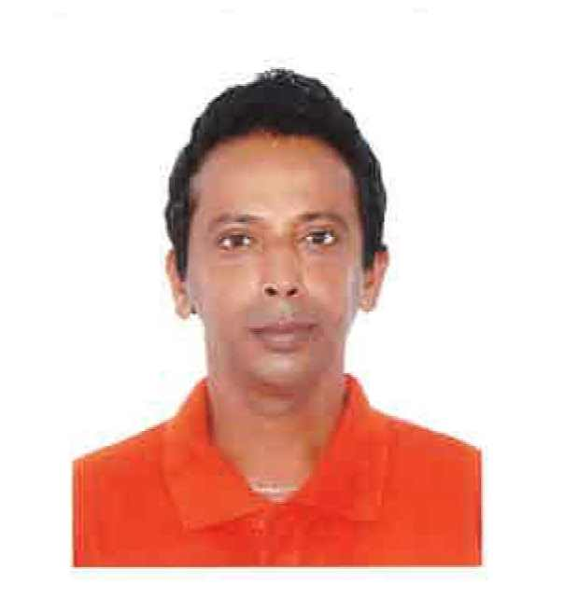ASHOK
Ashok.104124@2freemail.com

- Over 20 years of logistics, operations and general management administration
- A team player with ability to work under pressure, meet deadlines and firm goals
- Results-oriented, decisive leader and highly motivated and committed to excellence
- Dedicated, target-driven and performance oriented
- Excellent interpersonal skills with ability to operate effectively at all levels

PROFESSIONAL TRAINING and CERTIFICATIONS

- Certified KIAC (Key Information Air Cargo System)
- Certified ULD Inspection and Pallet building (Unit load device).
- Certified Tug Operator from FEDEX and Dubai Civil Aviation.
- Certified Forklift Operator.
- Certified ULD Shoring and Aircraft floor tie down..
- Ramp Safety and Handling Fire Extinguisher from Dubai Civil Aviation.

PROFESSIONAL QUALIFICATIONS

Work Experience
November 2009-Till Date | DFS Middle East | Cargo Operations Supervisor

Specific Accountabilities
- Acceptance & storage of all inbound and outbound cargo
- Buildup of Wide body and narrow body aircraft
- Manifesting of all types of cargo arriving in the airport.
- Sending of all preflight and post flight messages through the SITA communication network.
- Work allocation of staff in various sections like, warehouse, weighing scale operations and road feeder operation
- Coordinating with other departments like Operations, Ramp control, Passenger services.
- Liaising with other government departments like Dept of Customs, Police and Municipality/ Health services with regard to clearance of various types of cargo.
-------------------------------------------------------------------------------------------------------
November2009-to till date | DFS Middle East | Cargo Operations Supervisor

Specific Accountabilities:
- Practice safety at work at all times.
- Supervising all aspects of ground flight handling:
- Assisting with flights and cargo paper work
- Arranging the aircraft and cargo handling equipment’s as required
- Conducting pre-loading cargo inspections
- Supervising aircraft loading and offloading operations
- Any other duties relating to managing the aircraft arrival or departure
- Supervising or assisting in cargo build-up or breakdown of DFS operated or Chartered flights:
- Ensuring that the pallet build-up standards are maintained as airworthy
- Ensuring the build-up progress is reported in timely manner
- Reporting any cargo or ULD damage timely and in a prescribed format
- Acceptance of inbound or outbound cargo.
- Attending all company –organized training sessions and following all SOPs and working practices.
-----------------------------------------------------------------------------------------------------------------------------------

FEDERAL EXPRESS (Dubai International Airport) Aug 2004 – May 2009
Ramp and Hub Operation

- Secures the airplane and performs related preparation in accordance with AOD / local airport procedures.

- Supports the operation by operating any type of GSE equipment when required, in order to achieve optimal aircraft servicing.

- Supports operational goals by performing all related support duties and by providing contingency cover.
- Produces accurate off-load and on-load sequence instructions and co-ordinates offload and on load in order to optimize the productivity of the operation. Reports any serious and recurring issues to management.
- Enters all relevant Dangerous Goods information in the system. In accordance with the local operational requirements, verifies loading compliance and prepares, verifies all relevant paperwork.
- Co-ordinates all vendor services (aircraft catering, cleaning, and fuelling) and ensures that they are all in place at the required time.
- Handling Inbound and Outbound freight Documents.
- Supervising Loading for all kind of Aircraft – B1900C, FOKKER 27, AIRBUS310-200 & AIRBUS310-300, and DC10-10 & MD11 Freighters.

ACCOMPLISHMENT AND AWARDS

As a team:
- Awarded the International Ramp of the Year since 2004.
- Awarded the Circle of Excellence for the Outstanding Performance and on time departure of Aircraft.
- 100% Flight Safety and FAA Audit.

As an Individual (BRAVO ZULU Award) :
- for going above and beyond in service.
- for outstanding performance and showing positive attitude towards work and completing any task in minimum time.
- for 100% attendance throughout the years of 2005 – 2008

------------------------------------------------------------------------------------------------------------------------

ESTITHMAAR VENTURES – Dubai Media City May 2002 - Jun 2004
Admistration Assistant and Secretary

- Arranging appointments for Managing Director and daliy routine correspondences
- Strategies customer appeal in business enhancement through invitations
- Successfully developed an aggressive consumer promotion and advertising strategy
- Customer service orders and invoices and assiting in market surveys
- Facilitate logistics and arrange delivery of goods and supplies

SUPER FINE INTERNATIONAL LLC Jan 2001 – Apr 2002
Sales and Market Representative

- Updating and developing new customer profile on existing company products
- Liasie with manufactures and wholesales across the region
- Ensure trading is conducted with agreed credit facilities and follow on cash collections
- Participate in exhibitions and trade show to promote products and services
- Preparation of sales reports for individual business units

MOST FIRM INTERIORS LLC Dec 1993 – Dec 2000
Factory Warehouse Supervisor

- Organize global enquires and consolidate purchase to line agents
- Managed sales-marketing team charged with developing innovative approach for competing effectively in a competitive market
- Handle Sales Accounts and developed strategic relations with customers in providing tailored solutions
- Full line product selling that increased earnings by 25%
- Regained 30% of the dormant accounts achieving sales target for the year

EDUCATIONAL QUALIFICATIONS

Pre-University –1991 - 1993
St. Aloysius College, Mangalore,
Karnataka, India

SKILLS AND ATTRIBUTES

Application Skills

- Hardworking and ambitious:

- Willing to put in additional time and effort on a given task and commitment towards excellence.

- Time Management: Demonstrated ability to successfully plan, coordinate and meet deadlines of
multiple assignments

Interpersonal Skills

Communication: Confident, clear and succinct, both in written and oral English

Organizational: Work effectively with diverse group of people

Flexibility: Adapt well to changes and pressure in work place

Personal Skills

Boundary less Attitude: Enthusiast and positive with an extra mile approach

Optimistically high and pleasing business ethics and moral judgments

Friendly with an upbeat attitude

Exceedingly trainable and fast learner

Languages: English (Fluent), Hindi ( Fluent)
Personal Details:

Visa Status: – VISIT VISA (Expiring 15th March2016)

Valid UAE Driving License

Availability: Immediate join

CHARACTER REFERENCE: Available upon Request.
This is to certify that the above Information is true and correct with all my knowledge.

