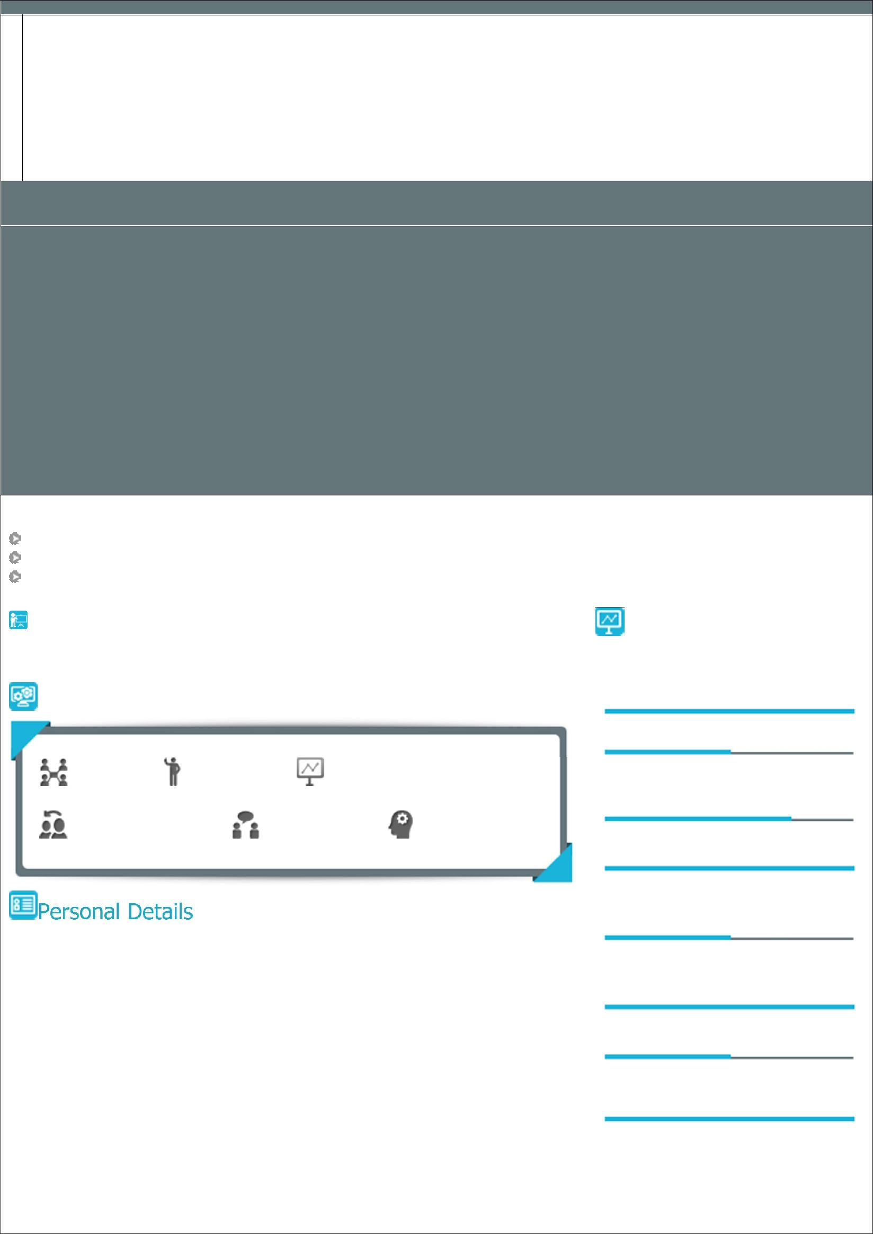
123

VENKATARAMANAPRASAD

BUSINESS DEVELOPMENT, CHANNEL MANAGEMENT, SALES & MARKETING
Acknowledged for strengthening companies to lead in highly competitive markets and delivering innovative concepts & strategies
VENKATARAMANAPRASAD.111506@2freemail.com

Profile Summary

Strategic sales specialist with 18 years including 15 years in apparel accessories and fashion industry. Strategizing the long term business directions to ensure maximum profitability in line with organizational objectives. Spearheaded the overhaul of customer segmentation, brand positioning and communications strategies that helped the brand to connect more emotively to consumers and increase loyalty. Directed the timely development and execution of marketing plans and strategies, product launches and new advertising campaigns while ensuring that sales growth and profit goals are met. Oversaw the conceptualization and execution of PR events and initiatives.

Impacted organization profitability through effective strategic and tactical management decisions and new business development. Rolled out Annual Business Plans for the business partners and aligned it with the company’s objectives ; monitored the timely launch & availability of new products across all retail counters.

Pioneered the roll-out of global launch plans including pricing, positioning, key account management, and portfolio selling. Skilled in forecasting monthly/annual sales targets & driving sales initiatives to achieve business goals & managing the frontline sales team to achieve them. Assessed competition after in-depth analysis of market information as well as identifying new business opportunities and competition. Designed, implemented and monitored strategically focused sales plans that created advantage for both the company and business partners.

Education

Post Graduate Diploma in Systems Management from NIIT, Hyderabad in 1992

B.Com. from Osmania University, in 1994

PGDM (Marketing) from ICFAI, Hyderabad

 |  |  | Area of Excellence
Soft Skills |  |  | Sales Management
 |  |  | Brand Management
Team Player | Problem Solver Analytical |  | Team
 |  |  | Management
Collaborator | Communicator | Innovator | Channel Management
 |  |  | Strategic Marketing(National
 |  |  | Level)
Date of Birth:22nd December, 1972 |  |  | Dealer & Distribution
Languages Known: English, Hindi, Telugu, Kannada
 |  |  | Management
 |  |  | Budget Forecast and Planning
 |  |  | Business Development

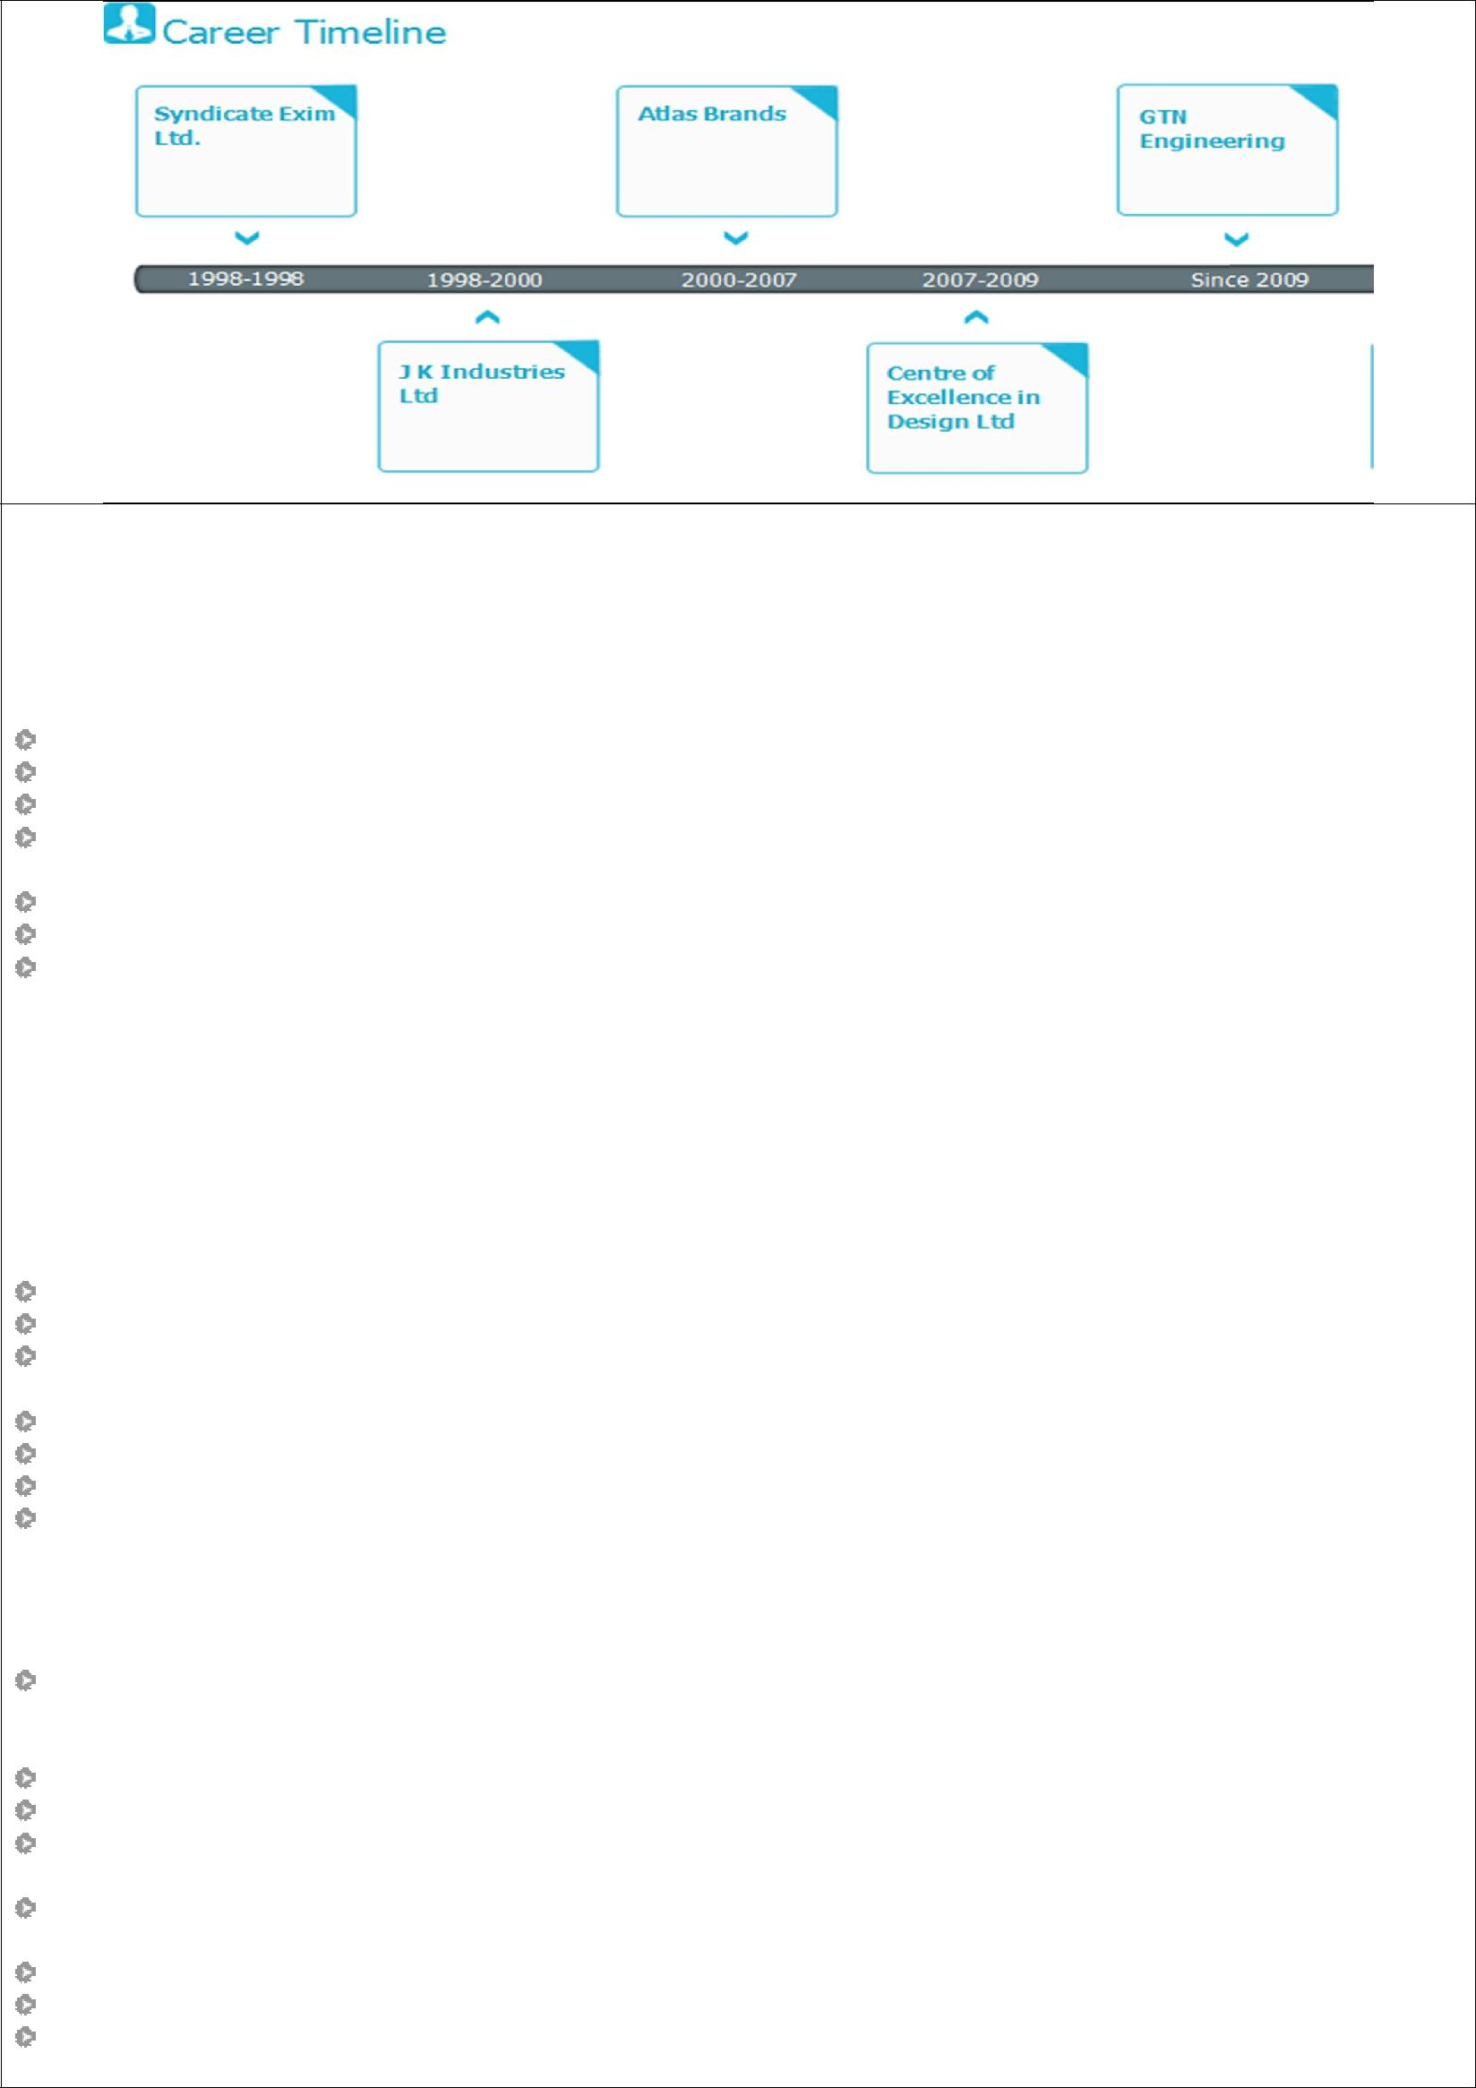

Work Experience

Nov’09-May’16

GTN Engineering (I) Ltd. – Unit Cotstyle Apparels (GTN Industries Ltd. Group), Hyderabad as General Manager - Brand Marketing
Key Result Areas:

Building Distribution network for Cotstyle brand across India and Nepal for both socks and collared t-shirts

Steering MBO presence for the brand which is now available in almost all the top most MBOs in India
Boosting entry of brand into the large format store chains like Shoppers Stop and Regal Shoes

Implementing brand marketing strategy through effective advertising and brand building programs

Notable Accomplishments
Attained a consistent growth curve of more than 50% Year on Year in Polos
Took active participation in London Garment Expo 2013 with a view to launch Cotstyle in the European Markets

Launched Cotstyle (Polos) in over 500 Multi Brand retail stores and socks in over 2000 stores across the country Managed a team of 40 sales professional of 4 Regional Sales Managers, 20 Area Sales Manager and 16 Sales Officers for Cotstyle

Successfully launched Young Wings (a sub brand of Cotstyle socks) in the year 2014 and established the same in over 1000 Multi Brand retail stores including Popular Shoe Store chain and Profit shoe store chain of South India

May’07-Oct’09

Centre Of Excellence in Design Ltd., Gurgaon as DGM – Sales & Marketing Notable Accomplishments

Planned and implemented strategies for launch of the brand KAOS in apparel and accessories in India

Built a strong sales team of 12 executives positioned at key cities in the country

Improved channel of 15 key distributors right from Jammu in the North to Kerala in South and from Gujarat in West to Guwahati in the East within a short span of two months

Boosted sales of KAOS into over 275 points of sale across the country within 4 months of the brand launch
Launched KAOS in Central, Shoppers Stop and the Planet M chain of stores

Attained the licenses of leather accessories under the brands: Arrow and Flying Machine from Arvind Brands Drove distribution network and entry into large format stores for Arrow and Flying Machine

Jul’00 – Apr’07

Atlas Brands (P) Ltd., Bangalore as National Manager – Sales & Distribution Notable Accomplishments

Spearheaded India operations for sales and marketing, channel management with team of 18 personnel, 7 C&F agents, 400 garment retail outlets such as Shopper’s stop, Lifestyle, Metro Shoes in 1200 watch retail outlets and 74 distributors across India
Recognized as Best Sales Team Leader and played a pivotal role in accomplishing a growth of 72%
Reduced cost of sales by 7% in 2005 as compared to the previous year

Managed the launch of Allen Solly, Van Heusen, Louis Philippe & Peter England branded leather accessories across the country and managed the licensing operations between Madura Garments and Atlas Brands (P) Ltd.

Steered the launch activities for Bulchee, a premium Branded range of leather products such as waist belts, leather accessories & watch straps and Madura brands of leather accessories

Achieved sales volumes as leading products in the regions through effective marketing and brand positioning
Streamlined logistics operations at the national level ensuring ready availability of stock as per the market demand Rolled out business development programs for promoting & enhancing visibility and secondary sales operations by keeping a watch on the activities of the dealers/distributors and assisting them in achieving the targets

Oct'98-Jun'00

J K Industries Ltd. (JK Tyre), Ahmedabad as Sales Officer- Passenger Car Tyre Segment Notable Accomplishments

Achieved growth of:
o 74% in car tyres; a comparative analysis shows industry growth of 12.4% and company growth of 24.8% o 90% of the assigned targets
Implemented launch of Ultima- XP a car radial at Ahmedabad
Organized first ever consumer campaign for car tyres which received response
Managed trade fair at Ahmedabad for creating customer awareness and strengthening the brand image
Jan'98 – Sep’98

Syndicate Exim (India) Ltd., Hyderabad as Research Associate Notable Accomplishments

Led research activities on various business verticals such as Marketing, Finance, Money Market, Economy, Business and Trade News
Built relationships with the eminent business personalities for gathering information
Published articles in the magazine; ‘Akaideas’- Strategies of Akai in the Television Market, ‘The future is in our hands' Special report on Geographical Information Systems , ' Dual Duel' The LML - Bajaj Scooter war

