

* Egypt - New Cairo,
* Date of birth: 24/12/1973
* [Mosa.115525@2freemail.com](mailto:Mosa.115525@2freemail.com)
* Mobile: C/o 971501685421

**.**

**Background A**

* B.Sc. of Mechanical Power Engineer (Helwan University Egypt)-1996
* Member of professional management institute (PMI)
* **PMP Certified** (Project Management Professional) from PMI, USA, July 2017.
* 21 Years of Experience

**Summary**

* MEP Manager with 21 years international experience in the construction industry.

Executed prestigious High rise Buildings, Hotels, Hospitals, Military Airport and Vehicles maintenance facility.

* Supervise and coordinate work according to contract conditions, budget, time frame, company proceed and ensure client satisfaction.
* Strong technical ability to design and construct air conditioning systems plumbing & fire protection.

Employment

* 2014- Present TURNER
* 2011 – 2014 PICCINI ITALY
* 2004 – 2010 KHARAFI NATIONAL
* 1996 – 2004 MATCO

**EXPERIENCE**

**2014- Present TURNER (TIME).**

***0f660b8***

**EGYPT, Cairo.**

[**St. Regis - Starwood Hotels & Resorts**](https://www.google.com.eg/url?sa=t&rct=j&q=&esrc=s&source=web&cd=1&cad=rja&uact=8&ved=0ahUKEwj3gszooOjJAhUBoxoKHcNCDg0QFggeMAA&url=http%3A%2F%2Fwww.starwoodhotels.com%2Fstregis%2Findex.html%3Flanguage%3Den_US&usg=AFQjCNHpd46M1j2mnY62V-g2T--r0LVEKA&sig2=MPB3eZdm1nlC90U03kGS3A)**-(Nile Cornish Project NCP)**

**Value $550Million**

**(MEP Technical Manager).**

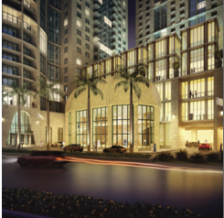

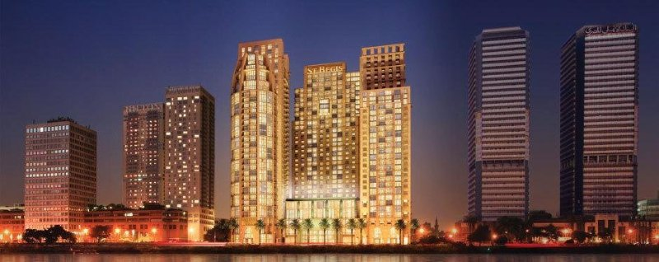

**Responsibilities:**

* Review MEP design drawings reports and specifications submitted by the Design Consultant(s) at each stage of the Design to ensure completeness, correctness,
* Compliance with the scope of work and agreement requirements.
* Carry out constructability review during the design stages.
* Review in a timely manner the design Consultant(s) submittals and forward comments to the Project Manager.
* Manage and co-ordinate the discharge of MEP Contractors obligations and all external influences likely to affect Project delivery on a daily basis.
* Manage and co-ordinate the discharge of MEP consultant’s duties.
* Manage and co-ordinate mock-ups, sample approvals and the like of all related MEP issues.
* Multidiscipline Coordination, provide a continuous support to the Design Managers and Site Team in providing a fully integrated problem-solving approach.

**2011 – 2014**

**PICCINI - Italy**



**Equatorial Guinea**

**Kempinski HOTEL**

**Value € 390 Million**

**500 Rooms Hotel , Conference Center, Golf Course, 50 Villas.**

**MEP Project Manager**

**Responsibilities:**

* Controlling all aspects of works including, planning, administration, commercial, engineering, site works and documentation.
* Leading a team of Electro-Mechanical Engineers.
* Ensure that works are completed on time, within scope & budget.
* Oversee all aspects of the day-to-day management of the project
* Define problems, collects data, establish facts and draw valid conclusions.
* Project planning and review progress against targets set.
* Establish the project construction methodology with the project team.
* Co-ordinate work of all in-house staff, suppliers and sub-contractor.
* Monitor and control expenses related to project work and ensure company's forecasts and budgets are met.
* Organize and attend technical meetings with Subcontractors to discuss shop drawings, material submittals and method statements as necessary.
* Delegate work to the project team and monitor progress.

**2004 – 2010**

**KHARAFI NATIONAL**



**AL HAMRA TOWER -KUWAIT**

**Value $500Million**

**MEP Construction Manager**

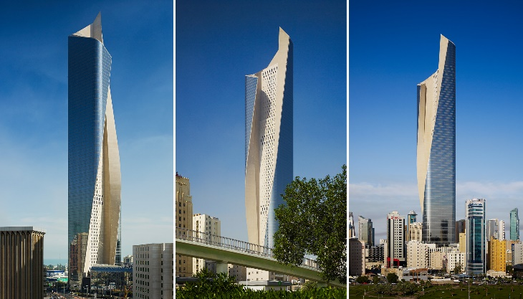

* Skyscraper designed by architectural firms Skidmore, Owings, Merrill, the [tallest building in Kuwait](https://en.wikipedia.org/wiki/Tallest_building_in_Kuwait), the tallest carved concrete skyscraper in the World, and the twenty third [tallest building in the world](https://en.wikipedia.org/wiki/Tallest_building_in_the_world) 414 meter.

**Responsibilities:**

* Review design to obtain best performance, prepare shop drawings with assist of CAD center.
* Prepare material take off, Material & equipment technical Submittals, in accordance to project specs, international codes & relevant standards.
* Responsible of material procurement thru coordination with procurement department, according to delivery time & project construction program.
* Study subcontractor prequalification, evaluate their technical and financial offers.
* Monitor project progress work to maintain project budget & time frame.
* Responsible for all technical issues related to construction.
* Prepare daily report with all site activity documentation.
* Manage weekly meeting with the contractors and consultant.
* Monitor all the variations orders and design modifications in order to reflect that financially in coordination with assigned commercial team.
* Supervise QA/QC teams for proper accomplishments for any outstanding issues.
* Full involvement in all interface systems i.e. controls Systems.
* Follow company procedure& management plan.
* Responsible for installation of 7.400 refrigerant ton system.
* Fabrication and installation of 1200 ton of galvanize duct and all aspect of equipment related to mechanical system

**2007**

**KHARAFI NATIONAL**

**American University ( AUC)**

**Cairo - EGYPT**

**MEP Construction Manager.**

**2004-2007**

**KHARAFI NATIONAL**

**SHERATON HOTEL-The Gambia**

**Mechanical Project Engineer**

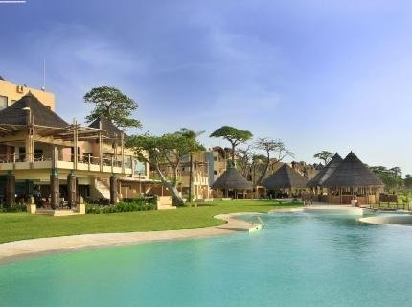

**Responsibilities:**

* Review design drawing for HVAC, Plumbing & Fire protection
* Cooling load design review.
* Material take off.
* Material technical submittals.
* Provide Fans & AHUS static calculation.
* Pumps head calculations.
* Review HAVC design using HAP program.
* Fire pump head calculation using elite program.
* Responsible for installation of Chillers, Pumps, AHUS, Fans, Fire pumps ducts installation, BMS system, piping , fire dampers & all equipment related to mechanical system.
* Installation of infra system including fire network, drainage & water supply system
* Startup, testing and commissioning of all mechanical systems

**1996 – 2004**

**MATCO (HVAC Technical /site Manager)**



**Responsibilities:**

* HVAC Engineer with extensive technical capability, Cooling load calculation Static head calculation Pipes support load calculation, pumps head calculation, smoke calculation, seismic selection based in SMACNA, prepare duct construction tables. Duct sizing with static regain or equal fraction methods.
* Prepare shop drawings, coordinate with other trades.
* Prepare technical submittal Material take off.
* Collect material offers.
* Responsible for site daily work activity.
* Installation of all type of Chillers, cooling tower, AHUS, FCUS, Packaged units, Fans , pipes , BMS & control systems.
* Startup, testing and commissioning.

**Participate in prestigious projects in Egypt**

**Fayed Air Force Base PV6 (F16)**

**2002- 2004**

**CONTRAC Inc -ORASCOM JV.**

**USA Corp of Engineers**

$750 million Air force Base, different type of military building air craft maintenance hangars, expatriate house, engine, maintenance facility. squadron operation, missile maintenance facility, power plant,

control tower.

**NAMA BAY HOTEL.**

**2000-2002**

Sharm El-Sheihk - Egypt

Contractor: Rodan For Construction.

Consultant: BACKRY Consultant.

240 Rooms 1500-ton Refrigerant Central Air Conditioning system air cooled chillers pumps, AHUS, FCUS, BMS system.

**ASWAN GENERAL HOSPITAL**

**1999-2000**

ASWAN - Egypt

Contractor: New Technology

Consultant: Mokhtar Consultant.

**Air Force Grand Celebration Hall**

**1998-1999**

Cairo - Egypt

Contractor: ORASCOM

Consultant: Maged Negm Consultant.

**Hyundai Maintenance and Body Repair Work Shop**

**1997-1998**

CAIRO - Egypt

Contractor: ORASCOM

Consultant: Dar El Handasa

**Al Qasr El Any Hospital**

**1996-1997**

Cairo - Egypt

Contractor: ARAB CONTRACTOR.

Consultant: SABOUR Consultant.

**Other Skills**

MS Project

HAP Design Program

Carmel Duct software

Word, Excel & AutoCAD