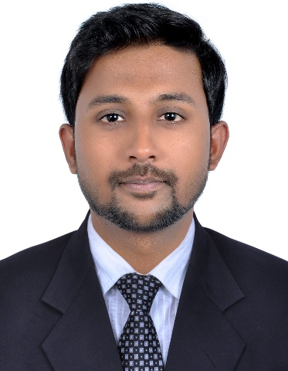**MUHAMMAD**

[**MUHAMMAD.116386@2freemail.com**](mailto:MUHAMMAD.116386@2freemail.com)

**Pharm-D, Rph, DHA and MOH**

**Current residence: UAE (Al-Baraha)**

***OBJECTIVE***

I am very energetic self-motivated pharmacist and more than 3.6 years of experience in JCIA accredited hospital and want to contribute and exercises all the capabilities and clinical experiences towards betterment of patient health through your organization policies.

***ACADEMIC QUALIFICATION***

|  |  |  |  |
| --- | --- | --- | --- |
| **Academic Qualification** | **Institution** | **Year** | **GPA/Grade** |
| **M-Phil** | University Of Karachi | continue | 3.2 |
| **Pharm-D** | University OF Karachi | 2012 | 3.45 |
| **Intermediate** | DJ Sindh GOVT. Science college | 2007 | A |
| **Matriculation** | The Children Academy | 2005 | A-one |

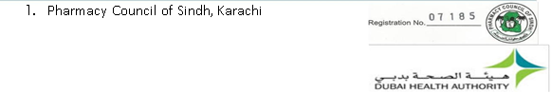***LICENSURES***

1. Pharmacy Council of Sindh, Pakistan



1. Dubai Health Authority, Dubai

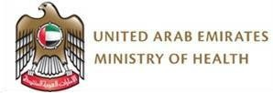

1. Ministry of Health, UAE

***PROFESSIONAL EXPERIENCE***

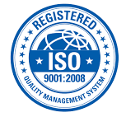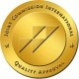

**From Jan 2013 continue present,**

**Hospital Pharmacist**

**AGA KHAN UNIVERSITY HOPSITAL** *(JCIA & ISO Certified*), **Stadium road Karachi.**

**3.5 years of experience**

Highly skilled pharmacist by profession and have three and half years of working experience in Tertiary Care Hospital. Started my career as a trainee pharmacist at Aga Khan University Hospital which included rotations in all the areas and got **“Best Trainee Pharmacist award”**. In the meantime I also got the opportunity to be enrolled in Karachi University in Masters in Pharmaceutics. After completion of my training, I was appointed as a full time pharmacist at sterile area including intravenous piggy back area and compounding area which proved to be a great learning experience for me. I am still affiliated with AKUH as an **“Oncology Pharmacist”** and have 2 years of oncology experience.

**Aug/2014 to present,** **Oncology Clinical Pharmacist**

**AGA KHAN UNIVERSITY HOPSITAL** *(JCIA & ISO Certified*), **Stadium road Karachi.**



* + Doing multidisciplinary clinical rounds in adult and mostly paediatric oncology unit to ensure safe & cost effective usage of drugs, monitoring of lab reports for proper indication of antibiotics, drug-drug interactions, dosing adjustments and optimize drug therapy.
  + Perform patient profile review, prospective drug evaluation and process orders accurately.
  + Analyse patients profile for adverse drug reaction and managing further therapy.
  + Review and interpret patient’s objective information for safe and accurate medication dosing.
  + Provide recommendations for medication therapy management services and pharmaceutical information.
  + Oversee technician staff to ensure all medication preparation and dispensing is accurate.
  + Ensure timely delivery of medication to the nursing units or patient.
  + Ensure the accuracy of the label before dispensing for right patient, right drug and right quantity.
  + Contact the physician for inaccuracy in cytotoxic medication order, proper documentation & communication of it to the nursing and pharmacy staff.
  + Provide drug information to medical and para medical staff for optimization of chemotherapy.
  + Developed Patient Education Material (PEMs) on chemotherapeutic drugs. Maintain and manage adequate inventory of cytotoxic drug.
  + Provide training to trainee pharmacists about cytotoxic drugs handling and managing the cytotoxic spill.

**JAN/2014 to JULY/2014, Pharmacist (TPN/IVPB & Non-Sterile and Sterile Compounding Pharmacy)**

**AGA KHAN UNIVERSITY HOPSITAL** *(JCIA & ISO Certified*), **Stadium road Karachi.**



* + Review and process the physician order for accurate and therapeutic dose of parenteral nutrition through CPOE.
  + Preparation of intravenous drugs, sterile compositions, TPN solution, extemporaneous and bulk compounding.
  + Pre- mixing of high alert medication.
* Ensure timely delivery of medication to the nursing units or patient.
  + Ensure the accuracy of the label before dispensing for right patient, right drug and right quantity.
  + Contact the physician for inaccuracy in medication order, proper documentation & communication of it to the nursing and pharmacy staff.
  + Maintain and manage adequate inventory.
  + Patient counselling.
  + Provide training to trainee pharmacists.
  + Provide drug information to medical and para medical staff. Unit dose, refill batch running/checking and timely delivery. Monthly floor stock inspection for proper storage of drugs.

**JAN/2013 to DEC/2013 On-Job-Trainee Pharmacist**

**AGA KHAN UNIVERSITY HOPSITAL** *(JCIA & ISO Certified*), **Stadium road Karachi.**



**Inpatient activities**: reviewing patients’ lab values and processing orders accordingly,managing inventory in assistance with the pharmacist, ensuring exchanges of bins in the wards, checking and dispensing of medicines to the nursing staff.

**Clinical rounds**: Four weeks rounds of critical areas like ICU and Cancer wards withpharmacists to ensure proper pharmacotherapy being given to the patient.

**Outpatient activities**: reviewing physician’s prescriptions, charging medicines withproper doses and frequency, filling and dispensing of medicines with relevant counseling.

**Drug information activities:** responding to calls with the authentic references, switchingof meropenem therapy to imipenem when possible, resolving queries of physicians and other internal customers and reviewing profiles of patients for creatinine adjusted dosing, therapeutic drug monitoring call handling, responding queries, literature survey, triggers and markers, ADR reporting, IV to PO switch, DUR's and other interventions, completing tasks assigned by the staff.

**Compounding activities**: compounding drugs with appropriated calculations, filling anddispensing of drugs to the wards and outpatient as per their requirements

**IVPB activities**: preparation of sterile products and calculate TPN and APN in accordancewith the policies defined.

***INTERNSHIP***

* One month internship at **LIAQUAT NATIONAL HOSPITAL, STADIUM ROAD KARACHI**. Reviewing profiles, making interventions, training for compounding drugs with appropriate calculations and exposure at outpatient services, inpatient services as well as drug information and poison center there at hospital.
* One month internship at **ABBASI SHAHEED HOSPITAL, KARACHI.**

Did Clinical rounds with my group, reviewing patients’ profile, identifying any interactions or adverse drug reactions in reporting to the chief pharmacist there.

***SEMINARS/WORKSHOPS***

* Participants in Quality Project Presentation in Quality and Patient Safety Symposium at **AGA KHAN UNIVERSITY HOPSITAL, STADIUM ROAD KARACHI.**
* Attended various CEs and workshops arranged by “AKUH Pharmacy services” and “University of Karachi.”
* Work ethics-development a positive work attitude Communication skills in pharmacy practices
* Pharmacy leadership and many others
* Attended session on Overview of USP 797 Standards – Pharmaceutical Compounding Sterile Preparations, **AKUH.**

***Skills***

* People soft inventory management system (FMS/HRMS) CPOE(computerized physician order entry system)
* Good knowledge regarding “**USP 797”** and “**USP 800”**
* Proficient with Microsoft office (Word, Excel, PowerPoint) Ability to work under pressure and priorities the work.
* Ability to work with multidisciplinary team

***OTHER ACHIEVEMENTS:***

* + Attending “**1st** **International Paediatric Oncology conference”** 21-22 April 2016 at Avari Tower Karachi, Pakistan.
* Abstract got selected for poster presentation in **“XV International Symposium** **2016 of**
  + **INTERNATIONAL SOCIETY OF ONCOLOGY PHARMACY PRACTITIONERS”** at the SheratonSantiago Hotel in Santiago, Chile from April 17-20, 2016.
* Got “**Best Specialized area Pharmacist of the Year Award”** for the year 2015 at **AGA**
  + **KHAN UNIVERSITY HOPSITAL, STADIUM ROAD KARACHI.**
  + Participant “**Bioavailability and Bioequivalence review faculty symposium**” Dec 2015 at University of Karachi, Pakistan.
  + Got “**Clinical Pearl Award”** for the year 2015 in **“world pharmacist symposium 2015”** at **AGA KHAN UNIVERSITY HOPSITAL, STADIUM ROAD KARACHI.**
* Organizer in “**world pharmacist symposium 2015”** at **AGA KHAN UNIVERSITY** 
  + **HOPSITAL, STADIUM ROAD KARACHI**
* Abstract **"Assessment of Health Care Professionals Knowledge about therapeutic drug**
  + **Monitoring of Vancomycin"** got selected for poster presentationin **“world pharmacist symposium 2015”** at **AGA KHAN UNIVERSITY HOPSITAL, STADIUM ROAD KARACHI.**
* Got “**Best Trainee Pharmacist of the Year Award”** for the year 2013 at **AGA KHAN**
  + **UNIVERSITY HOPSITAL, STADIUM ROAD KARACHI.**
* Organizer in “world pharmacist symposium 2014” and “world heart day” at **AGA KHAN**

**UNIVERSITY HOPSITAL, STADIUM ROAD KARACHI.**

* A lot of initiatives taken by me regarding compounding and chemo medications. Developed Patient Education Material (PEMs) on chemotherapeutic drugs, **AKUH**.
* Have arranged various events held at **University of Karachi**.
* Participated in different functions organized by University of Karachi.

***PERSONAL INFORMATION:***

**Nationality:** Pakistani

**Domicile:** Sindh (Urban)

**Marital Status:** Single

**Date of Birth**: 09-March-1988