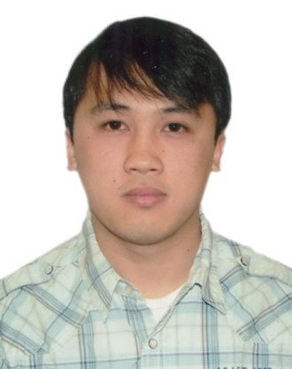
Gulfjobseeker.com CV No: 699534
Mobile +971505905010 cvdatabase[@]gulfjobseeker.com

To contact this candidate use this link
http://www.gulfjobseeker.com/feedback/contactjs.php

EDUCATION:
- Quezon Hill Elementary School 1991-1997
- University of Baguio Science High School 1997-2001
- Saint Louis University 2001-2002 (College of Accountancy and Commerce)
- Harrow International Business School- London, UK 2009-2010 (NVQ-3 Health and Social Care).
Nursing Education:
- Pines City Colleges , Philippines 2002-2006 (Bachelor of Science in Nursing)
Nursing Education Affiliates:
- Pines City Doctors Hospital - Baguio City, Philippines
- Baguio General Hospital - Baguio City, Philippines
- Benguet General Hospital - La Trinidad, Benguet, Philippines
- Tagudin General Hospital - Ilocos Sur, Philippines
- Philippine Orthopedic Center – Manila, Philippines
- Philippine Institute for Mental Health -Manila, Philippines

Trainings
- Basic Life Support -Philippine Red Cross 2006
- Venepuncture and cannulation -2007

Qualification

Philippine Nursing Board Examinations
Professional Regulation Commission

Work Experience
- Glympse Enterprises, managed the family business from 2006-2007.

- Entrepreneur (Buy and Sell) 2006-2009.

- Tagudin General Hospital Jan. 2007 – Jul. 2008
Ilocos Sur, Philippines.

- Worked as a part-time Private Nurse for a 13y/0 with ADHD and Epilepsy Nov.2009-April2010.
London, United Kingdom.
Responsibilities

As Staff Nurse:
- Facilitated admissions, discharge and transfers; prepared chart notes and other documentation.
- Worked with fellow nursing staff in providing bedside care, treatment and clinical documentation.
- Ensured patients rights are protected at all times.
- Secured health and safety by performing risk assessment.
- Handled medication administration, dressing changes, IVs, and all other aspects of nursing care.
- Provided a high standard of care in the promotion of health and quality of life.

As Private Nurse:

- Performed risk assessment before and after the shift to ensure the patients safety.
- Assisted with the patients’ ADL (Activities of Daily Living).
-Food preparation, personal hygiene, bathing, dressing etc.
- Preparation and administration of patients’ medication.
- Assisted with patients’ monthly check ups and contributed with the monitoring of the patients’ condition.
- Provided a quality nursing care to promote well-being.

Membership
- Philippine Nurses Association
- Rotary Club of Baguio Sunrise Dist.3790 2007-2009

Personal Data
Nationality: Filipino
Civil Status: Single
Gender: Male
Religion: Roman Catholic

