CURRICULAM VITAE
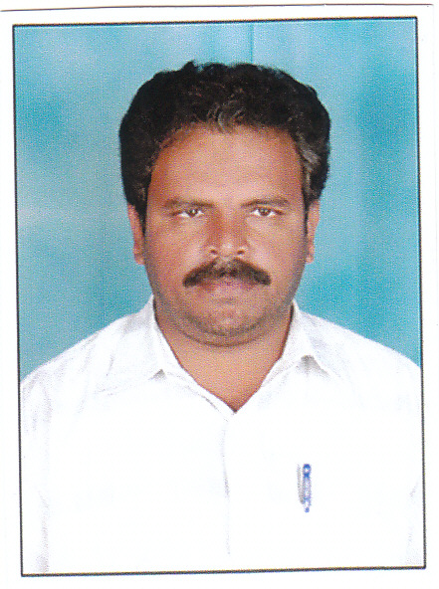
SYED
SYED.118375@2freemail.com

CAREER OBJECTIVE
To add value to myself and to the institution for which I work.
Want to be highly adaptive and standard professional preferably in the field of teaching.
Teaching being a noble profession in which I am very much interested. I consider it a privilege to
be a part of your illustrious institution with its excellent faculty. The experience will stand me in
good stead to enrich my knowledge in my future profession as a Teacher.

EDUCATIONAL QUALIFICATIONS
Education | Year of  passing | Percentage of marks | Institution Studeed
S.S.C | 1984 | 54% | Govt. Junior College, Irala
Intermediate (Bi.P.C) | 1986 | 59.6% | Govt. Junior College, Irala
Degree (B.Sc) (B.Z.C) | 1989 | 52 % | P.V.K.N.Degree College, Chittoor
D.T.E (Art & Design) | 1990 | 57% | Commissioner for Government Examinations, Andhra Pradesh, Hyderabad.
B.Ed Degree | 1991 | 50% | Annamalai University, Tamiladu State

EXPERIENCE DETAILS
Experience in Art & Design: - Free hand outline and model drawing, Still Life, Human Figure, Grid Method, and Memory Drawing etc.
10 years teaching experience in Art subject.
STRENGTHS: PERSONAL TRAILS:
Hard working Positive attitude
Good Communication Skills Adaptability to all types of environments
Patience Desire to continue learning while working
Confident Ability to work in group
Good communication skills

PERSONAL PROFILE:
Date of Birth : 18 – 02 - 1968
Nationality : Indian
Gender : Male
Marital Status : Married
Language Known : English, Hindi, Telugu, Urdu & Tamil
Hobbies : Reading books, Listening to music, Making
colourful Pictures and Playing Caroms.

I consider it a privilege to be part of your illustrious institution with its excellent faculty.
The experience will stand me in good stead to enrich my knowledge in my future profession as a Teacher.

