RESUME
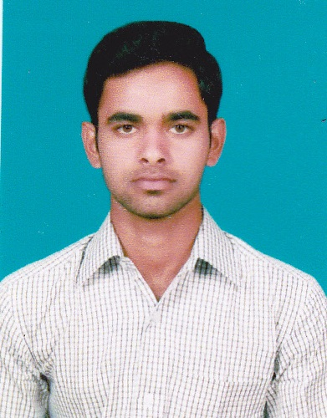
Gulfjobseeker.com CV No: 72600
Mobile +971505905010 / +971504753686

To get contact details of this candidates
Submit request through Feedback Link

http://www.gulfjobseeker.com/feedback/submit_fb.php

CAREER OBJECTIVE:

To pursue a challenging career in an esteemed and professionally managed organization with an opportunity to explore my skills that also favors my personal development along with the organization for which I bound to be resourceful, innovative and flexible.

EDUCATIONAL QUALIFICATIONS:

Qualification | Name of the institution | Board /  University | Year of passing | CGPA/Percentage  %
MBA | SRM university,  Kattankulathur,  Kancheepuram  . | SRM university | 2014 | 7.5
BBA | Jamal Mohamed college, Trichy | Bharathidhasan University, Trichy. | 2012 | 73%
H.S.C | Government higher secondary school, Singalandapuram. | State board | 2009 | 69%
S.S.L.C | Government higher secondary school, Singalandapuram. | State board | 2007 | 47%

PROJECT DETAILS:

- I did my MBA Mini Project in the title of “A STUDY ON PORT FOLIO MANAGEMENT” FOR AMBALAL SHARES AND STOCKS PRIVATE LIMITED, NAMAKKAL.
- I did my MBA Main Project in the title of “A STUDY ON WORKING CAPITAL MANAGEMENT” IN APINDHRATEX PRIVATE LIMITED, TIRUPUR.

SKILLS AND KNOWLEDGE:

- Technical competencies:
Software : MS Word, MS Office, MS PowerPoint, Tally,
Excel Working.
Operating System : Windows XP, windows7, Linux.

- Areas of interest:
Finance and marketing
E-commerce

- Positive Traits:
Eager to learn new things
Self Motivated
Hard Work

- Responsibility Held:

- Served as a member in Anti Dowry Association for two years(2009-2011) & Became the VICE PRESIDENT in the year (2011-2012)
- Conducted many Dowry Awareness Programs
- Working with teachers to improve staff and students relationship
- Association Member in the Department of Business Administration BBA
- Working as a Representative of MBA (2012-2014)
- TREASURER in SAMS School of management of SRM University (2012-2014).

- Responsibility Held:
- Participated in QUIZ Competition at State Level in EBIT College, Kanga yam.
- Participated in State Level Seminar from Jamal Mohamed College
- Meritorious Student Certificate Award in BBA(2009-12)
- Participated in Madras Management Association (MMA) 24 hours Program
- Participated in ANNUAL CONVENTION 2013 Program Organized by Madras management Association MMA.

PERSONAL DETAILS:

Date of birth : 14.06.1992
Marital Status : Single
Gender : Male
Religion : Hindu
Nationality : Indian
Languages known : English and Tamil (Read, Write and Speak)
Telugu (Speak)
Hobbies : Playing & Watching Cricket, social-networking,
Reading Tamil Book.

DECLARATION:
I hereby declare that the above-furnished information is correct and true to my knowledge and belief.

Place:
Date:

