CURRICULUM VITAE
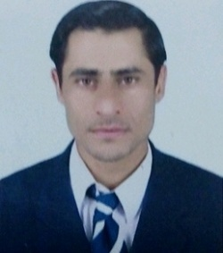

MUKHTIAR ALI KHAN
Mob: +97155-2739094
Address: Hor-al-anz, Dubai
Email:mukhtiarkhan761@gmail.com
MA_khan1@hotmail.com

Career Objective

A suitable position which excellent skills, enthusiastic customer relationship, and interpersonal skills with a frontline organization.

Work Experience

- Worked as Data entry Operator/Computer Operator in Pakistan for 4 years.
- Worked as a store keeper in UAE
- One year experience as field mobilization officer/Field coordinator.

Educational Qualification

- Bachelor of Commerce (B.com)
- Diploma in Information Technology
- Diploma in Computer Science

Computer skills

- Ms Office full package (Ms Excel, Ms Word, Power point and one Note.
- Graphic Designing (Adobe Photoshop, Ulead, Corel Draw)

Personal Details

Nationality : Pakistani
Religion : Islam
Marital Status : Single

Passport Details

Passport No : QK1791532
Date of Issue : 24/09/2013
Date of Expiry : 23/09/2018
Visa Status : Residence Visa (Transferable)

Skill /Qualifications:

Data Entry Skills, Typing, Confidentiality, Attention to Detail, Thoroughness, Independence, Documentation Skills, Problem Solving, Analyzing Information, Dependability, Results Driven, Computer Hardware & software installation etc.

Strength

- Equipped with leadership qualities, hardworking, punctual, ability to work under cross –culture environments.
- A keen communicator with exceptional inter personal relationship skills. Pleasing personality and self-motivated.

Trainings
- Attended one day capacity building workshop on child protection from Sparc.
- Attended three days CBW on child protection, child right, life skill, human rights from SDF.
- Two days Training on Drr (disaster risk reduction) from SDF.
- Two days training on life skill from SDF.
- Two days training on Research Methodology from World Vision

Language Known

- English
- Urdu
- Pashto
- Hindi

