 |  | 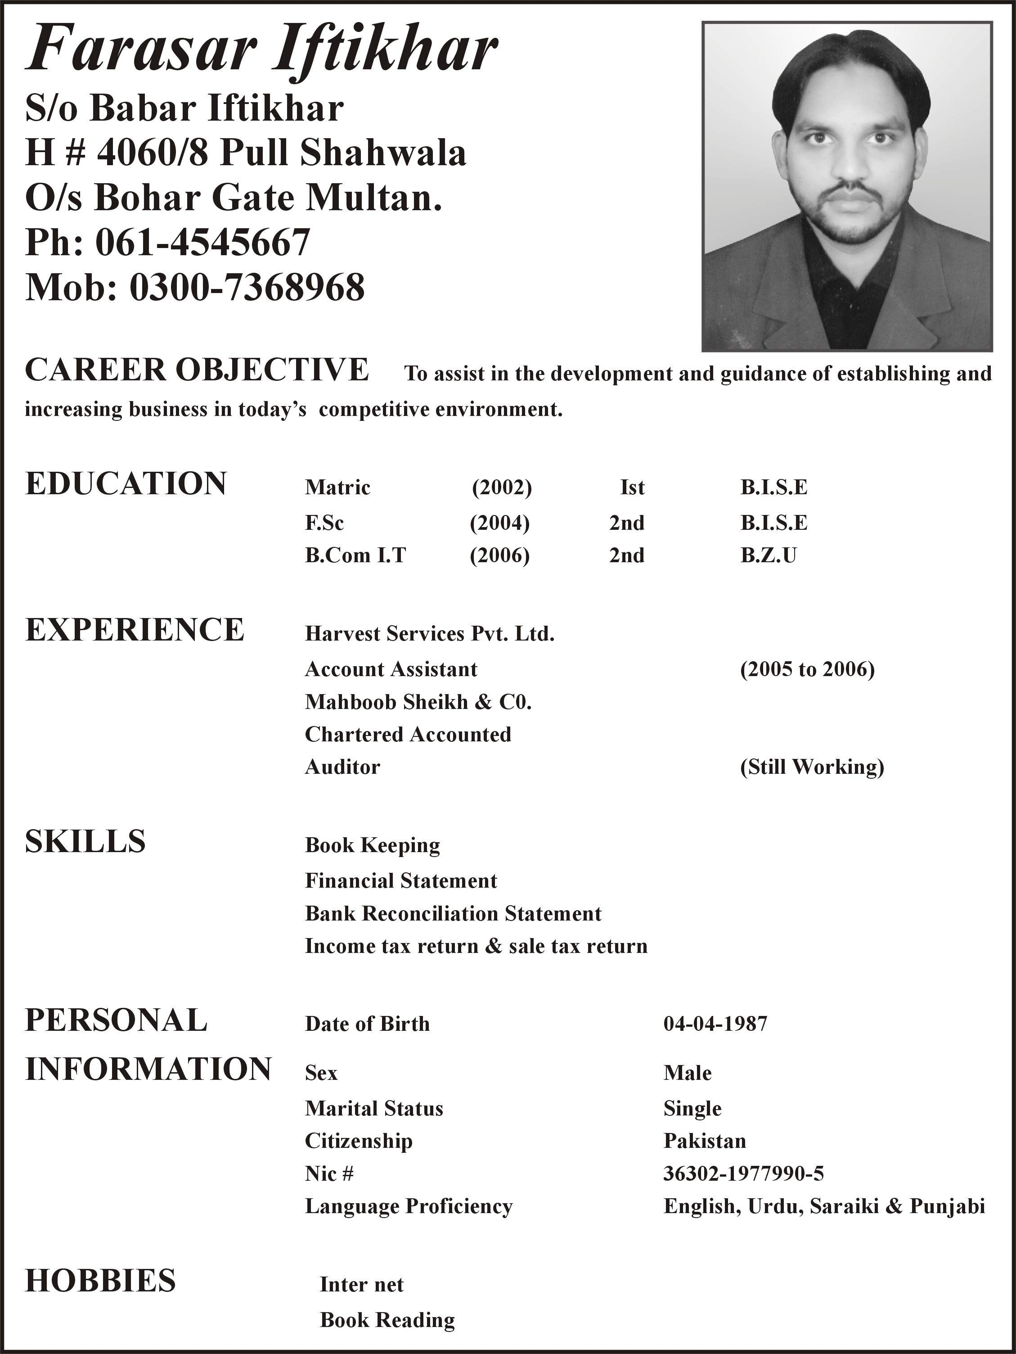
Gulfjobseeker CV No: 83358
To interview this candidate call 971505905010
Or email us back filled up Vacancy Form
http://www.gulfjobseeker.com/Free_Job_Posting_Form.doc
Career objective | Seeking a challenging opportunity to demonstrate my skills and abilities and aim for simultaneous achievement of corporate and personal goals in a rewarding organization offering career growth and professional development.
Professional qualifications | B.COM (IT) B.Z.U
 | M.B.A finance
EXPERIENCE: | LTD TANZANIA. Finance Manager sept-2012 to august t2014.  My responsibilities :-  - My job responsibility is to handle the entire Branch.  Maintaining proper accounting records, shipping records relevant  Shipping Airline, handling both Air & Sea exports & Import shipments.  - Developing the branch, making budgets, sales, Documentation, operation, Customer Support, Indoor sales. I am coordinating with the agents directly for their nomination shipments.  - Also maintaining DSR as per company policy. Implementing SOP's of company on a regular basis.  - Daily invoice preparation & deliver to client.  - Command on importation & Exportation like B/L Shipping line documents ,Invoice, packing list, A-Pad, prepad, Assessment, custom duties, port charges, delivery client premises, Transportation.  - Preparing monthly report outstanding, Payable report, Salaries wages report.  - Monthly submits Vat-return, Submit monthly employees Nssf, City service Levy submit every three month, submit monthly SDL to TRA.  - Cash flow statement weekly basis.  - Bank statement reconciliation monthly basis.  - Interacting with Banker to meet necessary financial requirements. Preparing Profit & Loss Account, Finalization of accounts for audit.  - Audit account submits & Director Return annually submits to TRA.  Yearly budgets planning, task discussion, Management meeting, presentation  monthly about company progress, any task about company progress  EXPATRIATES AGENCY (T) LTD (KENYA,TANZANIA) Assistants Account & financial manager Augt-2011 To Sept-2012.  My responsibilities :-  - My job responsibility is to handle the entire Branch.  Maintaining proper accounting records, shipping records relevant  Shipping Airline, handling both Air & Sea exports & Import shipments.  - Developing the branch, making budgets, sales, Documentation, operation, Customer Support, Indoor sales. Direct coordination with agents & shipping line  - Daily invoice preparation & deliver to client.  - Command on importation & Exportation like B/L Shipping line documents ,Invoice, packing list, A-Pad, prepad, Assessment, custom duties, port charges, delivery client premises, Transportation.  - Preparing monthly report outstanding, Payable report, Salaries wages report.  - Monthly submits Vat-return, Submit monthly employees Nssf, City service Levy submit every three month, submit monthly SDL to TRA.  - Cash flow statement weekly basis.  - Bank statement reconciliation monthly basis.  - Interacting with Banker to meet necessary financial requirements.  - Preparing Profit & Loss Account.  - Finalization of account submits to auditor.  - Participate management meeting sorting problem & new task.  - Audit account submits & Director Return annually submits to TRA.  - Yearly budgets plaining, task discussion, Managment meeting, presentation monthly about company progress, any task about company progress.  CONSOLIDATED TRANSPORT LTD. (GROUP) (TANZANIA DAR SE SALAAM).  GENERAL LOGISTICS & ACCOUNT MANAGER Augt -09 To Oct- 2011
- Submit of business status summary to C.E.O. on weekly and monthly basis.
- Full-charge Bookkeeping and Accounting
Excellent account management bookkeeping expertise; ability to accurately produce financial statements and proper documentation for annual audits. Expertise includes, but is not limited to:
• Billing and Collections • Inventory Management
• Budgets • Daily Bank Deposits
• Accounts Payable and Receivable • Fixed Assets Management
• Bank Statements • Payroll and Benefits
• General Ledger • Financial Analysis
- Supervisor for Accounts Receivable & Accounts Payable departments.
- Daily Cash receipts, credit card charges, and inventory.
- Submit report of Income statement and balance sheet.
- Monthly stock report, monthly NSSF report, monthly Vat-return, monthly SDL report, three month City service levy.
- Cash flow statement weekly basis.
- Bank statement reconciliation monthly basis.
- Interacting with Banker to meet necessary financial requirements.
- Preparing Profit & Loss Account.
- Finalization of account submits to auditor.
- Preparation transport contract, Checking transport document like registration cards, insurance, license, any relevant document that necessary for transport work.
- Monthly fuel report, Driver mileage, Driver salary, Trip allowance, Toll charges, Window screen document, relevant goods transit document.
- Tracking report daily about goods location.
- Participate in the management process.
PROFESSIONAL SKILLS: | - Business software  - Book keeping  - Financial Statement  - Bank Reconciliation Statement  - Income Tax Return & Sales Tax Return
ACCOUNTING SOFTWEAR: | - Peach Three Accounting Soft wear  - Tally Accounting Soft wear  - QuickBooks Accounting • Quicken
EXPERIENCE | Nature of Work
I worked as a Senior in the audit and assurance department of Mahboob Sheikh & Co. My responsibilities were:

- Managing, planning, supervision and review of financial statements audits.
- Review of compliance with International Accounting Standards by the companies being audited and providing them professional advice over their compliance status.
- Assessing compliance with regulations and controls by executing audit program steps, examining and analyzing records, reports, operating practices, and documentation.
- Assessing risks and internal controls by identifying areas of non-compliance, evaluating manual and automated financial processes, identifying process weaknesses and inefficiencies, and issuance of internal control memorandum and management letter.
- Meeting strict financial reporting deadlines requiring time management and on the spot decision making.
 | Some of the key experiences gained while working with Mehboob Sheikh & Company – include:
Textile Sector
- Khokhar Textile Mills Limited
- Zeyneb Textile Mills (Pvt.) Limited
- Hilal Fashion Garments (Pvt.) Ltd
- Maqbool Usman Fibres (Pvt.) Limited.
- Hilal Fabrics (Pvt.) Ltd.
- Hakkim Textile Mills Limited.
Other Manufacturing concerns
- Fatima Sugar Mills Limited.
- Multan Chemicals Limited.
- Solex Chemicals (Pvt.) Limited.
- Hamaz Pharmaceuticals (Pvt.) Ltd.
- Sun Lubricants (Pvt.) Limited
Service concern
- OMS (Pvt.) Ltd. Lahore. (Subsidiary of O&M Solutions Mauritius
- Fine Track Pakistan (Pvt.) Limited.
- Move (Pvt.) Limited.
- Ibrahim & Company (Pvt.) Limited. (KB & IB Transport Company)
Non Profit Organization
- Pakistan Cotton Ginners Association.
- NFC Institute of Engineering & Technology
Others
- Board of Management, Industrial Estate, Multan.

Computer skills | - Understanding of Computer Information System environment and its effects on business.  - Familiar with the following MS Offices applications:  - Microsoft Word  - Microsoft Excel  - Microsoft PowerPoint

Personal data:-
Date of birth | 04 April 1987
Nationality | Pakistani
Marital Status | Married
Languages | English (Fluent), Urdu (Fluent),Swahili
References | Available on request

