Reshmybiju.124337@2freemail.com

CURRICULUM VITAE

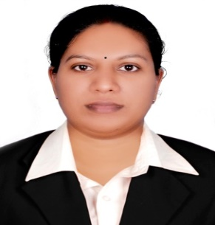
Objective
A suitable position with an organization where I can utilize the best of my skills and abilities that fit to my education, skills and experience a place where an encourage and permitted to be an active participant as well vital contribute on development of the company.
Professional Experience
- Travel Consultant (Osaka Air Travels Pvt. Ltd, Cochin)
1 year Experience in Ticketing by using Abacus and Amadeus.
- Customer Relations Officer , Ahalia Hospital, Abu Dhabi, UAE (2010)
- Junior Software Developer, SaNDSLab, Info Park, cochin, Kerala ( From February 2010 to October 2010)
- ECIT Computer Education Division Electronic Corporation of India LTD. (A GOVT of India Enterprise Under the department of Atomic Energy)
- 3Years Experience in National Computer Education as a Faculty, Cochin June 2007 to January 2010.
Project Details
- Developed Web application for “MY IT SCHOOL” in ASP & SQL Server.
- Developed Web application for “THOMSON FIBERS” in ASP & SQL Server.
- Developed Windows application on Billing System in VB.NET.
- Developing Job portal for Sands Lab in PHP.
- Study on Annamanada Co-Operative Bank (Bank Transactions) in 2005.

Technical Skills
Ms-Office, HTML, Java, VB.net, C, C++, SQL.
Educational Qualification

- IATA (Foundation in Travel and Tourism)

- Higher Diploma in Co-operation and Business management
(State Co-operative Union, Kerala)

- B.A.Economics (Calicut University)

- P.G.D.C.A (Electronics Corporation of India LTD)

