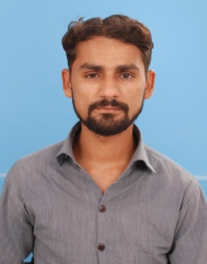
FAZEEL

Email: fazeel.124338@2freemail.com

OBJECTIVE:

To work in a Professional Environment to utilize effectively my knowledge and skills and secure a responsible and challenging position in a professional organization where I can contribute positively to achieve the objective of organization and enhance my professional growth

WORKING EXPERIENCE:

Crown Motor Company (Pvt.) Ltd. March. 2010 to till update
- Working as a Deputy Manager QC .
- Control all the problem which related to QC department during Assembly.
- Dealing all the vendors about QC problem and guide them to remove the faults.

Precision Forging (Pvt.) Ltd. April. 2008 to Feb. 2010
- Working as an Executive Development & Gauge Control.
- Preparation of drawings with the help of design concepts.
- Tool designing, Development of forging die drawings.
- Preparation of jigs, fixtures and gauges of forging parts
- Calibration of all measuring and checking instruments.
- Maintenance of all measuring instruments.

Suzuki Motorcycle Pakistan Ltd. Aug. 2007 to Sep. 2007
- 1 month Internship training

Others:
- Working on machines as mention below;
- All Conventional Machines.
- Operating of CMM machine.
- C.N.C Machine (Turning centre, machining centre) (Fanuc control).
- Wire cut, EDM, Jig boring.
- Working on MS Office ( MS World, Excel & Power point)

QUALIFICATION:
Professional:
- Specialized D.A.E ( Die & Mould Technology) in 1st Div. from Pak Swiss Training Centre.
- Auto-CAD & Master Cam designing & CNC Programming from Pak Swiss Training Centre.
- Pro-Engineering Wild Fire 02,03 designing & CNC Programming

Academic:
- Matriculation (Science)“A-Grade” from Board Of Intermediate & Secondary Education Bahawalpur Punjab Pakistan.

ACADEMIC PROJECTS:

- Technical Drawing (Designing of Three plate mould, Press Tool, Jigs & Fixtures ).
- Dies of Stepllar parts.

PERSONAL DATA:

Date of Birth : 05-01-1986
CNIC No. : 31302-2420244-7
Nationality : Pakistani

