Curriculum Vitae
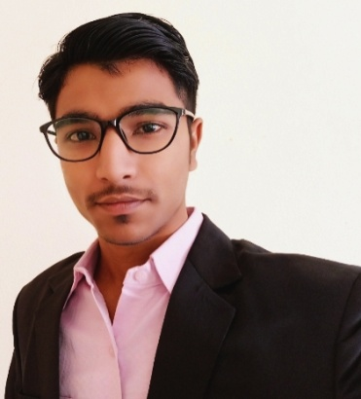
YOUSUF
E-Mail : yousuf.124910@2freemail.com
Date of birth : 02 Feb 1991
Nationality : Indian
Marital Status : Single

OBJECTIVE

To obtain a responsible position as Assistant Professor where my teaching and research experince will be helpful. I am an effective communicator with ability to present complex information to students and individuals. I possess more than 4 years of experience in Teaching and Industry in terms of Designing and various projects, I have excellent track record in the Academics.

Educational Qualifications

March 2017-July 2018Master of Science, HS Kaiserslautern University of Sciences,
Pirmasens,Germany.
Course of Study: Product Refinement
ContentsAdvanced Mechanics, Thermodynamics and Heat Transfer, Material
Science, Plastics technology, Injection Molding, Composite
materials, Refining of Polymer Compounds,Fracture Mechanics and
Tribology, Polymer sciences.
Laboratories Extrusion, Injection molding, Polymers, Composites.
Final Grade: 75-80% (As per German Grade)
Sept 2009 - May 2013 Bachelor of Engineering, Osmania University, India
Course of Study: Mechanical Engineering
ContentsMechanical Engineering, Production Engineering, Engineering
Drawing, Strength of materials, Machine Design, Kinematics&
Dynamics of Machines, Engineering Chemistry, Manufacturing
Technology, Machine Design,Thermal Engineering,Basic Electrical
Engineering,Computer Engineering
Laboratories Strength of Materials lab, work shops, Manufacturing Process,
Faundry, Metal cutting Machine Tool Lab, Hydraulic Machinary Lab,
Thermodynamics,Heat Transfer lab, Internal Combustion engines lab,
Refrigeration & Air conditioning Lab.
Final Grade: 85% (Silver Medal)
May 2007 - Aug 2009 Board of Intermediate, Pragathi Junior College, India
Course of Study: Chemistry, Maths& Physics
Final Grade: 96.6% (Gold Medal)
March 2006 - March 2007 Board of Secondary Education, Vani High School, India
Course of Study: Maths, General Sciences, English, Social.
Final Grade: 91.16%
Present Research work-Ongoing
Jan 2018 - June 2018 DYMO ENGINEERING B.V Berlicum, NETHERLANDS.
Master Thesis-Design of Clips, Production by Extrusion
Client- MG Vloerverwarming Netherlands
- Generated detailed drawings and presentation graphics for client review; recorded information from client meetings to drive the Clips design process and mitigate future client discrepancies with the end product.
- Testing and Design of various geometrical shaped clips.
- Collected and entered data on different types of underfloor heating pipe materials and Multilayer pipes with their mechanical and electrical properties for Research.
- Study of EVOH layer effect on recycling and designed different prototypes of clips.
- Gained vast knowledge of various materials and Extrusion manufacturing processes to enhance products with appropriate details expected by customers.
International Work Experince
Nov 2015 - Oct 2016 Noor Jazal Engineering & Contracting Company, SAUDI ARABIA.
Designation- Design Engineer & Procurement Engineer
- Unparalleled expertise in production, product development, sourcing, cost analysis and reduction, negotiations, quality testing, and technical processes.
- Expertise in HVAC design and Design Soft wares.
- Technical consulting of marketing functions and design agencies
- Support in the coordination of projects for successful completion.
- Following a project from material procurement to theirinstallations.
- Coordinated with different companies involved in a project towards completion and success of a project.
- Created, maintained and organized engineering procedure documents.
Teaching Experience

June 2013 - Oct 2015 Swami RamanandaTirtha Institute of Science & Technology,INDIA.
Designation - Assistant Professor in Mechanical Engineering
- Spearheaded efforts to manage and participate in the departmental curriculum review projects, and ensured that the class achieved a 100% passing score
- Taught core courses of Mechanical Engineering, Thermodynamics, Engineering Drawing, Dynamics& Kinematics of Machines, Strength of materials, Machine Design.
- Prepared and Maintained lab Machine lab exercises.
- Carried out an additional responsibility as the student organization's adviser for one academic year.
- Participated in Training and Placement activities, Attended several conferences and workshops
- Performed academic background reviews to develop tailored lessons based on student needs.

Study related Activities

Oct 2013 Presented a technical paper on “Thermodynamic Cycle of Vapour
Refrigeration System” at MJCET ADSOPHOS during annual student
Technical Festival of MJCET.
Sept 2012 Organized an event during IGENUS 2012 by EWB MJCET chapter.
Academic Project
Aug 2012 - May 2013 Testing and analysis of emission from two wheelers, India
Jan 2018- June 2018 Design of Underfloor heating pipe Clips, Netherlands.
Academic Achievements
Aug 2013 Got Silver Medal for 2nd rank in Mechanical Engineering Department.
Aug 2013 Got Merit Awards from Sultan Ul-Uloom Education Society.
Aug 2009 Got Gold Medal in Intermediate education for securing good academic
Percentage.
Additional qualifications

Computer skills MS-Office (Good knowledge)
C (Basic Knowledge)
CAD AutoCAD (Good Knowledge)
SolidWorks (Good Knowledge)
CREO (Good Knowledge)
ANSYS (Good Knowledge)
Languages
Deutsch Intermediate (B1 level studying at HS-KL)
English Fluent
Urdu Fluent
Hindi Mother Tongue
Telugu Fluent
Interests
Hobbies Travel, Cooking, and Cricket

Reference letters will be furnished upon request.

April 2018, Netherlands
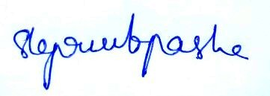
Yousuf

