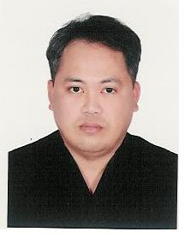
To: The Manager
Subject: Application for Post

I am pleased to submit my resume as reference of my brief background and work experiences.

Hoping for your kind consideration to my application and looking forward of personal interview in your convenient time

Thank you very much.

Danilo.128233@2freemail.com

Objective:
Seeking for a suitable position in your prestigious organization requiring a good human relations and interpersonal skills to enhance my abilities while gaining experiences.
Position Desire : BUS Driver for 34 setter/Light Bus and Car
Type Of Visa : Driver’s Visa/Residence

Personal Data
Name : Danilo
Date of Birth : January 01, 1971
Civil Status : Married
Height : 5’5
Citizenship : Filipino
Issued : January 24, 2011
Expired : January 23, 2016
Place of issue : Dubai UAE

Educational Background
Primary School : Sofronio A. Cordovero
Year : 1977 to 1984

Secondary School : Roxas City School for Philippines Craftsmen
Year : 1984 to 1988
College : Lyceum of the Philippines
Year : 1993
Course : Mass Communication

Employment Background
ASHLAR INDUSTRIAL CORPORATION
1991 to 1993 : Production Supervisor
SAUDI ROCK DEV’T CO. LTD
1994 to 1998 : Crane and Forklift Operator (Jeddah Saudi Arabia)
CARRARA MIDDLE EAST CO. LLC ( DUBAI)
2000 to 2007 : Fabricator

KUWAIT RECONSTRUCTION HOUSE (KRH) Dubai Branch
2007 to 2011 : Company Driver

Tips
With Valid UAE driving license
LIC No. : 1033819
Issued : 2006
Expiry : 2016
Skills : Driver with 15 years experience

Personal Qualities
- Responsible
- Dependable and Hardworking
- Honest and Trustworthy
- Creative and open to new ideas and suggestion
- Friendly
- Excellent in Location

I hereby confirm that the above information is correct according to the best of my knowledge belief.

