Anis.129918@2freemail.com

Dear Concerned,

My name is Anis . I have done MBA with the specialization in Human Resource along with the experience of five years in Human Resource (Administration, Recruitment and Training & Development).
I am a motivated individual and fully willing to work for the aforesaid position in your prestigious company. If provided a chance, I assure my honest and dedicated efforts and will prove to be an asset for the company.
Enclosed herewith is the attached resume for the necessary considerations please.

Best Regards,
Anis

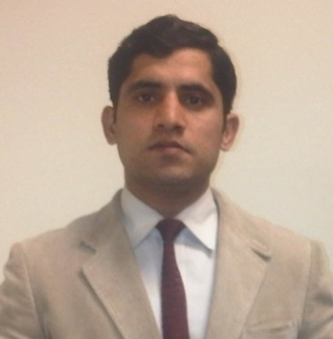
Anis
OBJECTIVE
I am young qualified male with four years of diversified experience in business support administration and HR practices. I am seeking long term position in human resource management to groom my career.
PROFESSIONAL HISTORY
Assistant Sales& Admin Manager at Ahsan Chicks & Feeds, Gujranwala (Present...)
(Report to Sales Director)
- Broiler and day old chicks sale
- Daily sales and hatch reports preparation
- Daily recovery reports
- Banks payments coordination
- All kind of invoices process and vendors coordination
- Office administration.
Deputy HR Manager (Recruiter) in Boss Moulded Furniture (01-July 13 to 15-Sep-2014)
(Report to Managing Director)

- Responsible for recruitment
- Training & Orientation for new Joiners
- Update forms & format files and prepare the probationary period increment list
- Follow up the policies
- Monthly appraisal.
HR & Admin officer in Tameer Microfinance Bank, Ltd. (08-Dec-11 to 25-June-13)
(Report to Business support & Admin Head)
- Responsible for administratively lookafter of 18 branches of Tameer bank.
- Deals with invoices of utility bills, travel & hotel invoices and maintain the MIS
- Responsible to acquire new locations and deals with indoor and outdoor vendors
- Follow up for vehicles, generators and other bank assets
- Recruitment planning and organizing training sessions
- I was first custodian for area collaterals (gold).
PROFESSIONAL TRAININGS (Apprenticeship Trainings)
- Training Coordinator in Pearl Continental Hotel Lahore (Five Star Hotel) (8 months training)
(Report to Training Manager)
Findings/Learning:
- Practice to develop training programs (On the job and Off the job)
- Organizing orientation trainingfor new joiners
- Preparation daily news flash and monthly calendar for trainings
- Cultural understanding within organization
- Releasing stress by achieving tasks within bracket of time.

- National Bank of Pakistan, Gujranwala, (2 months training)
(Report to Branch Manager)
Findings/Learning:
- Understanding of branch operations (Job rotation)
- Preparation the Western Union vouchers for customer’s payments
- Balance inquiry before cheque transfer
- Prepare customer’s file for loan apply and new account opening.
EDUCATION
Gujranwala Information of Future Technology University

MBA (HRM)
Passing Year 2010
Recognized by: Higher Education Commission (HEC), Pakistan.
Attested from: UAE Embassy
PERSONAL INFORMATION
Date of birth: 23-Dec-1984
Marital Status: Single
Languages Known: English and Urdu

