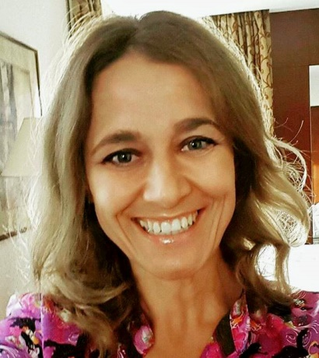
ZORANA.130252@2freemail.com

Current Employment

Abu Dhabi Grammar School (Canadian) From Jan 2016 – Jan 2017
PE teacher
Main responsibilities
- Plan, organize and deliver lessons consistent with the physical education curriculum
- Motivate, supervise and discipline students appropriately to make sure all students are participating in PE activities
- Measure student progress
Major achievements
- Responsible for writing and screening individualized physical educational plans for overweight children
- Coaching girls soccer team

Recent Employment History

Elite Private School, Abu Dhabi From Aug 2015 to Nov 2015
PE teacher

Future Centre for Special Needs, Abu Dhabi, UAE From Sep 2013 to July 2015
PE teacher

Main responsibilities
- Adapting PE games and activities to children with disabilities
- Create games and activities based on the specific needs of each individual child
- Recording and monitoring students' progress

Major achievements
- Planning school activities such as field day, fun runs, a walking program, and morning exercise breaks
- Organize dance classes and participate in major school events (National day, Autism awareness day, New Year day…)

Aloft Hotel (Starwood group), Abu Dhabi, UAE From Apr 2013 to Sep 2013
Recreation Manager

Main responsibilities

- Assumes full responsibility for planning, organizing, and supervising the development, implementation, and administration of recreation programs for fitness center and related facilities
- Plans, organizes, promotes, and monitors recreational programs, special events…
Major achievements
- Develop new recreation and sport programs for hotel guests and members
- Increased membership renewal rates by counseling members regarding fitness center’s resources, recommending additional classes, new equipment, or additional exercises

Past Employment History

Primary school “P.P.Njegos”, SerbiaFrom Sept 2012 to Apr 2013
PE teacher

"Imperial Hotels"- Rab, CroatiaFrom Jun 2012 to Sept 2012
Tourist animator – supervisor for sport activities

Sport Association Zrenjanin, SerbiaFrom Sep 2011 to Jun 2012
Organizer of schools sports activities

English language summer camp “California”, CroatiaFrom Jun 2011 to Sept 2011
Camp Counselor and sport activities specialist

Primary school “Sveti Sava”, SerbiaFrom Nov 2010 to Jun 2011
PE teacher

Fitness club “Natural”, SerbiaFrom Oct 2009 to Nov 2010
Fitness, aerobic and aquarobic instructor, personal trainer

Summer camp “MaaKeeYa, NY, USA From Jun 2009 to Sep 2009
Camp counselor, swimming instructor, lifeguard

Primary School “Servo Mihalj”SerbiaFrom Feb 2002 to Nov 2009
PE teacher

Education

University of Novi Sad, Serbia From Oct 1996 to Oct 2001
Faculty of Physical education
Master in physical education – Physical education teacher and recreation specialist

Skills and Interests

Courses attended and skills developed
- Red Cross certificate – CPR/AED Professional Rescue and Lifeguarding/Waterfront/First Aid
- Sport association of Serbia-Certification for swimming instructor

Extra-curricular offering
- Successfully participating in Young Researchers of Serbia and Voluntary Service of Serbia
- Played basketball at the national level in club “ PROLETER” Zrenjanin 1991- 2003, in all teams. Captain of “first”team from 2001 to 2003

Personal Interests
- Sports (swimming, fitness, yoga)
- Travel: Travelled extensively and have visited places which include America, France, Germany, Spain, Italy, Hungary, Austria, Greece, Jordan, Egypt, Tunisia, Thailand, Mauritius, India…

Other achievements
- Improvement English language in Buffalo, Chicago, San Francisco and NY- SAD through Au pair and summer camp programs
- Training course for animators in tourism – Remark, Serbia
- School of Tourism “Duke & Peterson”, Serbia

Additional required info:
Date of birth: 23/06/1977
Marital status: Single
Nationality: Serbian

