Tarek
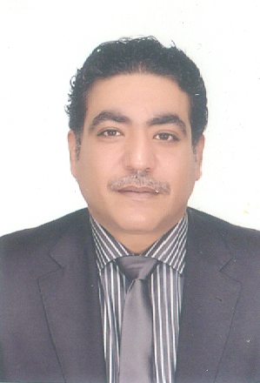
tarek.131806@2freemail.com

Professional Experience:
Sales Manager: A I T .Technology May 2014 till Now) at DUBAI
-Supervising daily performance of sales team by following up sales achievements
- Manage sales teams to achieve pre-determined operational target by providing and analyzing business plans to meet operation target
- Monitor and evaluate the sales team performance to ensure that the specific portfolios of business performance
- Responsible for ensuring sales processes are efficient and customer complaints are managed by promoting standard sales procedures to the sales team members
- Solving sales problem
General sales manager: Zotye Egypt (April 2013 till April 2014)
- Establish zotye web site
- Setting Sales and marketing plan
- Established professional organization structure, policies, functional roles, Job description and responsibilities
- Lunched several new models (V10, Z10, Z300, and T200.) At Auto Mac formula March- (2014)

Retail sales manager:
GHABUR DISTRIBUTER – HYUNDAI, MAZDA & GELLY: (August 2009 till March2013)
- Reestablished Sales Department
- Set targets and goals for the company, and planning strategies to achieve them
- Doubled the sales volume and showrooms set by the company
- Finishing deals with Banks and Customers
- Handled 2 branches with 13 employees
- Established a new bank sales Department
- Achieve best distributer at sales (2009-2010-2011)
- Launched several new models (Mazda 3- Gelly Emegrand-New Elantra-Ix35-I20-I30…..)

Brand Sales Manager:
Burgan international - ELSSAYR GROUB DISTRIBUTER NISSAN- HYUNDAI- FIAT:
July 2008 till July 2009
- Establish sales department
- Building sales team
- Design salary & incentive scale
- Setting sales branch target
- Setting 2009 & 2010 sales department budget
- Setting 2009 & 2010 Marketing plan with Marketing department
Banks Sales Manager
AUTO EGYPT FOR TRADING - MOHAMED ELKASRAWY. NISSAN (May 2007 to July 2008)
- Established Sales Department
- Building Sales team
- Design salary & incentive scale
- Setting sales branches target
- Setting 2009 & 2010 Sales Department budget
- Setting 2009 & 2010 Marketing plan with Marketing Department
- Increased sales by establishing partnership agreement with 10 distributers and maintained strong relationships with dealers

Banks sales manager& (Assistant General Sale's manager)
ARABIAN GROUP FOR TRADING - MOHAMED ELKASRAWY. TOYOTA
Jan. 2002 to April 2007
- Building sales team
- Design salary & incentive scale
- Setting sales branch budget
- Setting sales branch target
- Preparing reports to the chairman

Traffic Manager
SETI FIRST ATOM TRAVEL (Oct. 2000 to Sep. 2001)
- Established professional organization structure, policies, functional roles, Job description, authorities and responsibilities
- Managed fleet over 150 vehicles
- Set targets and goals for the company, planning the strategies to achieve them
- Continuous supervision for service and maintenance to meet requirements which Having a high standard of customer satisfaction

Sales Supervisor
KIA MOTORS EGYPT (Sep.1996 to November. 2000)
- Rotated in all Departments for experience
- Launched several new models ( Pride, Sephia, Sportage, Besta, Bongo) to the market
- Created new department ( traffic department)
- Sought clients and followed up

Education:
Bachelor of commerce - Business Administration-Marketing Branch, Cairo University- Egypt.
Training coursesـ
- Sales skills training AT Management and Development Center
- Marketing strategies Management and Development Center
- New model for sale kia motors Egypt
- Basic Technical knowledge Toyota Egypt
- New model for sales Toyota Egypt
- HI Ace for Sales Toyota Egypt
Personal Information:
Nationality : Egyptian.
Date of Birth : August, 23, 1971
Marital Status : Married
Languages : Arabic: (Mother tongue), English: (FLUENT)

