  - HARISH
B.Tech CIVIL, (PMP)
Sultanate of Oman
E-Mail: harish.133504@2freemail.com

Assignments in Civil Engineering, Project & Construction Management
Professional Synopsis
- A dynamic professional with 4+ Years of rich experience in Site execution, Inspection & Quality management.
- Demonstrative excellence in executing large scale residential & infrastructure project such as villas, road, service compound, apartments, headquarters and Building projects in India and Sultanate of Oman.
- Expertise in implementing ISO 9001 Standard in construction of high value projects with a flair for adopting modern methodologies in compliance with the Quality standards.
- Resourceful in supervising all construction activities including provisioning of technical inputs for methodologies of construction & coordinating with the site management activities while ensuring compliance for various construction activities as per the norms and regulations.
- Strong relationship management, communication skills with the ability to network with project members, architects external agencies / consultants / clients / sub-contractors and other utility agencies with consummate ease.
- Excellent analytical, troubleshooting & inter-personal skills with skills in driving numerous Quality and quality enhancement, process improvement & cost savings initiatives during career span.

Key Skills
Project Management
Quality Control & Assurance Site & Construction Management
Methods & Compliances
Site Inspection & Documentation

Languages Known: English, Hindi, Kannada & Telugu.

Organizational Experience
Al Turki Enterprises LLC.
Project Engineer November 2016 to Present
Projects Undertaken
The new headquarters complex will house two office towers sporting distinct geometrical forms above a podium with three levels of basement car parking. It will boast 40,000 sq m of built-up area. The main office tower, The Sun, will rise from basement level B3 to level six and will comprise six-storey (ground-plus-five) office floors with a mechanical plant room and a roof garden on level six. The second office tower, the Crescent, will comprise seven floors of office space. The proposed project will also incorporate several environmental features throughout its lifecycle to meet the globally recognized voluntary LEED (Leadership in Energy and Environmental Design) criteria set by the US Green Building Council The project is expected to delivered by the year 2019 January.

- Project Name : Omanel HQ Project
- Project cost : OMR 36 Million.
- Client : Omantel & Omran
- Consultant : SSH International

Key Deliverables
- The outer side boundary is surrounded by retaining wall of max height of 9m using Peri shuttering materials which is cast at one pour, & later on which is connecting to raft.
- The major difficulties which is of backfilling the retaining wall to cast the raft above it.
- Managing the construction activities time to time arranging the materials to site at in time to carry out the work smoothly.
- Co-ordinate execution of work and ensure that it is carried out as per approved working drawings & contract specifications.
- Assist in preparation of shop drawings & BBS for submission to the Consultant for obtaining approval prior to execution of works.
- Verifying project files available to site personnel include copies of method Statements, approved drawings and permits prior to start of field operations.

Alturki enterprises LLC
Site Engineer (Civil) June 2014 to November2016

Projects Undertaken
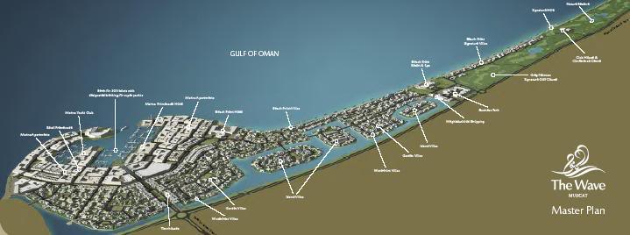
Al Mouj formerly known as Wave Muscat Rehana residence sector-6 Phase 1 (104 villas) Phase-2 (99 villas)
Al Mouj Muscat is the sultanate leisure and life style destination and it’s a unique public private venture between the Government of the Sultanate of Oman and the UAE-based Majid Al Futtaim Properties Each villa combines the promise of resort-style living with the sophistication of modern architecture G+1. Gardens, courtyards and swimming pools are only a few of the amenities residents can enjoy. Designed to make most of the beach and sea views.
- Project Name : Rehana Residence Phase 1 & 2
- Project cost : OMR 32 million.
- Client : Al Mouj Muscat.
- Consultant : Atkins & Parsons.

Key Deliverables
- Review the submission and comments for Contractor submissions.
- Reviewing of contract documents for each Construction stage/phase in respect of QA/QC requirements and procedures and advice the Project Manager of any deficiency.
- Directing and supervising the manpower for execution of the works, Project Quality Plan and HSE Plan.
- Review IFC drawings and raise technical queries arising from incomplete / missing details and coordination with services.
- Provide data of Site Progress for Daily and Monthly Progress Reports to be submitted to the Consultant.
- Monitor progress and quality of work as per the construction program.
- Identifying various materials required for construction from the IFC drawing & preparing the material approval submittal for seeking approval from consultant in order to proceed with the material for procurement.
- Arrange for incorporation of as-constructed information / details and check As-built drawings prior to submission to the Consultant. Conduct/Attend progress preview meetings and prepare necessary progress report

Fortuna Projects Pvt. Ltd
Civil Engineer (Execution & Quality) June 2013 to May 2014

Projects Undertaken
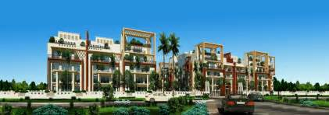
The project offers 2, 3 BHK Apartment from 1100 sqft to 1650 sqft in Bangalore North. Among the many luxurious amenities that the project hosts are Pool Table, Car Parking, Multipurpose Room, Lift Available, Recreation Facilities etc. Fortuna Center Park is Completed project and possession in Mar 2015.
Project Name : Fortuna center park
Project cost : INR 60 Cr
Client : Fortuna projects

Key Deliverables
- Conduct daily tool box talks to all personnel involved at work.
- Liaising with clients and representatives which will include surveyors, Architects and Designers
- Responsible for the overall quality activities and administration of all quality related policies on site.
- Reviewing the implementation of Quality procedures on site and report to the Project QA/QC Manager.
- Resolving any technical queries and other problems that may crop up.
- Overseeing and managing the site labor force and sub-contractors.
- Liaising with sub-contractors.
- Identifying the training needs and provide trainings to the people on time in all the construction activities.
- Conducting Quality& safety induction to the new entrants as required.
- Conducting daily site inspections, find out the defect works and improvement conditions, propose corrective actions and follow up with the construction team for the effective implementation.
- Reporting infractions and give suggestions to the Project manager for improvement.

Extracurricular Activities
- Environmental society of Oman - Currently active member participating in hands on project and awareness raising campaign on environmental
- Other activity CESA member during college days conducted various programme like Technical talks & modeling

Academics.
- B.E in Civil Engineering from VTU, Belgaum, 2013 with FCD.

Membership
- Member of Institute of Engineers – India

Personal Details
- Date of Birth : 24th March 1991
- Nationality : Indian.
- Marital Status : Single
- Driving License : Oman & India
- Languages Known : English, Kannada, Hindi & Telugu.
- Present Address : Muscat, Sultanate of Oman.
- Passport Details : valid upto 4th April 2023

