Anila
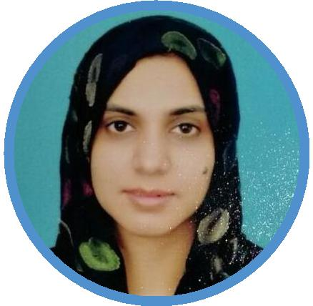
English Subject Specialist

English Subject Specialist having more than 9 years teaching experience. Proven track of excellent results, raised multiple students' societies and contributing a lot in improving the academic standards of the institute.

Anila.134460@2freemail.com

Work Experience

08/2007 - Present Chakwal, Pakistan

English Teacher

Fauji Foundation Model School

Tasks/Achievements

Teaching English Language & Literature of various classes with innovative techniques and methodologies

Contributing in framing and implementing the SIP(School Improvement Plan) eﬀectively

Preparing School briefing on ppt.

Worked as a Senior Section Head for two years and received certificate of merit as the Best Section Head

Incharge of Literary Club, Media Club & Dramatic Club and an active participant in conducting co-curricular & extra-curricular activities.

Education

08/2013 - 08/2015

M.A. TEFL

Allama Iqbal Open University Islamabad(Pakistan)

Courses

Research Methodology English For Specific

Purpose(ESP)

Educational Psychology & Semantics & Discourse

The Management of Learning Analysis

04/2013 - 04/2014

Masters in Education Sargodha University(Pakistan)

Courses

English Language Teaching Educational Psychology

Educational Administration Curriculum Development

08/2004 - 02/2006

Masters in English Language & Literature

International Islamic University Islamabad(Pakistan)

Courses

EFL in the Classroom English For Specific

Purpose(ESP)

Classical & Modern Drama Classical & Modern Poetry

04/2011 - 04/2012

Bachelor in Education Sargodha University(Pakistan)

Courses

Methods of Teaching Teaching of English

Assessment in Education Classroom Management

Skills & Competences

Language Teaching

Lesson Planning

Public Speaking

ESL

Classroom Management

Microsoft Oﬃce

Teachers' Training

Leadership

Certificates & Awards

Certificate of Merit in SSC Result(2012)

Certificate of merit for achieving 6/6 GPA in SSC Result(2012-13)

Certificate of Merit in SSC Result(2014)

Certificate of merit for achieving 5.29/6 GPA in SSC Result(2014-15)

Certificate of Merit in SSC Result(2016)

Certificate of merit for achieving 5.81/6 GPA in SSC Result(2015-16)

Honorary Award for Best Section Head(2014-15)

Certificate of Best Section Head in Session 2014-15

Honorary Award of Best Teacher(2015-16)

Award of the Teacher of the Year in 2015-16

Personal Projects

Media Awareness Campaign (2015)

Successfully ran a campaign to create awareness about media among students, teacher sand parents

Result Improvement Plan

Created and executed a Result Improvement Plan with tangible improvement in school reult

Training

Reflective Pedagogy 2008

Fauji foundation Education System Teachers Training Program

Eﬀective Communication Skills 2015

Fauji foundation Education System Teachers Training Program

Active Learning practices(ALP) 2016 as Course Coordinator

Fauji Foundation Education System Teachers Training Program

Languages

English Urdu

Expert Native or Bilingual

