Mustafa

IT Engineer

Education

University of technology Baghdad Control and systems Engineering Computer branch

MK for IT solutions
CCNA R&S course

Fikra Space for programming
HTML & CSS & JS & firebase course

Skills

CCNA R&S
MySQL
JavaScript

CSS
HTML

MS office

Address Contact

Iraq Mustafa.135232@2freemail.com

Experience

4 years at Samar al khair company Computer service
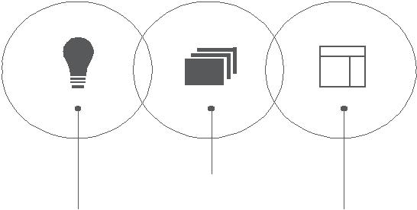

Networking

programmin Minimal Web Design

HOBBIES & INTERESTS

^{Music} Books

Language | Profile
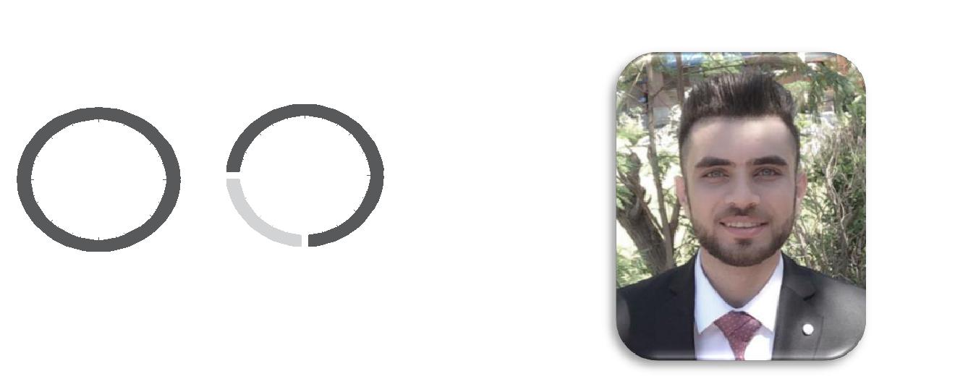

_{Arabic} English

Mother language | Advanced level

Mustafa Adnan

