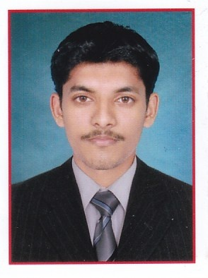
Curriculum Vitae
(BE in Civil Eng. Site Engineer)

AVIN
Avin.135263@2freemail.com

OBJECTIVES:

To Achieve high career growth through a continuous process of learning for achieving goal & keeping myself dynamic in the changing scenario to become a successful professional and leading to best opportunity. And willing to work as A G M/DGM (Civil) and in the reputed construction industry.

PROFESSIONAL EXPERIENCE:

Company- GR PROJCT AND MANGEMENT, BANGALORE, INDIA
- Designation : Site Engineer.
- Duration : Since July 2015 to August 2016 (1.4 years)
- Location : Bangalore, Karnataka, India.
- Job role : Inspecting the site on daily basis to ensure conformity of
the established quality/ safety standards.
Site Execution & supervision.
Coordinating and updating the project head about project.
Monitoring of the schedule through daily, weekly and
monthly basis.
Taking measurements and Billing.
Site supervision in the commercial cum residential building project,
Preparation of Material Approvals and Execution of
works according to project specification.
Responsible for management of material and human
resources on sites.
Budgeting for the all items required for construction for
next few week.
Finding problems & giving solutions for execution of work
at site.

ACADEMIC DETAILS:
Qualification | University | Institution | Year of Passing | Marks  Obtained (%)
BE In Civil Engineering | VTU | Vivekananda College Of  Engineering & Technology  Puttur.  Mangalore,  Karnataka, India. | July  2015 | 68.86%
PUC | Department Of  Pre University  Education  Karnataka | St. Philomena PU College  Darbe, Puttur  Mangalore,  Karnataka, India. | July  2011 | 57.84%
SSLC | Karnataka  Secondary  Education  Examination  Board | St. Philomena PU College  Darbe, Puttur  Mangalore,  Karnataka, India. | March 2009 | 63.68%

COMPUTER PROFICIENCY:

- Proficiency in MS Office (MS Word/Excel/PowerPoint etc)
- Effective surfing of internet for research purposes and data collection,
e-mail, Microsoft word, excel etc.
- Auto CAD 2004, 2006, 2013 and Staad Pro (Basic)
- Revit Architecture 2011.
- Microsoft Project 2011
- Windows 7, 8 operating system

QUALITIES:

- Excellent office management skills with technical knowledge.
- Motivation.
- Leadership Quality.
- Good Communication Skills.
- Confident decision making ability and Creativity.
- Critical Thinking.
- Project Management.
- Good team work skills.

ACADEMIC PROJECT:

“Analytical Investigation on Active Control System is completed on 9-02-2015”

ACTIVITIES:

- Attended extensive survey camp held on Jan 2014 at Perlampadi.
- Participated in the 10 days Internship Training Programme Conducted by the Department of Civil Engineering during the period 16-07-2014 to 25-07-2014.
- Represented college cricket team in zonal vtu matches held at NITTE
- Participated in Krishi Mela held on VCET, puttur 2014
- Participated in Jnana Sangama National Level Paper Presentation held in VCET, Puttur 2015

PERSONAL INFORMATION:

- Date Of Birth : 03 October 1993
- Hobbies : Cooking, Tracking, playing Cricket, Badminton, Chess
Social Work
- Gender : Male
- Marital Status : Unmarried
- Nationality : Indian
- Known languages : Kannada, English and Hindi (Read And Write)

I hereby declare that the above mentioned information and facts stated are accurate and correct to the best of my knowledge.

Note: I am currently residing in Dubai on “Visit Visa” and available for immediate interview and to take up the new Job role.

Looking forward to taking our interaction to a successful association.

