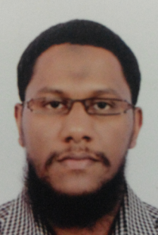
Alaa
- M: C/o 971505891826 - E: alaa.136185@2freemail.com

- Date of Birth : 15 Oct 1987 Dubai - Nationality : Sudanese

- Marital Status : Married - Religion: Muslim

Personal Summary
IT /Telecom engineer Graduated with GPA: 3.69 with almost Four years of experience in Service Desk Support Engineer & Call Centre , supported with Extensive Courses and Training which qualify me for the Position of IT Support Engineer.

Work Experience
Service Desk Support Engineer
JAN 2017 - MAY 2017 TECH MAHINDRA LIMITED
- Log all user interactions and record all relevant details in HPSM ITSM tool.
- Categorize and prioritize the incident/Service Request.
- Provide Level 1 support and diagnosis.
- Resolve those incidents that are under the scope of SD
- Escalate incident to Level 2, if they cannot be resolved.
- Monitor user interactions from inception to closure as per SLA.
Call Centre Agent
MAY 2013 - AUG 2016 EMIRATES POST GROUP HOLDING
- Attending phone calls of the customers.
- Anticipating problems and needs of the customers.
- Handle calls in a pressure environment.
- Handling issues and complaints with providing solutions to the customers.
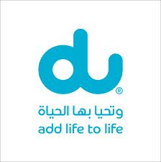
Sales officer
SEP 2011 - JAN 2012 DU AUTHORIZED PARTNER (HKMC)
- Handle end-to-end sales cycle including cold calling, setting up appointments, lead generation, regular follow-ups, co-ordination with the Domestic Clients.
- Generating appointments from prospective clients across the industry presenting DU promotion and services.
- Ensure clear communication and adherence of pricing and promotions.

Education
Bachelor Degree in Telecommunication Engineer
NOV 2005 - MAR 2011 AL GAZIRA UNIVERSITY

Training & Courses
Cisco Certified Network Professional (CCNP)
NETMATRIX Solution. India

Cisco Certified Network Associate (CCNA)
ZOOM Technology. India

Microsoft Certified IT Professional (MCITP)
ZOOM Technology. India

Exchange Server.
ZOOM Technology. India

Diploma in Basic Network (N+)
F-12 Networks Solution and Training. India

Diploma in Computer Hardware (A+)
BEDER INSTITUTE Of Information Technology (BIIT). India

Linux Administration.
ZOOM Technology. india

Diploma in Wireless Networks (Wi-Fi).
F-12 Networks Solution and Training. India

International Computer Driving License ( ICDL) .
Sharjah institute, UAE

Master Diploma in Project Planning & Management (PPM)
CADD Center. India

HUAWEI 2G BSS / 3G RAN.
HUAWEI TECHNOLOGY co .Ltd India

UMTS RAN / CN.
ZTE Corporation India

GSM RF Engineer Training.
Bharat Sanchar Nigam Ltd. (BSNL) India

Diploma in Advanced Wireless Telecommunications
APEX Telecom. India

Certifications
CCNA (ICND1 ) 100-101
ITIL Foundation v4 (on tracking)

Skills
- Arabic & English

- Presentation & Communication Skills

- Work Under Pressure

- Troubleshooting Skills

- Driving License

