Gulfjobseeker.com CV No:831090
Mobile +971505905010 / +971504753686

To get contact details of this candidates
Submit request through Feedback Link

http://www.gulfjobseeker.com/feedback/submit_fb.php

OBJECTIVE

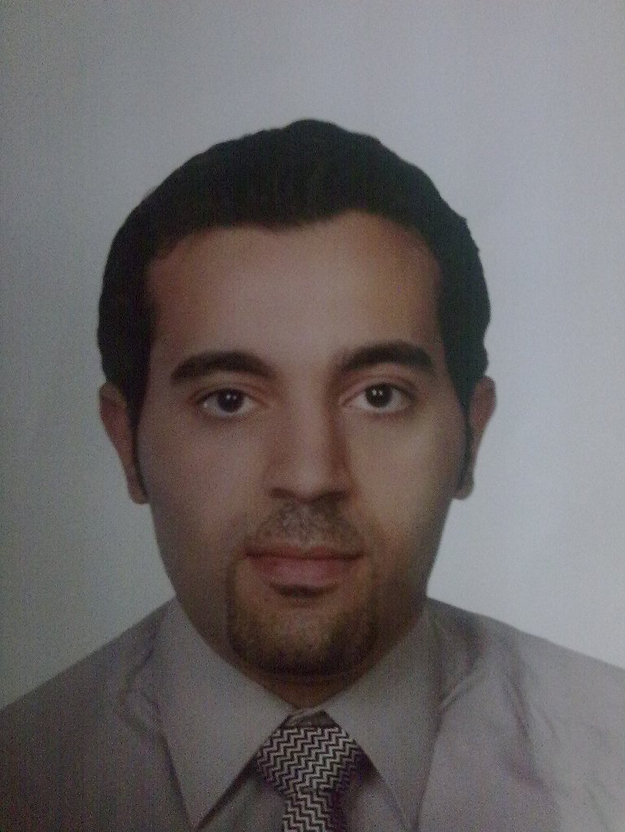

- Personal Info. –

Date of birth: 31:1. 1984
Nationality: Syrian
Marital Status: single

-

Preeminent, energetic, innovator, graduated as veterinarian, seeking an opportunity, in order to pursue a professional career as a veterinarian in a prestigious place that will challenge and augment the skills and knowledge I have obtained while providing valuable service to the company.

KEY STRENGTHS

- High ability and adaptation skills to working within teams.
- Experience of working in a high pressure environment.
- Animal Welfare and Humane Slaughter.
- Safety and Health in the Workplace.
- Proficient with treatment of most of the animals and taking care of them.

EDUCATION

University Of Albaath

2008 Bachelor (BA) in Veterinary medicine, Grade: good
2011 Master (MA) in Veterinary medicine, Grade: very good

AWARDS

2006 Award: AL-BASEL governmental award for high achievers

WORK EXPERIENCE

Apr 09– Present Aleppo Slaughterhouse

Position: Veterinarian
Duties Include:

- Supervises slaughter, meat fabrication activities.
- Meat inspection.
- Supervises other activities related to slaughterhouse training and extension Services.
- Inspect and monitors actual operations in the production areas of meat and meat products and by-products.
- Supervises and prepares annual work plan of activities for the quality control unit.
- Prepares weekly report.
- Conducts unit researches Reviews and evaluates work performance of staff in the slaughterhouse.
- Prepares and submits reports on the activities and accomplishment of the slaughterhouse.
- Performs other duties as maybe assigned by the chief.

Aug 07 – Apr 09 Zanobiya Al-Sham

Position: Veterinary Pharmaceutical Sales Representative

Duties Include:

- Make sales calls to present current and new pharmaceutical products to marketing and selling veterinary medicines to Veterinarians, animal clinics and hospitals and animal facilities.
- Make regular visits to Veterinarians, animal clinics and retail outlets to keep in touch with clients and monitor stoking levels.
- Ensure high knowledge levels about their assigned pharmaceutical products to enable them to explain their benefits compared with competitor brands.
- Maintain healthy business relationships with the customers in assigned sales areas.
- Provide sales report to management

TRAINING AND COURSES

Oct 09 – present
Master Research : Study on Lead concentration in Pastoral plants and Cow Milk in the Surrounding Areas of Hama Iron Factory

June 09 – Jun09
Training course in AL Basel club of equestrian in the field of horse
medical care, feeding and breeding.

Nov 07– Apr 08
I worked with vet Ahmad Awas as veterinarian assistant, I got a good
knowledge in veterinary domain, I visited many ranches and stations of
cows, learned diagnosing and treatment complicated cases which were
difficult and different.

Jun 06 –Jul 07
Practical training in pet clinic in Al-Baath University.

Apr 05 – Sep 05
Training in yoghurt factory I was working in dissection of milk sample and
choosing expedient ones to make cheese and other preserves.

Jan 04 – Mar 05
Training period for 14 months in poultry breeding farm and hatchery
management at Hama coached during the study.

COMPUTER SKILLS

International Computer Driving License (ICDL)

LANGUAGE:

Arabic: Mother Tongue, Excellent Speaking, Reading, Writing and Listening

English: Good Speaking, Reading, Writing and Listening

