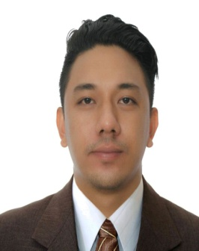

Ramon
Ramon.139150@2freemail.com

Objective

Seeking a rewarding career in a quality environment where my knowledge and experience can be shared and enriched through a right opportunity in order to excel myself as a good professional.

Work Experience

STI College San Fernando
Oct 2014 to May 25, 2016
San Fernando Pampanga, Philippines

Marketing Officer/ frontline admission officer
Providing information
Giving advises and guidance to help students to make the right choices about their education or course they will take in the future
Dealing with a large number of students
Dealing with school principals, guidance counselors and teachers
Dealing with different types of students and parents
Working on field
Responsible in advertisement and sponsorship
Also serve as receptionist
Greeting visitors
Answering phone calls, inquiries and concerns
Doing competitors survey, presentation and target market

Eats and Spirits Restaurant
May 2016 to Nov 2016

Dining Staff
Greet Costumers
Take orders
Serve food
Maintain Cleanliness
Assist costumers with concerns

Sinukwan Training Center for the Art
January 2010 to Present

Staff
Organizes and assisting in every events, performance and showcasing of talents through dances
Assesses and evaluates performances

University of Assumption
January 2012 to 2015
University of Assumption
San Fernando, Pampanga, Philippines

Trainer & Choreographer
Training potential dancers and members to condition their body to develop their Skills, Flexibility and Showmanship
Choreograph dances in the upcoming performances.

Skills

Computer literate, enthusiastic, quick to learn with good interpersonal and organizational skills and have a high sense of responsibility

Education

Tertiary
Systems Plus College Foundation
Bachelor of Science in Secondary Education
Major in MAPEH
Balibago, Angeles City, Philippines
2013-2014

Holy Angel University
Sto. Rosario, Angeles City, Philippines

Bachelor of Science in Secondary Education
Major in MAPEH
2009-2013

High School
Franciso G. Nepomuceno Memorial High School
Citi Center Pandan, Angeles City, Philippines
2005-2009

Seminars and Participations:

February 12, 2011 Seminar on Writing Learning Objectives

February 5-6, 2010 International Dance Exchange (NCCA)
Sining Makipamuhay
“Dialogue and Culture Exchange among Contemporary Artist and Indigenous Communities”

Sept 19 to 24, 2015 Career adviser seminar for senior high school

Personal Information

Date of Birth : December 21, 1992
Civil Status : Single
Sex : Male
Height : 5’7 ft
Languages : English, Pampango, Tagalog
Skills : Driving, Dancing, Choreographing and Organizing Skills
Marketing skills
Visa Status : Tourist Visa

