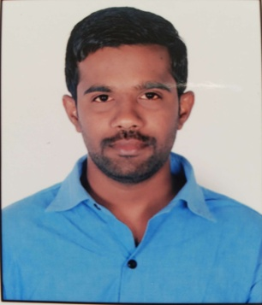  Contact. No:  Visa Status  Visit Visa  Arrival Date:10/12/2016  Due Date:02/03/2017 | Patil  Patil.139221@2freemail.com  Objective  To work in a quality environment with freedom to be innovative, creative and using my ability, management skills that could drive the growth further and make a significant contribution in achieving the business focus and mission of the company.  Professional Experience  - I worked as a customer service executive (BPO) Inbond and Outbond tele caller with hermes I ticket private ltd as a collection executive 3 years  - Handling inbond and outbond calls  - Determines requirements by working with customers  - Resolves problems by clarifying issues; researching and exploring answers and alternative solutions; implementing solutions; escalating unresolved problems  - Maintains call center database by entering information  Educational Profile  - M.com correspondence (Banking) (2012-2014) from Karnataka university dharwad, Karnataka  - B.com (regular) (2009-2012) from K A lokapur College, Karnataka University, Dharwad and secured an aggregate of 70%.  Area of Interest  - Customer service executive  - Tele calling collection dept  - Tele sales and marketing  - Receptionist  My Skills  - Interpersonal  - Leadership  - Problem Solving  - Decision making  My Strengths  - Hard working  - Team player  - Good communication  - Time management  Co-Curricular Activities  - Member of National Service Scheme During 2007-10  - Undergone a personality development camp “AWAKENING” at KKID,Anaikati, Coimbatore.  - Represented college in All Indian management Association (AIMA) management games.
Computer skills
- Packages : MS Office,MS excel
- OS : Windows
- Internet Knowledge

Personal profile:
Name : patil

DOB : 01/06/1991

Marital status : Single

Languages Known : English, Hindi, Kannada & Marathi

Declaration

I do hereby confirm that the information given in this form is true to do the best of my knowledge and belief.

Date:
Place:

