irshad.139284@2freemail.com
Ershad
system administrator (it) || tech sales || fleet management || operation || ITIL

Driven fleet professional with exceptional leadership qualities and hands-on experience in appropriately selecting and maintaining vehicles; targeting assignments in Fleet Management / Technical Support with an organization of repute preferably in UAE / GCC
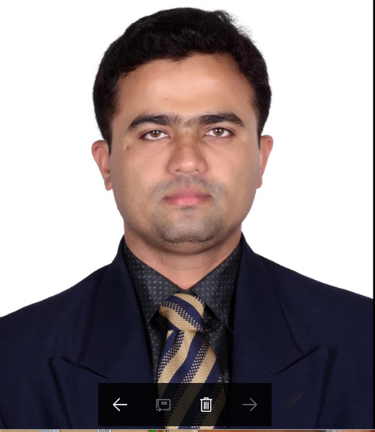
Profile Summary
Offering 10 years of experience in:
~Technical Support(IT) / Assistance ~Vehicle Management ~Supply Chain Management ~Performance Enhancement

- Possess in-depth knowledge of heavy and light vehicle operational and repairing procedures with excellent skills in preparing &performing troubleshooting, repairing, and maintenance techniques
- Rendering capabilities in managing complete procurement management activities involving planning, techno-commercial negotiations, vendor management, stores and logistics; also skilled in ensuring optimum inventory levels to achieve maximum cost savings without hampering the operations
- Leveraged skills in maintaining and updating up-to-date record of all vehicles for efficient tracking tofacilitate the registration renewal / insurance renewal and security pass renewal of fleet vehicles
- Take charge professional, known for showing continuous effort to improve fleet operations, decrease turnaround times, streamline work processes, and work cooperatively with the service provider
- Superior administrative skills, encompassing budgeting, reporting and compliance matters with strong record of cost reduction and quality / performance management; resilient advocate of proactive maintenance measure
- High integrity & energetic leader with proven skills in quality assurance to deliver quality services to clients / customers

Skill Set
Change Agent
Planner
Motivator
Communicator
Collaborator
Core Competencies

Fleet Management / Security | Technical Support | Repair & Maintenance Operations
Inventory / Material Management | Acquisition Management | Contract / Negotiation Management
Cost Optimization | Vendor / Customer Management | Team / Data Mgmt. and Leadership

- Organizational Experience
JAN’2018–PRESENT company in Dubai as Transporttaion/Business coordinator.
- Maintaining Financial Records
- Providing Consistency
- Administrative Support
- Customer Service
JAN’16 to NOV 23 2017 with Abu Dhabi Suppliers and Commercial Services, Abu Dhabi (EPIC) as Operation /Fleet Administrator
Key Result Areas:
- Steering entire gamut of operations such as:
- Uploading of vehicles commercial data in to UAE traffic system
- Queries regarding customer day-to-day issues related lease /rent vehicles
- Maintain and monitor data management system to organize fleets as per various schedules and requests
- And defining user roles in ERP (Gateway) software
- Drivers and vehicles in operation
- Interfacing with the maintenance team to find ways to reduce downtime due to repairs or lack of routine maintenance
- Safeguarding that all the paperwork associated with each run is accurate and submitted to the proper people
- Assisting and advisingmanagers & staff on all transport related issues to improve service level and efficiency
- Dealing with customers for lease and rent vehicles
- Creating & sustaining harmonious relations with all staff within the supply chain to ensure a smooth flow of all operations
- Leading tasks / activities related to dispatching, routing, and tracking transportation vehicles
- Scheduling and administering the work of subordinate staff to ensure that the work is accomplished in a manner consistent with organizational requirements
- Coordinating with other managers and staff members in order to formulate and implement policies, procedures, goals, and objectives
- Planning and leading work of fleet supervisors in various statewide locations; evaluates employee performance; ensures adequate training of personnel; administers disciplinary action as required
- Checking fleet operation in compliance with local and state rules and regulations

Career Timeline(Recent 6)  NOV’12 –JULY’13  Knowledge Works India Pvt. Ltd., Bangalore  E4E Business Solutions, Bangalore  Infinite Computer Solutions, Bangalore  National Drilling Company, Abu Dhabi  Emirates Nuclear Energy Corporation, Baraka  Abu Dhabi Suppliers and Commercial Services, Abu Dhabi  AUG’07-APR’09  JAN’10 – JAN’11  JAN’11 – FEB’12  AUG’13 – NOV’15  JAN’16- NOV17  - Trainings  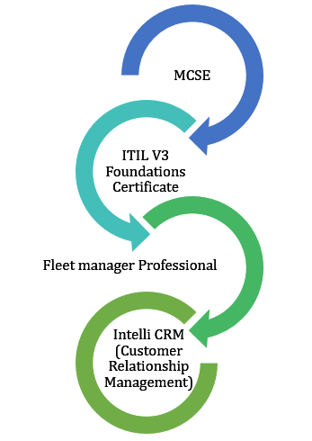  Academic Details  - ITIL V3 Foundations in 2012  - MCITP in 2012  - Diploma in Electronics & Communication Engineering from Technical Board of Karnataka, Bangalorein 2005  - Bachelor of Technology in Electronics and Communication Engineering from Kalinga University, India in 2017  IT Skills  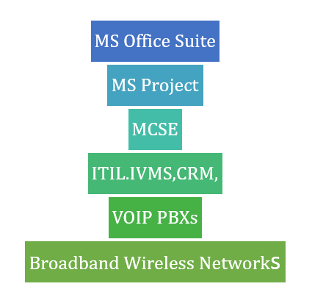 | Previous Experience  AUG’13 – NOV’15 with Emirates Nuclear Energy Corporation, Baraka UAE as IVMS/Fleet Administrator (Fleet Management)  Key Result Areas:  Installation, configuration, Operation and managing IVMS system for all ENEC fleets. Closely working with HSE ENEC:  - Led tasks such as :  - Scoring RAG report and nominate the best Company Driver  - Tracking Company Vehicles online  - Generated monthly IVMS reports of events for company & its contractors  - Liaised with IVMS Supplier (FMSI) and rectify need of system; also followed up with Company Contractors for monthly IVMS Reports  - Issued blue key to employee on receiving required documents for driving company vehicles in nuclear plant premises.  - Supported HSE and Security department by providing information about violations and events when they required  - Managedconfiguration changes of vehicles like speed setting,odometer settings and fixed vehicles configuration changes remotely using fleet management system  Transportation (Team Size: 20 Subcontractor - Transportation on ENEC Project)  - Operated as anAdvisor for all operations personnel to ensure that a high level of communication is maintained with regards to the Company’s Fleet  - Developed timely preventive maintenance & service schedule to ensure minimum downtime and safety and reliability of the vehicles  - Led replacement vehicle administration & maintain a record of all in and out check list of replacement cars  - Simplified procedures such asregistration renewal / insurance renewal andsecurity pass renewal of fleet vehicles  - Adhered compliance with all statutory compliance requirements related to the vehicles concerning Road Transport Authorities, Municipal and other government agencies to protect the company against any statutory penalties  NOV’12 –JULY’13 with National Drilling Company, Abu Dhabi as IVMS Administrator  Key Result Areas:  - Scored RAG report and nominated the best company driver  - Ensured completion of operations such as tracking company vehicles online, following-up on events to individually and report and reporting all accidents/Incident and near miss  JAN’11 – JAN’12 with Infinite Computer Solutions, Bangalore as Senior Tech Support  (Remote Infrastructure Management Project)  Key Result Areas:  - Safeguarded that assigned problems are defined and analyzed in-line with the Problem Management Process  - Rendered skills in providing telephonic support to customers for technical issues with computers, routers& printers and remote support to UK, US &Australian customers for day today issues with software and hardware issues  - Ensure that solutions to problems meet the architectural standards within the technology area and thus impact to the business is minimized  - Participated as an link within different technical teams, application teams and Customer support team and dissipate the solutions required for all incident management and service request for all assigned business areas  - Accomplished IT service requests (like new installations, reconfigurations & moves) as per agreed SLO  - Recognized recurring problem areas and articulatingtrends for root cause analysis therefore liaised with problem & give a permanent solution  - Planned and executed proactive maintenance on peripheral devices on recurring schedule to eliminate possible incidents and minimize possible impacts on customers  - Directed solutions and other requested services as per the procedures provided by other technical teams  JAN’10 – JAN’11 with E4E Business Solutions, Bangalore as Senior Tech Support  Key Result Areas:  - Assisted client and provided support on technical issue resolution via E-Mail, phone and other electronic medium  - Ensured timely configuration of client's equipment to connect to the Internet via modem/DSL Router (Dialup/DSL customers only)  - Configured software to connect to Internet application servers  - Gained general understanding of OS and application operations related to company offered services  - Recognized and advised clients on operational issues in client computer systems; supported customers solve technical issues with our widgets  - Certified that solutions to problems meet the architectural standards within the technology area and thus impact to the business is minimized  AUG’07-APR’09 with Knowledge Works India Pvt. Ltd., Bangalore as System Administrator  - Key Result Areas:  - Steered complete operations such as:  - Installation, configuration & administration of network Infrastructure like server, routers, switches and access points along with structured cabling and cable management  - Rack mounting and deployment  - Overall planning, scheduling and implementing of IT projects so as to ensure completion of assignments within time  - User administration and privilege management  - Installation of Network Printers  - Backup using synchronization for real-time file recovery  - Dealing with vendors and suppliers for relevant products and AMCs  - Feasibility, planning, deployment, installation and post installation procedures.  - Providing advice and support to technical support team on network related problems; conduct training to end-users  - Identified and attended network faults, analyzed the problems through root-cause analysis or theory of constrain to suggesting technical solutions for overcoming the same  - Managing the installation, configuration & maintenance of servers like Internet Servers, File servers, Printer servers, Fax servers, Workstations and peripherals  - End user systems upgrade plan and implementation  MAR’06-JULY’07 with Sharp Point Computers as Hardware & Network Engineer  - Key Result Areas:  - Served being a member of the Network Deployment, Troubleshooting and Maintenance Team undertaking data systems & ensured various operations like:  - Planning of corporate network environment  - Assembling of computers as per the daily requirements by installing necessary software  - Administered day-to-day issues of hardware, software and networks spread across different geographical locations  - Installed hardware parts of computers and loading software byproviding configuration details of computers for customer according to their needs  - Interfacedwith various vendors and suppliers for relevant products and AMCs
Personal Details
Date of Birth: 20/05/1984Languages Known: ENGLISH,HINDI,KANNADA
UAE driving license
Address: Dubai

