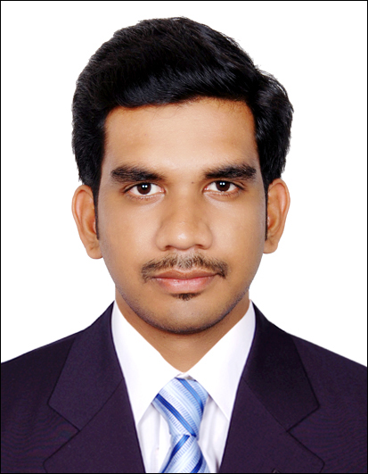  Personal Data:  Date of birth: 18/07/1990  Nationality: Indian  Languages Known:  English, Malayalam and Hindi. | Gulfjobseeker.com CV No: 92880  Mobile +971505905010 / +971504753686  To get contact details of this candidates  Submit request through Feedback Link  http://www.gulfjobseeker.com/feedback/submit_fb.php  Career Objective  Desirous of seeking a responsible and challenging position in the field of Finance, that would provide an opportunity for utilizing the auditing, accounting skills that I’ve gained over the past years.  Qualitative Skills:  Good leadership qualities with sheer hard work and ability to work well in a team. Confident to take up new challenges and keen to learn new concepts.  Professional Experience:  Worked With ASTEN SOLUTIONS Thrissur as Accountant from August 2013 to February 2014.  Roles and Responsibility  - Prepare and maintain a computerized accounting database.  - Plan and prepare the cost budget for the organization.  - Analyze and evaluate the difference between actual cost and budgeted cost of the organization.  - Ensure that the cash handling and banking procedures are followed which includes checking cash and credit card sales recorded and banked.  Previous Employer  Worked with Indian furniture Adoor for tenure July 2010 – August 2011 as accounts assistant.  Roles and Responsibility  - Over see the inventory movement procedures, which include recording incoming and outgoing inventory, ensuring that daily transactions are recorded, carry out spot checks on weekly basis and ensure the stock count procedure is followed.  - Recording daily sales and send the sales report to the organization management.  - Ensure implementation of stock count procedure and communicate any information to senior management on the stock position and variance reports.
Education

Master’s Degree in Business Management, Specialized in Finance/Marketing
MEC College of Business: Tamilnadu, Certified on August 2013

BBA (BACHELOR OF BUSINESS ADMINISTRATION) Co-Operative Arts And Science College Thrissur as on December 2010

Projects done (academically):

A six month Marketing project at Jyothy laboratories Ltd, Thrissur, Kerala
Project Title – A study on retailer’s opinion towards the market performance of jyothy laboratories products with special reference to Thrissur district.

Computer Proficiency:

Operating Systems:
Microsoft Windows XP, 7, 8& Linux.
Tools:
MS Office, Tally ERP.9. Peachtree, Quickbook.

Achievements & extracurricular:

- Presented a paper in the title Emergence of Viral Marketing in National Level Seminar held by Muthayyammal engineering college sponsored by AICTE.
- Presented a paper in the title “Impact of Foreign Direct Investment in India” in national level seminar held by RVS College Coimbatore.

