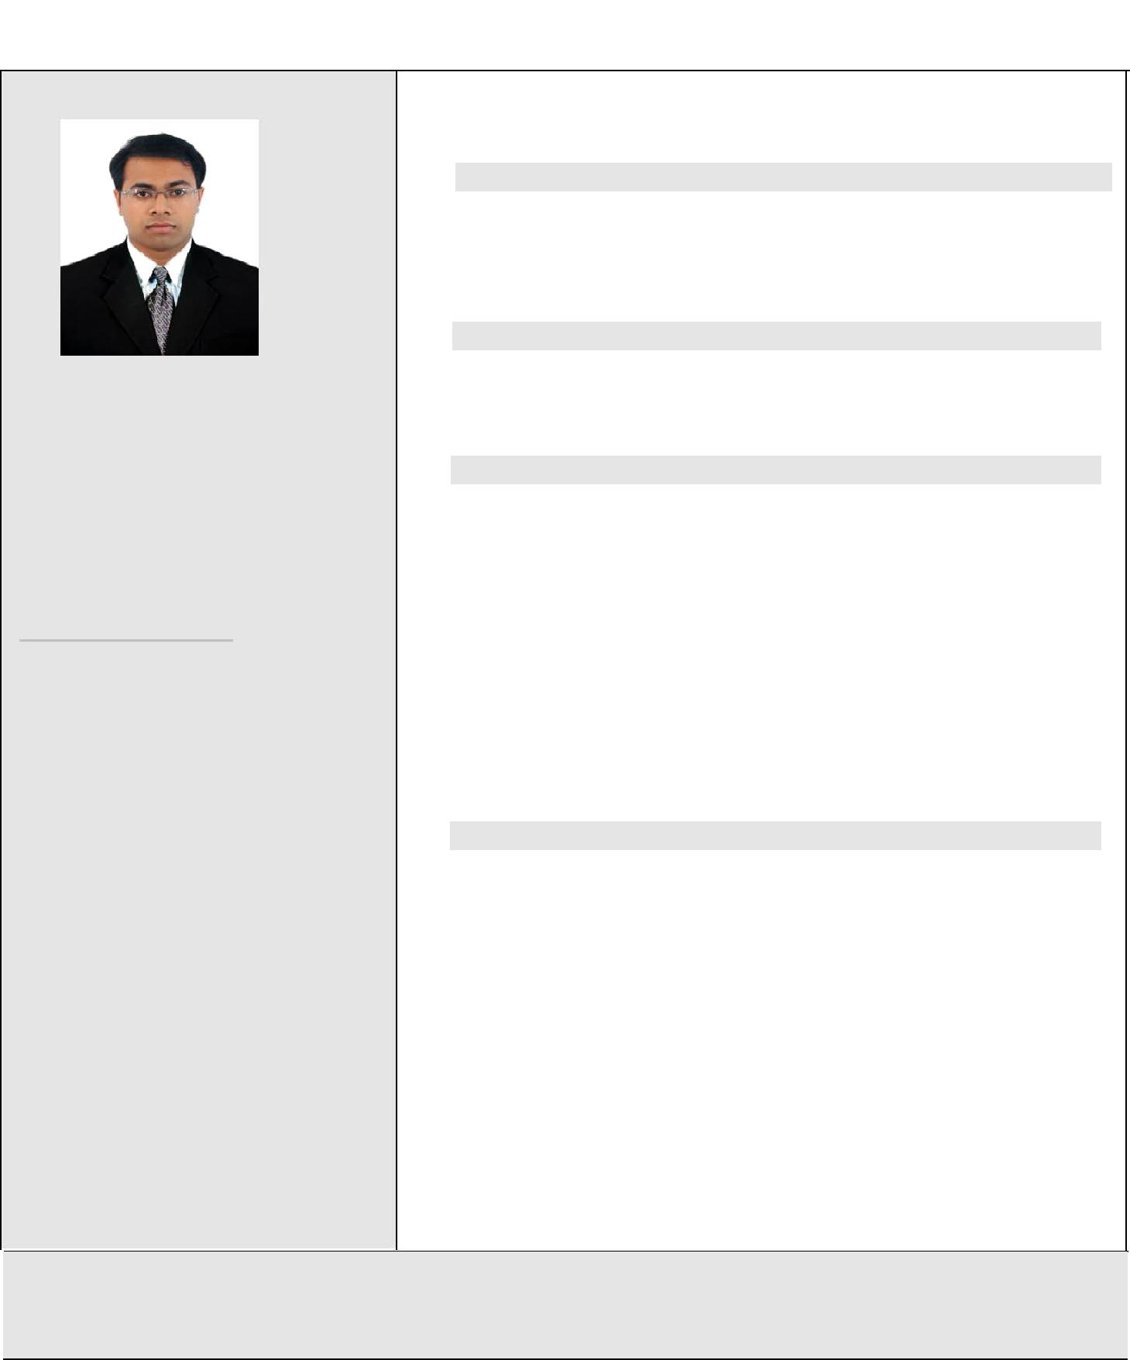

SEBASTIAN JOSE

Mob: +971 551448921
E-mail : saby.1987@gmail.com

PERMANENT ADDRESS
Cheriakkara House, Kuruvilassery P.O., via Mala, Thrissur Dist., Kerala-680735.

PERSONAL DATA

Father’s name | : C D Jose
Date of Birth | : 09/05/1987
Age | : 27
Sex | : Male
Nationality | : Indian
Marital Status | : Single
Languages | : English, Hindi,
 |  | Malayalam, Marathi
PASSPORT DETAILS
Passport No |  | : J9777699
Place of Issue |  | : PUNE
Date of Issue | : 04/10/2011
Date of Expiry | : 03/10/2021
HOBBIES AND INTERESTS
Movie making, Dancing
CURRICULUM VITAE

CAREER OBJECTIVE

To work for an organization of distinction that recognizes my true potential and provides me sufficient avenues for professional growth through nurturing my skills and competencies.

PROFESSIONAL EXPERIENCE FIELD
Area Sales Manager [June 2012 – June 2014] – Multi-Pro Ent.
Ltd., Tolaram Group, Nigeria
Sales Executive [June2009-Apr2010]-CD Power Systems,
Mumbai of LCD, CCTV and Access control
QUALIFICATION

MBA in Marketing (major) and Operations (minor) – 7 CGPA

Icfai University, IBS Pune, Pune, 2012

B.Tech in Electronics & Communication Engineering – 66.3%

Calicut University, Calicut, Kerala, 2009

Higher Secondary - 63%

Maharashtra State Board, Vani Vidyalaya Junior College, Mulund, 2005

Xth Standard – 78.53 %

Maharashtra State Board, Model English School, Dombivli, 2003
SKILLS

Software skills:
- Excellent knowledge in MS Office, power point and excel
- Basic knowledge in computer languages like C,C++

Communication skills:
- Process excellent written and oral communication skills in languages such as English, Hindi, Malayalam and Marathi

Managerial and multi-tasking skills:
- Being a head of a department, I have the proven record of efficiently managing a team effectively towards achieving the goals of the organisation
- To initiate new ideas, set high standards for the company and willingness to use new technologies to the desired standard
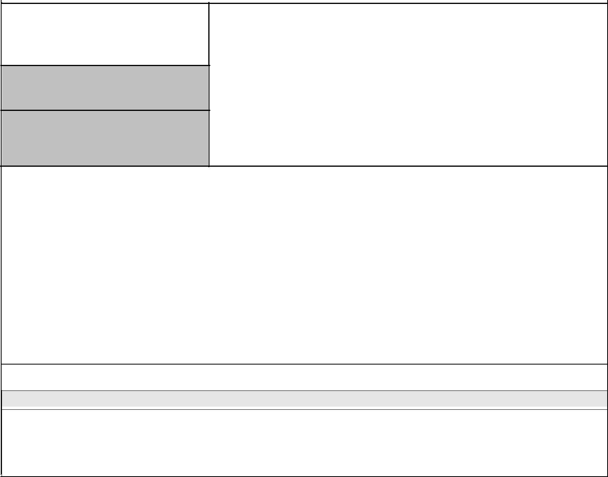
Organization | Tolaram Group
 | Web Site –www.tolaram.com

Position

Area Sales Manager in Multipro Ent. Ltd.

June 2012 –Dec 2012 (Lagos State),
Period Jan 2013 – Dec 2013 (Enugu, Benue and Ebonyi States),
Jan 2014 – June 2014 (Cross River and Akwa Ibom States).

Nature of Job

- To achieve the set targets of all the four Multi-Pro products such as Indomie, Hypo, Power Pasta and Power Oil in the above mentioned states of Nigeria. Indomie Instant noodle is the no.1 brand in the noodle sector in Nigeria.
- To manage the selling, distribution and redistribution process of all four above mentioned products.

- To handle the operational process of a sales team force of more than 30 people.
- To handle the logistics of the above mentioned products from the source to the distributor outlets.
- To plan the BTL marketing activities for the above mentioned products.

DECLARATION

I hereby declare that the above-mentioned information is correct up to my knowledge and I bear the responsibility for the correctness of the above-mentioned particulars.

* Visa status – Visit Visa (available in Dubai from 25th September 2014 onwards for 1 month visiting visa)

Place: Dubai Sebastian Jose

Date: 15/10/2014

