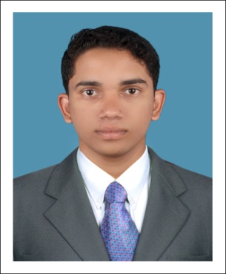  PERSONAL PROFILE:  Date Of Birth: 19-07-1990  Sex: Male  Nationality: Indian  Religion: Muslim  Marital Status: Single  Visa Status TOURIST  Languages Known: English, Hindi,  Malayalam and  Tamil | Gulfjobseeker.com CV No: 94134  Mobile +971505905010 / +971504753686  To get contact details of this candidates  Submit request through Feedback Link  http://www.gulfjobseeker.com/feedback/submit_fb.php  Curriculum Vitae  Objectives  - Prove to be an asset by playing a major role in the prosperity of the organization and growth of oneself. Always strive to do very best to evaluate success in order to live up to the standards set by management.  - To bring out the best out of any activity through dedication, hard work and sincerity.  Academic Profile  - Passed MBA (Finance and Marketing) with First Class from Anna University Chennai in 2014 at Vidyaa Vikas College of Engineering and Technology, Tiruchengode.  - Passed B.Com with Second Class in 2009 at Calicut University  - Passed Higher Secondary School with First Class in 2008 at Kerala Higher Secondary Board  - Passed Secondary School with First Class in 2006 at Kerala Secondary Board  General Assets  - Hard worker and having willingness to learn quickly  - Ability to adapt to any situation  - Ability to deal with people diplomatically  Technical Expertise  Operating System: Windows (98/2000/XP/Vista,Windows7 and 8),  Packages: MS Office (Word, Excel, Access, Power Point)  Tally  DTP (Desk Top Printing)  Hardware and Networking
EXPERIENCE:  ABOUT MYSELF:  DECLARATION: | CURRICULUM PROJECT  Project Title : A study on Fundamental Analysis of  Five Pharmaceutical Companies Listed  in BSE  Duration : 6 Month  Team Size : Single  Environment : Under Hedge Equities, Cochin.  .  - Worked as Project Assistant in Uniwave Consultancy Services, Kerala.  - Done Internship Training in Accounts Department of Hedge Equities Cochin, Kerala.  - Worked as Area Sales Manager for one year in Aircel, Kerala.  - Worked as DTP Staff in Smartway Communication, Kerala.  As I believe hard work is the key to success and character to personality, I always keep myself Proactive, Industrious and Good-natured.  I declare that the information and facts stated herein above are true and correct to the best of my knowledge and belief.

