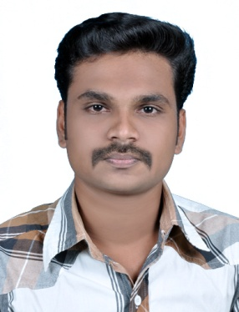

ANPHAS RAHIM
Contact No: +971 501084218, +971 508541864
E-Mail: anfasrahim@gmail.com

Target Jobs:

CCTV Technician, Electric/Electronics Technician, Electronics/ Security Systems Sales Man
CAREER OBJECTIVE

Seeking a position to utilize my skills and abilities in the Industry, this offers professional growth while being resourceful, innovative and flexible. Intend to build a Career in a Leading Corporate of hi-tech environment with committed and dedicated people, which will help me to explore myself fully to realize my potential.

ACADEMIC CREDENTIALS

- Diploma in Electronics and Telecommunication Engineering from AMET Technical college of Technology, (IETE New Delhi - India)

- PLUS TWO (Computer Science) from V.V.H.S School (Kerala State Board, India)

- S.S.L.C from V.V.H.S School, (Kerala State Board, India)

WORK EXPERIENCE

- Two years’ Experience as a Security System Technician at Aspire fire and safety Bangalore, India.

  - Installing and Configuring CCTV Surveillance system such as DVR and NVR installation and configuring, Wireless and wired camera installation, Coaxial cabling and Network cabling.
  - Installing and configuring wireless and wired Burglar alarm/Intrusion alarm systems.
  - Configuring DVR and Domain Name System (DNS), Network configurations, Estimation and Cabling.
  - Various Electrical works and wiring.

ACADEMIC ACHIEVEMENTS

- Diploma in Electronics and Telecommunication Engineering.

- Designed and circuited different types of electronics devices for college exhibition.

- Conducted and organized various events in the college.

KEY SKILLS

- NCVT in Electronics
- Languages: C ,C++
- Fundamentals of Computer
- MS Office
- Operating Systems: Windows 8, 7, XP

PERSONAL DETAILS

Father’s Name : Rahim K.T
Date of Birth : 13-02-1992
Sex : Male
Nationality : Indian
Languages Known : English, Hindi, and Malayalam
Passport No : J9448002
Passport Exp Date : 22/12/2021
Visa Status : Visit Visa

DECLARATION

I hereby declare that the above furnished details are true to the best of my knowledge and belief. If I get an opportunity to work under your esteemed organization, I swear that I will perform my duties with the almost sincerity & commitment.

ANPHAS RAHIM

