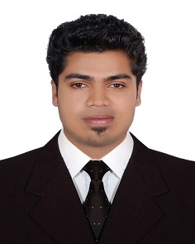
Arun .N

arun.naraen@gmail.com
+971 528 728 201 (uae)
+91 9916503056 (ind)
AL Qusais, UAE

Objective To pursue a demanding role within a reputed firm with the approach to take up responsibilities to accomplish organizational goals where in my skills and potentials are being utilized & gaining knowledge to contribute to the growth of the firm and be a sociable person.

Profile My main strengths are adaptability, dependability and the determination to get a job done as proven by my varied work experiences. I try to learn something new from every experience because I believe there is always room for self-improvement both personally and professionally.

Experience Financial Associate, VAYAMA, BANGALORE (AUG 2012 – MAR 2014).
Responsible for maintaining, updating & entering journals for sales revenue and other transactions.
Supporting Management Accountants as required. Daily inputting of sales & purchase invoices to the finance system.
Developed strong relationships with managers and staff, creating a cohesive and productive team within a deadline-driven environment.
Trained new departmental members on sales techniques, client protocol, and policy guidance if necessary.
Provided initial contact to responding quickly and diplomatically client concerns to ensure superior service and satisfaction.
Experience in the preparation of financial statements and preparation of financial reports.
Knowledge of business software application software.

Education Master in Human Resource Management (MBA)
(waiting final year result)- Bharathiar University- 2014.Tamil Nadu.
Bachelor of Computer Applications (BCA) – 2012.
Bharathiar University-Tamil Nadu.
Oracle PL/SQL & Database Administration.
National Institute of Information Technology-2014.

Skills Well versed with use of computer for office use and feeding inspection data.
Familiar with software packages like Google Apps and MS Office.
Familiar with Windows and Mac OS X Operating Systems
Organizational: Effective at time management and prioritizing tasks to achieve deadlines.
Interpersonal: Collaborate with a team, leadership and communication skills.

Personal Details Male, INDIAN, Bachelor, DOB – 03/03/1988.
Passport NO: L2983327.
Languages: English, Hindi, Malayalam and Tamil.

------------------------------------------------------------------

