 | 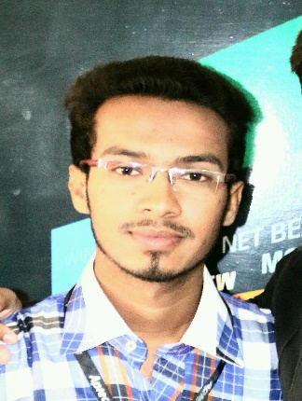  Pakistan  Karachi  Email: Muhammad.143609@2freemail.com | Muhammad  IT Software  About Me  I am a IT software Engineer. I have done from Aptech Computer Education Pakistan. And I am Matriculation and intermediate from Karachi, Pakistan Board.  Certificates  Scholarship of Middlesex University.  CPISM, DISM  Master Mind.
 | Objective  Seeking a challenging career within a dynamic progressive organization where enthusiasm, dedication and the ability to manage tasks effectively are prerequisite in driving the organization. | Experience  2016-date 2009-2012 2001-2009  Prime gas company H.O.C of DigiTech Computer And Language Centre Great company  This is Gas Company I was working there in IT department and controlling all the systems and data. That was my own centre where English language and Computer skill would be taught and I was teaching computer skills. I work on Freelance I worked on C# desktop application I made school management project and I also I worked on Android, Windows Application HTML, Css and Php.  Education  2012-2014 A school  Matric from R.R.B.K.School  2014-2016 Bachelor of Science  Intermediate from Government Collage.  Done Software Engineering from Aptech Computer Education System.  Visa Status  Visa : 3Months(Visit Visa)
Skills

Entirety command on Microsoft Office (Excel & word).
Well known computer Software & Hardware.
Good control to install each and any type of program/ software / hardware.
HTML.
Word Press
ASP.Net
Java
Php
Android Studio
Visual Studio (C#)

