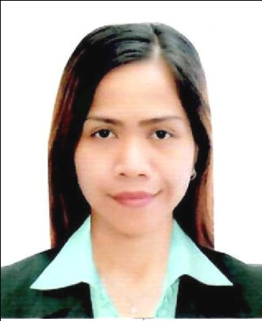
MARY
Mary.143680@2freemail.com

WORK EXPERIENCES:
Cashier
KFC, Kuwait Food Company (Americana)
Dubai, UAE
(July 21, 2014-July 21, 2018)
- Good customer service.
- Knowledgeable in every products and make suggestive selling.
- Properly of doing transaction in every purchased of the customers.
- To keep safe of money and sales.
Store Clerk
Rustan’s Department Store
Makati City, Philippines
(October 4, 2013-January 15, 2014)
- Gift wrapping, receiving, and claiming items.
- Assists inventory of remaining items in stockroom.
- Telephone operator reliever in inventory of the store.
Clerk
Sta.Lucia Realty Development Inc.
Ortigas City, Philippines
(May 29, 2012-October 29, 2012)
- To assists the buyer of their follow ups and concerns about the documents.
- Filing the control ledger and monitor the releasing documents.
- Encode information titles and others.
Data Encoder
Cherry Foodarama
Mandaluyong City, Philippines
(January 29, 2010-May 10, 2012)
- Encode change price and new product.
- Double checked barcodes of the product used the scanner.
- Printing barcode stickers and sale cards.
Cashier
Landmark Department Store
Trinoma Quezon City, Philippines
(November 6, 2009-December 29, 2009)
- Good customer service.
- Properly of doing transaction in every purchased of the customers.
- To keep safe of money and funds.
Cashier
SM Supervalue Inc.
Fairview Quezon City, Philippines
(April 21, 2009-September 15, 2009)
- Good customer service.
- Properly of doing transaction in every purchased of the customers.
- To keep safe of money and documents like banks copy in credit and debit cards.

Accounting Clerk
Legacy Consolidated Plans Inc.
Makati City, Philippines
(March 14, 2007-December 2008)
- Processing check preparation in the investment of the investors.
- Assists the investors in releasing and receiving checks.
- Answer telephone calls and investors to give the status of the checks.

SKILLS:
- Computer literate especially basic applications such: as Microsoft Word, PowerPoint and
Microsoft Excel.
- Good Communication skills
- Typing Speed 30wpm.
- Multi-tasking.

EDUCATIONAL BACKGROUND:
Bachelor of Science in Business Administration Major in Management
National College of Business & Arts, Fairview Q.C. Philippines
(June 2002-March 2006)

TRAINING/SEMINAR:
Call Center Training
Oredian Training Solution
Greenhills, San Juan Philippines
(December 18, 2012-January 17, 2013)

On-the-Job Training
Committee on Labor & Employment
Committee Affairs Department
House of Representatives, Q.C. Philippines
(June 21-October 2006)

