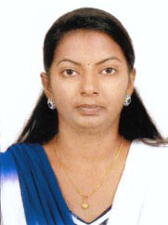
GOPIKA
GOPIKA.143765@2freemail.com
PRIMARY TEACHER / ASSISTANT TEACHER

OBJECTIVE
To pursue a challenging career in professional excellence through implementing acquired knowledge and skill from previous experience.
A good teacher with great emotional intelligence, attitudinal transformation, motivational, skills and personal management .
EXPERIENCE SUMMARY
Two years of teaching experience in Primary School in India :- ST.Thomas English Medium School, Adilabad , A .P( June 2014 to April 2016)
EDUCATIONAL QUALIFICATION
TTC -(Teachers Training Course)-
General Education Department, Govt. Of Kerala - Year 2014
Plus Two –
Board of Higher Secondary Education ,Govt. of Kerala - year 2012
SSLC –
Board of Secondary Education, Govt. of Kerala - Year -2010

PERSONAL DETAILS
Date of birth : 23.11.1994
Nationality : Indian
Languages known : English , Malayalam
Marital Status : Single
Visa Status : Visit Visa
Validity : From 12th December 2016 to 10th February 2017

Declaration :-
I do hereby declare that the above-furnished details are true and correct to the best of my knowledge and belief.

