= 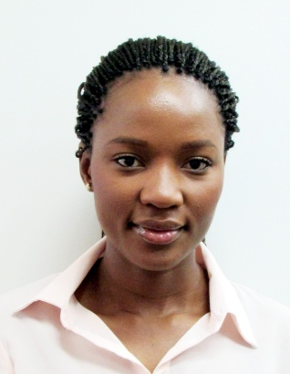
AMANDA

EMAIL: Amanda.143861@2freemail.com
PERSONAL PROFILE
An energetic, motivated and highly dynamic individual with excellent administration, customer service and marketing skills. Career objective: to associate with a dynamic establishment that offers opportunity for personal growth, while utilising my academic qualifications and interpersonal skills to excel the establishment.

EMPLOYMENT HISTORY

RESTAURANT RECIPE MANAGEMENT (U.A.E) January 2017 to November 2017
CUSTOMER SERVICE
- Customer service dine in, take away and delivery
- Handling delivery portals, restaurant line check
- Meeting customer expectations in areas such as timeliness, quality and consistency.
- Handling customer group bookings
ACCOUNTING EXCELLENCE (SOUTH AFRICA) JANUARY 2014 – DECEMBER 2016
RECEPTIONIST JAN – SEP 2014 PROMOTED TO TAX CONSULTANT OCT 2014
RESPONSIBILITIES
- Receiving and screening incoming calls and escalating to relevant personnel.
- File company documents and sort incoming mail faxes and courier parcels.
- Write business letter and reports (BEE letters, letters to South Africa Revenue Services).
- Submission of annual returns to CIPC (Company and Intellectual Property Commission).
- SARS (South African Revenue Services) registrations PAYE, VAT and Income Tax.
- Reply to general information requests with accurate information.
- Capturing of various client source documents onto Pastel.
- PAYE and VAT calculations of various clients and submission to the revenue services.
- Ordering of office supply and stationary, debtors and supplier processing.
- Liaising with the Revenue Service and the Department of Labour on behalf of clients.
- Submission of statutory returns, objections and any Revenue Service related submissions.
- Personal assistant administrations for the company director and accounting manager.

ALTIVEX 481 cc (SOUTH AFRICA) AUGUST 2008 – December 2013
OFFICE ADMINSTRATOR
- Arranging coordinating meetings for management and clients.
- Manning the switchboard ,taking memos and maintaining the filing system in the office both soft and hard copy.
- Handling the managers diary (meeting scheduling, travel diary etc.)
- Weighbridge payments.
- Liaising with suppliers in different countries (SADC).
- Submission of sales reports to the director.
- Handling enquiries, invoicing and quotations.
- Client account management.
- Submission and application of customs permits to the government.
- Organising logistics, transportation of product.
- Handling border control together with the customs agent.

TAPVICE ENTERPRISES (ZIMBABWE) JANUARY 2007 – JUNE 2008
OFFICE ADMNISTRATOR
- Switchboard operations, receiving calls and forwarding to relevant personnel.
- Administrations, correct filing of documents manually and electronically.
- Meeting agendas and minutes.
- Drawing up memorandums
- Banking and credit control.
- Handling of petty cash.
- Invoicing and quotations.
- Travel arrangements and hotels bookings for director’s business travels.
- Assisting the company directors and diarising their schedules every week.
- Ordering of office supply for the company.
- Data capturing of supplier and customer information.
EDUCATION
1.HOSPITALITY MANAGEMENT DIPLOMA (CITY AND GUILDS) DAMELIN COLLEGE SOUTH AFRICA
2.SUPERVISORY DEVELOPMENT PROGRAMME (SWISS SCHOOL OF TOURISM AND HOSPITALITY)
3.LCCI MARKETING (London Chamber of Commerce Industry)
COMPUTER SKILLS
- MS OFFICE (Word, Excel, Outlook, PowerPoint)
- Pastel Accounting
- ACT accounting software
- Hotel Software ( Fidelio, Opera, Micros, Pilot, Pixel Point)

REFERENCES: Provided upon request.

