Deva

An analytical and a troubleshooting expert targeting Middle Level Assignments with a leading organization of repute

deva.144006@2freemail.com

Key Skills
Projects Management Installation & Commissioning Electrical Engineering
Automation & Control Instrumentation

Testing & Documentation Troubleshooting & Maintenance Quality Assurance
Materials Management Team Building & Leadership

Profile Summary
8 years of experience in managing maintenance of heavy machinery & equipment, implementing process enhancement & quality control techniques Experience in planning & preventive/ predictive based maintenance schedules of various machinery and electrical equipment to increase machine uptime and equipment reliability
Proficiency in implementing ISO to execute continuous improvement in operations of an organization, with widespread involvement of employees at all levels
Excellence managing activities right from the conceptualization stage to the execution, involving finalization of technical specifications, procurement, erection, testing & commissioning, site management, manpower planning; familiar with principles of fire safety and occupational safety
Insightful knowledge in developing, scheduling and maintaining schedule protocol and implementing the same to ensure performance capacity of various process control equipment
Proficient in evaluating electrical systems, products, components, and applications by designing and conducting research programs; utilizing technical knowledge and skills acquired during the engineering in the field of design, development, production and maintenance of systems
A leader with excellent communication, negotiation and relationship building skills

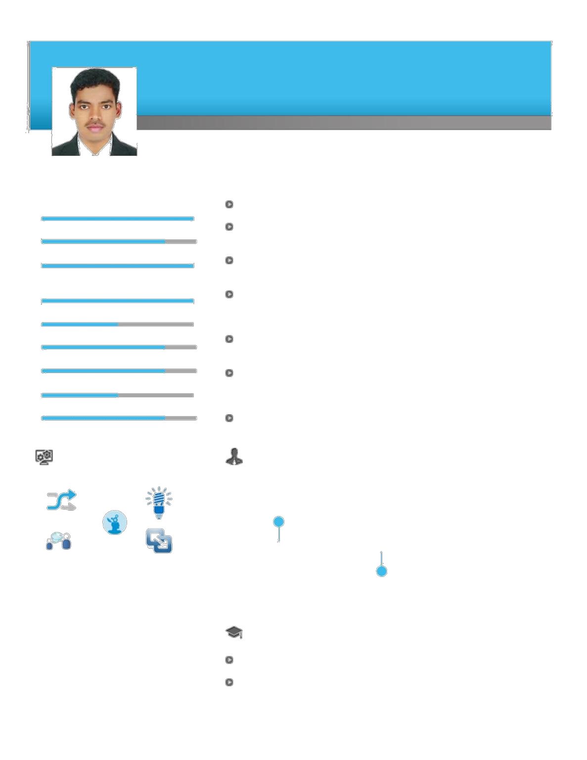

Soft Skills | Career Timeline
 | Origami CelluloPvt. Ltd.,
 | India as
 | Electrical Technician
Communicator | Innovator
Thinker
 | Apr’10 - Jan’14 | Since Mar’14
Collaborator | Intuitive
 |  | Arabian Packaging (Al
 |  | Ghurair group) Dubai as
 |  | Senior Electrical Technician
 | Education

DEEE from NMS Kamaraj Polytechnic College & Tamil Nadu, India

Work Experience
Since Mar’2014 with Arabian Packaging (Al Ghurair Group), Dubai as Senior Electrical Technician
Apr’2010 - Jan’2014 with Origami CelluloPvt. Ltd., India as Electrical Technician

Role:
Manufacturing & executing inspection of PLC & instrumentation control panel as per built internal mounting & wiring; planning & designing preventive maintenance schedules of various assigned equipment’s to increase machine up-time & equipment reliability
Designing internal inspection report for projects, review its test certificates & BOQS & planning sheet for current & future projects; ensuring formulation of plans for tackling breakdowns, spare parts management and inventory control Executing cost saving & energy saving techniques and modifications to achieve substantial reduction in O&M expenditures within the budge
Documenting of ISO audit reports for particular projects for production & site erection department Listing out calibration report for used instruments and checking the due date of calibration & removing faulty instruments; Monitoring to quality systems and complying with quality standards
Surveying site as per P & ID drawings & approved cable schedule, checking of dispatched materials & reporting for required materials to project division for material
Planning site & budgeting for projects and managing manpower at site as per safety rules
Drawing cable schedules as per approved input/output list, installing cable tray as per approved route and cable schedule & erection of instrumentation & PLC panels as per as built drawing
Commissioning of site with loop checking, termination & final testing
Facilitating the implementation of preventive and periodic maintenance, spares management system & total electrical plant maintenance
Monitoring & interacting of day-to-day work progress with contractors and follow safety rules
Conducting failure investigation analysis to identify gaps & take corrective measures so as to reduce equipment downtime & maximize plant availability
Maintaining of PLC based automation panel system, field instruments for instrument work & on-site maintenance of pumps, valve, motors from electrical work

Knowledge Purview
Executed functions such as installation of: o Automation and PLC machines
- Troubleshooting of PLC & drives
oThe Lenze, Mitsubishi, Servo, sew, elau,Siemens drives and controller,and all types of elau,lenze, Siemens and sew synchronous and asynchronous motors
- Drives are VFD drive & SERVO drive and all type of encoder
Maintenance process instrument, SIEMENS plc, lenze drives and all type of sensors
Installation and commission of conveyors like lifting table, turn table, transfer car of ducker, motor and sensors Knowledge of ASI-LINE AS-I card siemens 300 series 343-2,profibus342-5. Cpu upto 318
Knowledge of plc 400 series Siemens drive control module FM458-1,Exm448-1,Repeaters Rs485 siemens

PLC SIMATIC,S-7300&400 worked with machine handling
machines
o BHS-Corrugated Machine-MF1, MF2, Double Facer, Knife, Stacker (made in by Germany)
Printing machines o Gopfert& BGM-Feeder, Printing, Slotting, Die-cutter, Folder, Stacker (made in by Germany)
Flexo machines-Martine 618, Martine 924 (made in by france)

- Wrapping Machine-automatic plastic machine (made in by Germany)
- Conveyors-Ducker
- Lifting table, Turning Table-Ducker Corrapal (Made in by Germany)
Expertise in total productive maintenance (TPM), preventive maintenance (PM) and predictive maintenance (PDM) to increase the machinery up-time
Checking, Maintening and Troubleshooting of: o PLC, drives & motors & Conveyors
  - Sensors, counter, timer, temperature controller, limit switch, level sensor, transducers

