Yaalarasan
Email: yaalarasan.144198@2freemail.com

RESUME  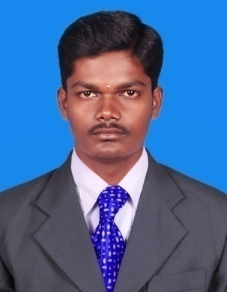  Area of interest  - Quality Management  - Manufacturing  - Production  Personal Information  Visa Status: Visit  Date of Birth: 14-06-1992  Nationality: Indian  Marital Status: Single  Mother Tongue : Tamil  Languages known : Tamil, English & Hindi(R&W). | Objective  To get a challenging career in a good concern, to provide a meaningful contribution for the growth of the concern that provides me good growth opportunities.  Assets  - Adaptable and Hard working  - Flexible and self motivated  - Continuous Learner  - Dedication of work  Academic profile  Completed B.E., Mechanical Engineering(2011-2014), at Kalaivani College of Technology, Coimbatore, Secured 6.99 CGPA (April 2014)  - Completed Diploma in Mechanical Engineering(2009-2011), at Bharath Polytechnic College, Tiruchengode, Secured 83.38% (April 2011)  - Completed HSC in SRI BVM Matriculation Higher Secondary School, Gurusamipalayam, Secured 62.66% (March 2009)  - Completed SSLC in Sengunthar Mahajana Higher Secondary School, Gurusamipalayam, Secured 70% (March 2007)  Technical expertise  - Auto cad  - Solid Works  Industrial Exposure  - Harita Seating Systems Ltd, Hosur  - Sri Venkateswara TVS  Projects  - Active Vibration Control of Flexible Structures Using PID control  - Design & Fabrication of Automatic Foot Dust Cleaning Machine  - Design & Fabrication of Manual Operated Yarn Removing Machine  Papers Presented & Workshops  - Presented a paper on “Design & Fabrication of Foot Dust Cleaning Machine” in LIME᾽14 National level conference  - Participated a seminar on Fabrication & Characterization of Thin Films for Engineering Applications  - Participated in the workshop on “Laser Applications” in National Institute of Technology, Tiruchirappalli  - Participated in the Industry Certification Robotics-Level 2  Declaration  I hereby declare that the above particulars furnished by me are true to the best of my knowledge and belief. I assure that, if I am given a chance, I will execute my work to the fullest satisfaction of my superiors.  Date:  Place: (YAALARASAN.D)

