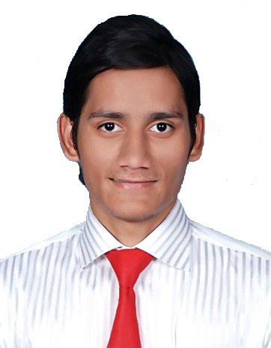
Adrian

E-Mail: Adrian.144218@2freemail.com

Contact # : C/o 971502360357

Objectives
I am looking to further my capabilities in the world of hospitality, management and customer services. I wish to explore new opportunities that will enable me to practice dealing with a variety of challenges faced by these industries. Such learning would strengthen my understanding and knowledge of customer services, a field that I am passionate about. I am driven by my curiosity of interacting with new and different people in different situations.
Experiences
Reservation / Guest Relationship Officer (Jan 2016 – Till Date)
Lal Qila ( A Theme Restaurant ) Dubai.
- To make reservations, take away, delivery orders by calls & by emails.
- To carefully mention all customer’s reservation’s instructions.
- Multitasking while on the call with the customer in person & sending them confirmation email.
- To multitask during busy operations, as in giving a helpful hand to other colleagues.
- Coordinating with the other department regarding the guest’s booking and their concerns.
- Handled escalated issues that are dealt by the managers.
- Sending daily, weekly & monthly sales reports to the management & to the owner directly.

Senior Customer Support Representative (April 2014 – Sept 2015)
Ibex Global ( Square Trade ) Karachi, Pakistan
- To handle calls and emails to report their hardware/software complains for their cellphones, computers and other electronic/non-electronic items.
- To charge their cards for the repairs.
- To carefully mention all customer’s item’s problems, instructions and requirements in the system while making their complain.
- Handling complaints on phone or by email as well.
- Multitasking while on the call with the customer by making their complains in the system, sending them confirmation email.
- To multitask during busy operations, as in giving a helpful hand to other colleagues.
- Coordinating with the partner super stores, repair depots and the banks for the customers concerns.
- Making sales when there is too busy working day without any benefits.
- Handled escalated issues that are deal by the supervisors.
- Troubleshooting with the customers for their items software ptoblems, how to make it work with different options.
Senior Customer Representative (Team Leader) (Feb 2013 – Jul 2014)
E-Planet Communication, Karachi, Pakistan
- To handle calls, to report their complains for beauty products.
- To carefully mention all customer’s item’s problems, instructions and requirements in the system while making their complain.
- Handling complaints on phone or by email as well.
- Multitasking while on the call with the customer by making their complains in the system, sending them confirmation email.
- To multitask during busy operations, as in giving a helpful hand to other colleagues.
- Coordinating with the banks for the customers concerns.
- Dowselling the product.
- Mostly handled all escalated issues that are deal by the supervisors.
- Troubleshooting with the customers for their items software ptoblems, how to make it work with different options.

IT Assistant (Aug 2011- July 2012)
British Council, Karachi, Pakistan
- To provide Assistance to IT Manager in any work.
- To provide assistance to all Users of office in the absence of IT Manager
- To give support to British Council Karachi All Staff.
- To check the Daily Back-Up Data of computers is successful or not.
- Maintain Daily, Weekly & Monthly check list and maintain of Back-Up Data.
- Update all Laptops weekly.
- Manage and update IT Equipment inventory of Hardware and Software inventory office and ware house.
- To fulfill IT Services, accessories requirement and maintenance issues.
- Trouble Shooting of wireless/wired connectivity.
- Given support on Video Conferencing Facilities.
- Given support from Network Administration for User ID’s, Services.
- To provide guidance and troubleshooting to users on the use of software as necessary.
- To ensure Call Centre Server and workstation running smoothly.
- To ensure British Council PABX (Telephony System) running smoothly.
- And if required, coordinate with IT Hub colleague in Delhi to resolve any issue.

Education
- Intermediate…2nd Division (Aug2011–Jun 2012)
S M Art & Commerce College, Karachi, Pakistan
- SSC… B Grade (Mar 2008–Jun 2009)
St.Patrick’s Technical School Karachi, Pakistan
Software Skills
- Good in computer softwares, repairing the computer in a good working condition.
- Proficient with different Microsoft operating systems, particularly usage of Microsoft Office, including Word & Excel.
Core Skills
- Excellent communication and interpersonal skills.
- The ability to grasp new concepts quickly and generate fresh and innovative ideas.
- The ability to multi-task.
- An aptitude for teamwork.
- Genuine leadership and management skills.
Personal Attributesn
- The ability to work in any environment
- Motivated & innovative
- Honest and trustworthy
- Hardworking & Driven to excel in my career
- Possess cultural awareness and sensitivity
- Eager to Learn
Personal Details
DATE OF BIRTH : Sept 30, 1989
NATIONALITY : Pakistani
MARITAL STATUS : Unmarried
LANGUAGES : English, Urdu, Gujarati Hindi, Konkani, Sindhi & Punjabi
DATE OF Expiry : January 9, 2018
VISA STATUS : Employment Visa
References
References are available upon request

