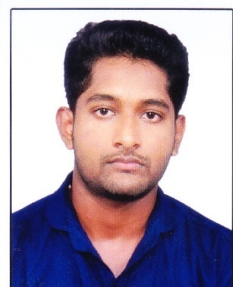
JOJI
JOJI.144551@2freemail.com

CAREER OBJECTIVES :

Intend to build a career with leading corporate of hi-tech environment with committed and dedicated people, which will help me to explore myself and realize my potential.

EDUCATION QUALIFICATION:

- Master of Business Administration from Girideepam College (2011-2013) , affiliated to M G University with 70%
- Bachelor of Science in Physics from S B College (2008-2011) , affiliated to M G University with 65%
- H.S.E from Kerala State Board with 79%
- S.S.L.C from Kerala State Board with 80%

ACADEMIC ACCOMPLISHMENTS :

- Student Coordinator of EXCEL’12 National Management Meet In Girideepam Institute Of Advance Learning.
- Organized several Seminars & Presentations in the college.
- Participant in several management fest in other colleges and won prizes
- Member of TRAMA
- Participated in National Workshop conducted by RCI-INDIA
- A member of YMCA. Organized many social events

PROJECT WORKS:

- A study on Working Capital Management at Travancore Cements Ltd. Nattakom.
- An Organization Study at Phillips Carbon Black Ltd Karimugal,Ernakulam.
- Project work on Viscosity of Various Liquids.

SKILLS

Personal Attributes
Analytical skills
Adaptability
Problem solving
Hardworking, Self-motivated
Strong interpersonal skills

Computer Proficiency
MS Office
Internet applications
Tally

WORK EXPERIENCES :
.
- Worked as Operations Executive in Pest Control India Pvt LTD for a period of 2 year from 10.02.2014 to 25.03.2016
- Worked as Administration Executive from 11.04.2016 to 26.11.2016 for the period of 6 months.

Job Description :
- Documentation & Record Keeping
- Erp System
- Chemical & Equipment
- Accounts Maintaining
PERSONAL PROFILE :

- Age : 26
- Date of Birth : 25-07-1990
- Nationality : Indian
- Sex : Male
- Languages Know : English,Malayalam,Hindi
- Hobbies : Travelling , Listening to music , Watching
Movies , Net surfing
- Visa Status : Visit Visa
- Visa Valid : 27/02/2017

DECLARATION :

I hereby declare that the information furnished above is true to the best of my knowledge and I bear responsibility for the correctness of the above mentioned particulars.

Place:
Date:

