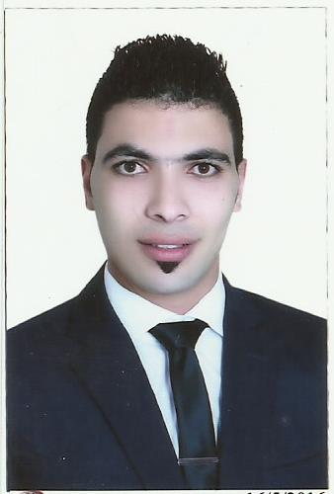

Mahmoud
Mahmoud.147606@2freemail.com

Personal information
- Date of Birth : 14/11/1990
- Nationality : Egyptian
- Present Address : : Dubai United Arab Emirates
- Languages Ability : English, Arabic
- Driving Licenses : Dubai
- Marital Statue : Single

Objective:
Seeking long term employment in an organization where I can grow professionally and further enhance my skills, knowledge and experience to face and overcome the challenges of today’s changing work environment.

Educational Qualifications:
College of International Transport and Logistics "Arab Academy For Science Technology & maritime transport "
Graduation grade : V good ( 3.2 \ 4 )

Skills
- Listening, Nonverbal Communication, Clarity and Concision, Friendliness, Confidence.
- Empathy, Open-mindedness, Respect, Feedback, Picking the Right Medium.
- Acting as a team player, Flexibility is a valuable asset.
- Effective communication is paramount, Problem-solving skills and resourcefulness.
- Accepting feedback and applying lessons learned , Creative thinking.
- Knowledge of computer hardware, Windows installation and software.
- Good observation skills to find and solve isthe Major factor.
- Ability to access company needs and priorities.
- Excellent team motivation, management Skills.
- Fast learning for new Technology and their applications.

Work Experience
Mar 2014 –Jan 2015
Teller at Money Exchange company in Egypt.
Job Responsibilities:
- Balance currency, coin, and checks in cash drawers at ends of shifts, and calculate daily transactions using computers, calculators, or adding machines.
- Cash checks and pay out money after verifying that signatures are correct, that written and numerical amounts agree, and that accounts have sufficient funds.
- Examine checks for endorsements and to verify other information such as dates, bank names, identification of the persons receiving payments and the legality of the documents.
- Enter customers' transactions into computers in order to record transactionsand issue computer-generated receipts.
April 2015-Mar 2016
Sales at Sohib Shop For Oud and Perfumes in Egypt.

Job Responsibilities:
- Find out the customer's needs.
- Answer customer queries regarding the store and the merchandise.
- Handle more complex customer problems and inquiries.
- Assists with training new Lead staff.
Mar 2016 _ Jan 2017
Sales at Flash center for Woman needs
Job Responsibilities:
- Greet customers.
- Find out the customer's needs.
- Recommend, select and help locate the right merchandise.
- Describe a product's features and benefits.
- Arrange and display merchandise.
- Schedule sales activity.
- Develop and maintain a customer database.
- Develop and maintain sales and promotional materials.
- Take stock inventory.
- Requisition new stock.
- Ensure customer service satisfaction and good client relationships.

