Ojeah | 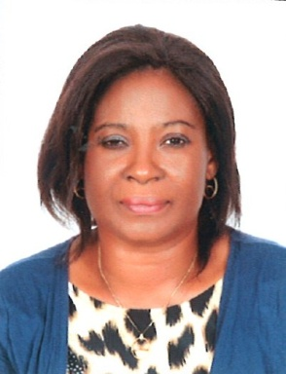
About to take dha exam
Ojeah.147755@2freemail.com

PERSONAL - PROFILE

Date of Birth : 30th July 1968
Nationality : Nigerian
Marital Status : Married
Languages Known : English
Visa Status : Visit Visa

OBJECTIVE

Seeking a position to utilize my skills and abilities to the fullest in the environment that offers professional growth which being resourceful, innovative and flexible, analyze my experience and sharpen my skill.

KEY QUALIFICATION

- Highly adaptable, resourceful team player, positive, flexible, patient, and honest
- Strong desire to take extra responsibilities
- Well organized, emotionally matured, professional
- Energetic, hardworking, reliable and trainable

PROFESSIONAL EXPERIENCE

- Kairos Pharmaceutical Ltd.
- Asaba Delta State, Nigeria
Superintendent Pharmacist and CEO Dec 2006-Date

- Vofmed Pharmaceutical Industry Limited,
Capwire Road, Asaba, Delta State, Nigeria
Production Pharmacist Aug 2003-Nov 2006

- Rico Pharmaceutical Industry Limited
Omoba Phase II Onitsha, Anambra State
Production Pharmacist Aug 2001-2003

- B. Olojo Pharmaceutical Limited, Kano State
Superintendent Pharmacist June 1996-Dec 1998

- Murtala Mohammed Specialist Hospital, Kano State
Internship May 1994-May 1995

EDUCATIONAL INSTITUTIONS ATTENDED WITH DATES

- University of Benin, Benin City, Edo State 2005 – 2007
- University of Nigeria Nsukka 1986 – 1994
- Owerri Girls Secondary School, Owerri, Imo State 1980 – 1986
- Orlu Township School, Orlu, Imo State 1973 - 1979

QUALIFICATIONS OBTAINED WITH DATES

- Doctor of Pharmacy, Clinical Pharmacy May 2007
- Bachelor of Pharmacy with Hons February 1994
- O Level (WASCE/GCE) June 1986
- First School Leaving Certificate June 1979

MEMBERSHIP WITH PROFESSIONAL BODIES

- Member, Pharmaceutical Society of Nigeria (PSN)
- Vice Chairman, Association of Community Pharmacists (ACPN), Delta State Branch
- Member, International Pharmaceutical Federation (FIP)
- Member, West African Post-graduate College of Pharmacists

PIBLICATIONS/SEMINARS

Have successfully conducted many public seminars on Drugs and Health related issues: - Women and Contraceptives, Understanding your body and avoiding unwanted pregnancy for singles, drug use and drug interactions, wound management, safety measures, HIV/AIDS, youth stress management, keeping fit, hypertension and diabetes management, care of toddlers and young children.

AWARDS

- Award for female achievement in Nigeria (in the area of pharmacy). By People State and Resource Magazine – September 2010
- Meritorious Service Award by the Association of Community Pharmacists of Nigeria (ACPN) Delta State – August 2015

HOBBIES

- Reading
- Making sure people get quality medication

SPECIAL QUALITIES

Puts God First, Honest, Hardworking, Humble, Proactive, Positive and Thinks win-win.

REFEREES

DECLARATION

I hereby certify that the above information is true and correct to the best of my knowledge and belief

