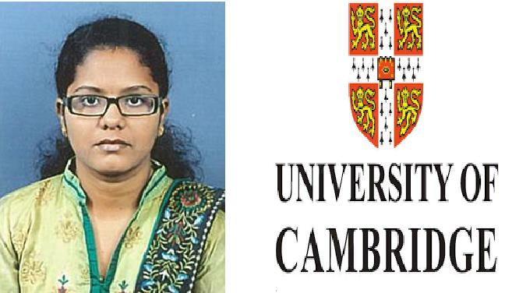

RAECHAL

Email id – raechal.147822@2freemail.com

Seeking of entry level position with a growth oriented organization in area of

Engineering in Civil Branch

PROFESSIONAL PROFILE

Building a Engineering professional with a Bachelor Degree in Civil Engineering from Ponjesly College Of Engineering under Anna University Chennai, Consistent academic record with zeal to learn new concepts, innovative ideas, goal oriented with a passion to succeed.

ACADEMIA

Bachelor Degree in Civil Engineering from Ponjesly College Of Engineering under Anna University Chennai, in April 2017. (Secured 80%)
Class 12th from St. Joseph’s Convent Higher Secondary School in March 2013. (Secured 80%)
Class 10th from St. Joseph’s Convent Higher Secondary School in March 2011. (Secured 95%)

INTERNSHIP

Worked as a Civil Trainee under the Leadership of Er.G.RAJEESH KUMAR Chairman of Builders Association Kanya Kumari(Duration:10 days) as a part of Engineering Curriculum.

I had learned how the initial steps have to be done for the construction of a structure.

I gain some knowledge about Site works and office works.

PROJECT DETAILS

I had done minor project on “DESIGN OF CEMENT SILO ”

Faculty Guide: Ms. Jessin Brindha, Asst. professor, Dept. of Civil Engineering, PJCE

The cement silo can be constructed in industries or working sites for the storage of materials which are used for the future production process.

I had done major project on “EXPERIMENTAL INVESTIGATION ON CHARACTERISTICS

OF LIGHTWEIGHT CONCRETE USING EXPANDED POLSTYRENE BEADS” Faculty Guide: Ms.C.Kinsy, Asst. Professor, Dept. of Civil Engineering, PJCE This research project mainly concerned about the behavior of concrete using EPS .
The project contains all the initial tests for the materials used for making concrete with EPS.

The comparative study is done between normal concrete and concrete with EPS.

CAMBRIDGE UNIVERSITY BUSINESS ENGLISH CERTIFICATE

I have cleared BEC vantage level examination.

SKILLS

Area of Interest : Interior Designing.

Software : Auto CAD, Revit, 3ds Max, STAAD Pro, Primavera.

Technical skills : Prefabricated Structures, Concrete technology, Design of reinforced brick masonry.

WORKSHOPS

- Gained informations through workshop on the topic “NEW ERA OF CIVIL ENGINEERING” conducted by Edu CADD Learning Solutions, Nagercoil.

- Gained informations through workshop on the topic “HEALTH AND SAFETY TRAINING-CONSTRUCTIO SAFETY WORKSHOP” organized by SAFAL, Coimbatore.

- Gained informations through workshop on the topic “REMOTE SENSING & GIS” organized by

GOVERNMENT COLLEGE OF ENGINEERING, Konam.

Information:

Date of birth

: 04th November 1995

Marital status

: Single

Nationality

: Indian

Driving license

: India-Driving License.

Languages known : English, Tamil.

Strength & Interests:

- Self-confidence.

- Listening and problem solving skills.

- Dedication and drive as a hard-working individual.

 | DECLARATION
 | The Information Furnished above is correct to the Best of my knowledge
Place: Bur Dubai | Signature
Date: 17.06.2017 | Raechal

