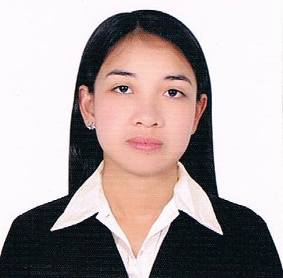
Melba
Nationality: Filipino
Email: melba.147823@2freemail.com

JOB Objective |  | To work in your respective company as Human Resource/Admin Staff or any other related position where I can utilize and employ the skills I have learned and be able to share knowledge for my personal growth and for the betterment of the company.
WORK EXPERIENCE |  | Company: EPFVET- Trading  Position: Sales Representative  Address: San Lucas Calabanga, Camarines Sur, Philippines  Duration: March 2, 2015 - April 30, 2017  Duties and Responsibilities  - Provide direct customer services by informing them of the products and services  - Research sources in order to develop new business connections  - Make cold calls to prospective clients and inform them about new products/ deals  - Promote new products to walk in costumers and record orders  - Explain products value and capabilities to customers  - Meet individual and company sales targets  Company: FACADE ADVERTISING  Position: HR Staff  Address: 1129 Brgy. Paltok Del Monte Avenue Quezon City, Philippines  Duration: Sept 3, 2012 to Nov. 14, 2013  Duties and Responsibilities  - Supports human resources department by screening and interviewing applicants  - Prepare payroll of the employees  - Administering employee benefit programs  - Maintain human resources records by recording new hires, transfers, terminations, changes in job classifications, merit increases, tracking vacation, sick and personal time.  - Orient new employees by providing orientation, reviewing company policies and other payroll information.  - Documents human resources actions by completing forms, reports, logs and records.  - Schedules examinations by coordinating appointments  - Contributes to the team effort by accomplishing related results as needed  Company: SUMMIT TECHNOLOGIES INCORPORATED  Position: HR/Admin Staff  Address: Jesseva Bldg.MT Villanueva Ave. Naga City, Philippines  Duration: June 17, 2011 to March 30, 2012  Duties and Responsibilities  - Provide payroll information by collecting time and attendance records  - Coordinates to the main office; organizes events to the company  - Maintain employees’ confidence and protects operations by keeping human resource information confidential.  - Provide secretarial support by entering, formatting and printing information; organizing work; answering the telephone; relaying messages; maintaining equipment and supplies.  - Maintains employee information by entering and updating employment and status change data.  - Submit employee data reports by assembling, preparing and analyzing data.  - Schedules examinations by coordinating appointments to the applicants  - Welcome new employees to the organization by conducting orientation  Company: INNOVATIONS FOR POVERTY ACTION  Position: Field Interviewer  Address: DMG Bldg, Peñafrancia Avenue, Naga City, Philippines  Duration: May to June 2011  Duties and Responsibilities  - Conduct interview to the respondents  - Ask questions in accordance with instructions to obtain various specified information  - Compile, record and encode results and data from interview or survey, using computer or specified form  - Review data obtained from interview for completeness and accuracy  - Explain survey objectives and procedures to interviewees and interpret survey questions to help interviewees comprehension  - Locate and search the address of the respondents  Company: Coca Cola Bottlers, Philippines  Position: On the Job Trainee - HR Department  Address: Naga City, Philippines  Duration: January to March 2011  Company: Ateneo de Naga University  Position: Encoder  Address: Naga City, Philippines  Duration: December 2011 to January 2012
EDUCATION |  | June to October 2016 Special Learning Package (Methods of Teaching) - 18 units  Bicol State College of Applied Sciences and Technology  Naga City, Philippines  Tertiary BS Psychology  2007- 2011 Ateneo de Naga University  Ateneo Avenue, Naga City, Philippines  Secondary Union National High School  2003-2007 Calabanga, Camarines Sur, Philippines  *Graduated as First Honorable
PROFESSIONAL/ CIVIC AFFILIATION |  | Passed the Licensure Examination for Teachers March 26, 2017  Member Association of Psychology Students of Ateneo 2007 – 2011  Member Ateneo Student Researchers Pool 2008 – 2010  Member Ateneo Gabay Scholars 2007 – 2010
tRAININGS/  INVOLVEMENTS |  | Participant General Information Seminar  Social Security System  East Ave. Diliman Quezon City, Philippines  March 8, 2013  Student Researcher/ Participatory Rapid Appraisal  Co-Facilitator Brgy. Bagacay Tinambac  Camarines Sur, Philippines  November 2010  Participant Outreach Program  Ateneo de Naga University, Philippines  June- October 2010  Participant 6th Bicol Region Association of Psychology Students  Ateneo de Naga University, Philippines  January 27, 2010  Field Enumerator A Study on Peñafrancia Devotion in Naga City  and Camarines Sur  November 2008  Student Researcher/ Participatory Rapid Appraisal  Co-Facilitator Brgy. Gabas Buhi, Cam. Sur, Philippines  October 2008  Participant Basic Computer Course with Values Education April-August 2004
SKILLS AND PERSONAL QUALIFICATION |  | - Knowledgeable in Microsoft Office  - Good in verbal and written communication  - Highly experienced in orienting employees  - Professionalism  - Teamwork  - Creative and can easily adapt to the environment
I hereby certify that above information is true and correct to the best of my knowledge. Character reference/s and supporting documents will be provided upon request.

MELBA
Applicant

