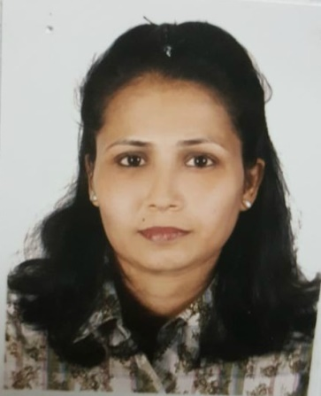
SHAILA
E-mail: shaila.147841@2freemail.com
Dubai, UAE

CAREER OBJECTIVE:
Seeking a position to utilize my skills and abilities in the Medical Industry. An industry that offers professional growth while being resourceful, innovative and flexible as well as contributing to the success and goodwill of the organization.

MAJOR STRENGTHS:
- Very hardworking
- Excellent team skills
- Good communication skills

EDUCATIONAL QUALIFICATION:
- Assistant Nursing, KMC Hospital Mangalore, India
- Higher Secondary Certificate from Central Board of Secondary Education. – Milagres College, Kallianpur, Karnataka, India.
- Secondary School Certificate from Central Board of Secondary Education. – Milagres College, Kallianpur, Karnataka, India.

WORK EXPERIENCE:
- Mitra Hospital, Udupi, Karnataka, India
Worked in Emergency ward, Trauma centre and OPD and in all wards (1994-1996)

- Belhoul Hospital, Satwa, U.A.E.
Handling Geriatric Patients (1997-2000)

- Dubai Hospital, U.A.E.
Worked as a private nurse in I.C.I. (2001)
PROCEDURAL EXPERIENCE:
During my in-service period I have done/assisted routine and emergency procedures including:
- Routine and Surgical wound dressing
- IV cannulations, Ryles tube insertions and Catheterizations
- Vital signs recording
- Care of patients on ventilators
- Nebulizer, steam inhaler

HOBBIES:
- Cooking
- Baking
- Singing
- Gardening

PERSONAL PROFILE:
- Date of Birth: 4 February, 1972
- Nationality: Indian
- Hometown: Mangalore, India
- Languages known: English, Hindi, Konkani, Tulu, Malayalam and Kannada
- Visa status: Husband’s visa

Declaration
I hereby declare that the above information is true to the best of my knowledge.

Place: Dubai – UAE

Sincerely,
Shaila

