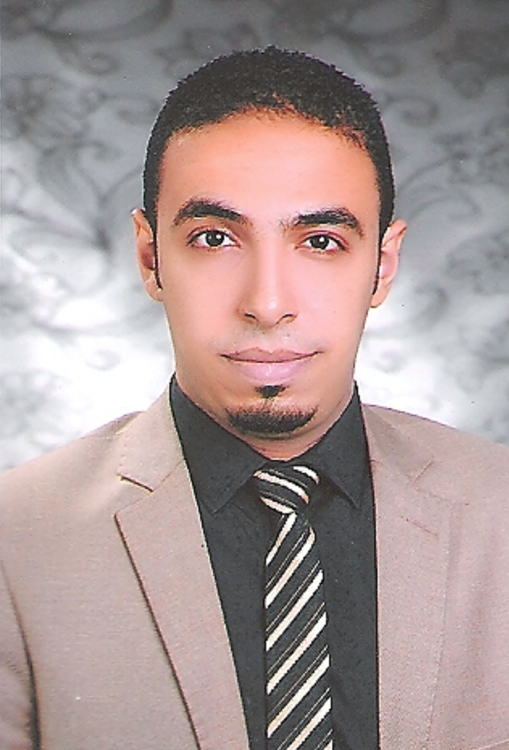
Mahmoud

Date of Birth: 01/04/1989
Nationality: Egyptian
Social Status: Single
Military Status: Exempted
Email Address:

Mahmoud.147849@2freemail.com

Objective

- I am seeking a career at a reputable firm, or agency, which encourages continuous education and development of its employees, and where creativity can be appreciated, and through which I can interact and work efficiently in a dynamic Environment to prove myself.
- Looking for a career opportunity in the field of architecting or as a site engineer.

Academic

- Higher Institute of Engineering and Technology.

- Architecture Department. ( 2014 )

- Academic supervision of the University of Ain​​Shams

Courses:

♦ ICDL

At The Arab Academy for Science & Technology

During: (10 / 2015 – 12 / 2015)

♦ Project Management Professional (PMP)

At Engineers Syndicate in Alexandria

During: (10 / 2015 – 11 / 2015)

♦ Technical Office Course

At Engineers Syndicate in Alexandria

During: (10 / 2015)

♦ 3D Max

At The Arab Academy for Science & Technology

During: (2/2014 – 5/2014)

♦ Auto Cad 2D
At Enter Training Centre
During: (8/2011 – 10/2011)

Work Experience:

- Architect at Ajyad Consultant Engineering Office

(Al Ain-Abu Dhabi) (4/2016 - To Present)

Architectural Designer.
Deputy Director of Architectural Design.
Supervision Manager.
Technical Office.

- A site engineer at IQ Design & Interior Architecture ( 2015)

Site engineers perform a technical, organisational and supervisory role on construction projects, setting out and determining the location for above and underground infrastructural installations involved in construction operations.

- A site engineer at Elryad Company for Construction, Real Estate Investment and Project Management ( 2014 )

Site engineers apply designs and plans to mark out the site and can be involved in projects ranging from small scale to multi-million pound ventures.

- Trained at Vertex Designs for Interior Designs ( 2012 )

- Trained at MKA Designs for Decoration & Finishing Works ( 2012 )

- Languages:

- Mother Language: Arabic.

- Others: English very good in writing, reading, and speaking.

- Computer Skills:

- Excellent in using MS. Word

- Excellent command in (Excel / Access / PowerPoint)

Personal Skills:

- Team work ability

- Creative and problem solving attitude

- Presentation skills

- Functional Skills

- Decision making skills

- Decision taking skills

- Well Organised

- Team worker

Looking forward joining your esteemed company
Your urgent reply will be highly appreciated
Thanks and best regards.

Mahmoud

