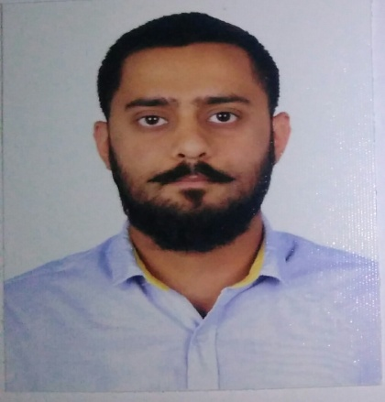
Siddarth

Email : siddarth.147872@2freemail.com

Professional Profile
- Content review and Quality Analyst.
- Digital marketing specialist.
- Ecommerce fraud investigator.
- Customer support executive.

Skills
- Q&A manual testing with knowledge on software lifecycle.
- Microsoft Excel, Microsoft Office and Google Spreadsheet.

Work Experience
2014 - 2016 |  | Data Analyst  Facebook – Hyderabad, India  - Worked as advertising review analyst and community operations specialist.  - Reviewed content of advertisements and profiles on Facebook on a daily basis in order to be policy compliant.  - Worked as transaction investigator for payments and purchase of products through Facebook.
2013 - 2014 Quality Analyst /Customer Support
Serco private limited – Hyderabad, India
- Worked as content review analyst for Google maps.
- Reviewed data and checked for policy violations of all businesses on Google maps.

Leadership Activities and Awards

2014 - 2016 Facebook – Hyderabad, India
- Was in-charge of handling high priority escalations on an account review level.
- In-charge of handling financial requirements of Samsung, Mercedes with regards to customer targeting.
- Awarded for designing a ticket system that resolved billing, payments and policy issues.
2013 - 2014 Serco private limited – Hyderabad, India
- Was given the responsibility to the quality of highly sensitive data on Google maps.
- Was promoted to the role of Mentor.
- Was in-charge of identifying bugs and error trends in Google based atlas tool.
- Promoted to Back up Lead and level 2 Quality Analyst.

Education
- Communications Engineer from Jawahalal Nehru Technological University (2008-2012) with a percentile of 68.
- State Secondary Schooling from St. Andrews High School (1994-2008) with a percentile of 81.

Personal Details
- Date of birth : 26-03-1991
- Passport : Indian
- Visa : UAE Tourist valid till 26-07-2017
- Marital status : Single
- Gender : Male

