Mohammed
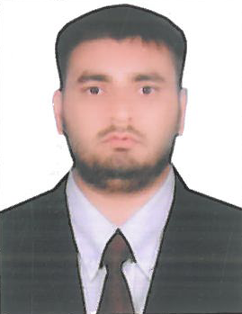
Mohammed.148408@2freemail.com

Career Objective:

To utilize my skills and abilities to the full extent in order to achieve desired goals. I aspire to a position in an Organization where my Personal Skills and Abilities will be challenged to achieve results through Leadership and Team Management.

Educational Qualifications:

- Bachelor of Arts in Human Resource Development (BAHRD) from SDM College, Mangalore.
- P.U.C from Anjuman Junior college, Bhatkal.

Additional Educational Pursuits:

- Well versed with MS Office Applications (MS-Word, Excel & Power Point).

Work experience:

- 15 months experience in Platoon Technologies LTD Bangalore. Worked as HR recruiter.

Roles and Responsibilities:

- Handling the entire end to end recruitment cycle for assigned clients.
- Responsible for handling contractual staffing.
- Short listing resumes based on the requirements.
- Gathering information about candidates work experience present and expectedcompensation location relocation information, work authorization status notice period availability for the interview and motivation factors.
- Conducting preliminary round of interview before sending their profile to the client by meeting them face to face or thru webcam.
- Collects feedback from interviewers and informing thecandidate on the same.
- Scheduling the interviews & arranging for walk-in- drives.
- Handled initial rounds aptitude test of interview.
- Logistics arrangements for interview issuing offer letters salary negotiation.
- Completing the entire joining formalities of the new hires.
- Employee background verification for newemployees.
Personal Dossier:
Date of birth : 07-11-1986
Nationality : Indian
Marital status : single

Declaration:

I hereby declare that thecontentsmentionedabove are truetothebest of my knowledge.

