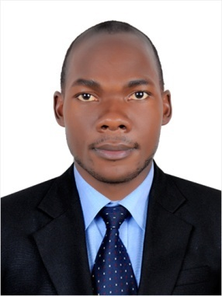
CURRICULUM VITAE

ALEX

DATE OF BIRTH: 28/Dec/1992
NATIONALITY: Ugandans
LANGUAGE: English
VISA STATUS: visit visa
Alex.148810@2freemail.com
PERSONAL SUMMARY
I am highly experienced Security Guard who is committed to complying to the highest work place standards in terms of attendance, health and safety, and conduct towards the public. Am more than able to respond effectively to medical situations, and fire emergencies, as well as bomb threats. I have comprehensive working knowledge of all Security Guard orders and duties, and am physically fit enough to be able to walk around for long periods, stoop, kneel, crouch, push, pull and grasp things. In my previous role I was regularly exposed to hot and cold weather conditions, smoke, loud noise, and bright lights. Right now I want to join an ambitious company that is looking to recruit a Security Guard who has the bags of enthusiasm and motivation needed to ensure the highest levels of safety and security
PERSONAL ACHIEVEMENTS
- An award in security industry regulatory agency (SIRA)
- An award of international ward for security and safety personal (Qatar)
- Best employee of the year (2016) Hemaya security services Qatar
- Certificate in computer applications including Microsoft applications, java net bean package.
- Awarded certificate in fire warden and fitness test.
CAREER HISTORY

HEMAYA SECURITY SERVICES QATAR
SECURITY GUARD June 2014- Present
Responsible for impeding criminal activity and ensuring the safety of the company, its employees and assets. Also involved in interacting with a variety of persons including clients, visitors and the general public

Duties
- Providing assistance and guidance to managers, visitors and general staff.
- Contacting the police, authorities and other emergency services when necessary.
- Checking badges of employees and visitors, and verifying authorization of visitors to enter the facility.
- Responding to emergencies.
- Reporting all incidents, accidents or medical emergencies.
- Monitoring and patrolling business areas on a consistent basis.
- Performing any light maintenance work that may be required.
- Issuing parking violation citations.
- Investigating incidents and preparing written reports with the details of the incident.
- Checking emergency call boxes, staff radios, security lighting and alarms to ensure they are working correctly.
- Having a highly visible presence on the premises.

AREAS OF EXPERTISE
- Emergency procedures
- Customer service
- Building evacuations
- Report writing
- Parking enforcement
- Security escorts
- Crowd control
- Control procedures
- CCTV
- Investigating disturbances
ACADEMICS
Mackay College School; Advanced level (2010) –(2011)
BIOLOGY (D), PHYSICS (E), CHEMISTRY (D), ENTRENUERSHIP (D)
ST THERESA SEC SCHOOL ORDINARY LEVEL (2006-2009)
REFERENCES
Available on request.

